2014小学六年级英语寒假作业
作业要求：
- 本作业分为朗读和笔头两部分；
- 在假期中以作业中的短文为载体，认真练习并提高你的口语朗读能力。读熟后请你读给家长听，并请家长签字；
- 认真完成笔头作业，提高你的阅读能力；
- 为此作业设计一个你认为漂亮、有意思的封面（包括你的班级、姓名、学号)。

Date(日期): January _____ Day（星期）: ________ Weather（天气）:________

1.
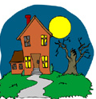
Alice looked at the moon. It was big. It was round. It was white. It was much bigger than all the stars. The stars were little lights. The moon was a big, bright light. She looked around. She could see other houses. She could see the sidewalk. She could see the street. The moon was bright. It was not as bright as the sun. But it was much brighter than the stars. She looked at the moon. Her dad said there is a man in the moon. She looked for the man in the moon. She looked for his eyes. She looked for his nose. She looked for his mouth. She did not see the man in the moon.
词汇积累
sidewalk n. (美) 人行道
基础练习
根据短文内容，判断正（T）误（F）。
( ) 1. Alice looked at the sun.
( ) 2. Alice could see houses because the moon was bright.
( ) 3. The moon was as bright as the sun.
( ) 4. Alice’s mother told her that there is a man in the moon.
( ) 5. Alice couldn’t find the man in the moon.
拓展练习
根据表格内容，完成任务。
Name | Age | Comes from | Where did she/he go? | What did she/he do?
Sara | 11 | Canada | Beijing | visited the Great Wall
Steve | 12 | Australia | Hangzhou | walked along the West Lake
Jacob | 10 | Germany | Shanghai | visited the World Expo Garden
Alice | 15 | Japan | Hainan | swam in the sea

Task 1 读表格，把Sara所缺的信息补充完整。
My name is Sara. I’m eleven years old. I am from __________. I went to ________ this summer holiday. I _____________________.

Task 2 请从Steve, Jacob, Alice三人中任选一个人物，将名字写在方框中。根据表格内容，以第一人称的口吻，为他/她写一段自我介绍。（不少于5句）

难度：★★★★ 阅读所需时间： _________
个人评价： 家长签字：________________

Date: January ________ Day: ____________ Weather:___________
Visit the park
2.
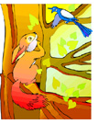
Nancy took her daughter Donna to the park. The park had lots of trees. It had lots of squirrels and birds. The squirrels ran up and down the trees. The squirrels chased one another. The squirrels played with one another. The birds flew around. They flew down to the ground. They flew up into the trees. The squirrels and birds were good neighbors. Nancy sat down on a bench. She took a magazine out of her bag. She was reading it now. Donna ran over to a squirrel. She tried to catch the squirrel. Then she tried to catch a bird. Donna chased the squirrels and birds. She never caught one squirrel. She never caught one bird. But she had a lot of fun.
词汇积累
1. squirrel n. 松鼠 2. chase v. 追赶；追逐
3. magazine n. 杂志；期刊
基础练习
根据短文内容，选择正确的答案。
( ) 1. What’s the relationship (关系) between Nancy and Donna? _______.
A. They are aunt and niece. B. They are mother and son.
C. They are mother and daughter.
( ) 2. What did run up and down the tree? ___________.
A. Squirrels B. Birds C. Nancy and Donny
( ) 3. Where did Nancy sit down? ________________.
A. Under a big tree B. On a bench C. Next to a big tree
( ) 4. Who did chase the squirrels and birds? ______________.
A. Donna B. Nancy C. Nancy and Donna
( ) 5. How did Donna feel in the park? She felt _________.
A. sad B. happy C. bored
拓展练习
根据表格内容，完成任务。
Name | Age | Comes from | Where did he/she go? | How did he/she go there?
Andy | 13 | England | Sanya | by plane
Lingling | 9 | China | London | by air
Tina | 11 | Australia | Tianjing | by train
Jack | 8 | the USA | Dalian | by ship
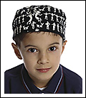
Task 1 读表格，把Andy所缺的信息补充完整。
My name is Andy. I’m thirteen years old. I come from __________. I went to __________ this summer vocation by ________.

Task 2 请从Lingling, Tina, Jack三人中任选一个人物，将名字写在方框中。根据表格内容，以第一人称的口吻，为他/她写一段自我介绍。（不少于4句）

难度：★★★☆ 阅读所需时间： _________
个人评价： 家长签字：________________

Date: January ________ Day: ____________ Weather:___________
An email after summer holiday
3.
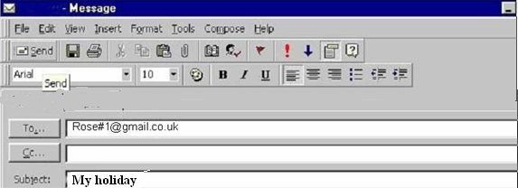

Hi Rose!
What’s up? I hope you’ll read the email very soon. I’m back home. I’ve got lots of things to tell you. I had a wonderful time in Spain. I met a nice girl there. She is American too. Her name is Tracy. We spent most of our time together: We went to the beach. We played volleyball. We swam in the sea. We took sunbath…. That was great. We had so much in common.
Rose, what did you do for this summer holiday? Did you make any new friends? I miss you so much. Well, if your parents agree, maybe you could come over here for a few days during the winter holiday, that would be great!
Well, C.U.
Your best friend, Laura
词汇积累
1. Spain n. (国名) 西班牙
2. sunbath n. 日光浴
3. in common 共同的，共有的
基础练习
根据短文内容，选择正确的答案。
( ) 1. Who wrote this email? It’s ____________.
A. Laura B. Rose C. Tracy
( ) 2. Where did Laura go this summer holiday? She went to ________.
A. America B. Spain C. Canada
( ) 3. Where does Tracy come from? She comes from _________.
A. America B. Spain C. Canada
( ) 4. Do you know which thing Laura and Tracy did not do at the beach?
They didn’t _________.
A. play volleyball B. take sunbath C. go fishing
( ) 5. What is this email about? It’s about _________.
A. Rose’s summer holiday B. Tracy’s summer holiday
C. Laura’s summer holiday
拓展练习
你的假期生活过得怎么样？仿照电子邮件的格式，试着给你的一位朋友写一封E-mail，向他/她说说你的暑期生活。（正文不能少于5句话）
难度：★★★★ 阅读所需时间： _________
个人评价： 家长签字：________________

Date: January ________ Day: ____________ Weather:___________

4.

现代人的生活压力越来越大。医生们说压力和睡眠不足可以导致许多疾病的发生。读一读下面几个青少年关于健康的采访发言。
I think I am a healthy person. I have headaches sometimes, if I’m very tired. Actually, I didn’t sleep well last night. So I have got a headache now. I will take some medicine and have a rest. (Kate, 15)

I have colds quiet often because I don’t eat enough fruit or vegetables. If my colds get too bad, I go to the doctor and see what he gives me- cough medicine and antibiotics. (May, 17)

I can’t say I’m healthy but I’m a sportsperson. I play football, American football and volleyball. I think I have more energy since I’ve been playing. Yesterday I broke my left arms. And now I am in hospital. I hope I will get better soon.
(Peter, 14)
词汇积累
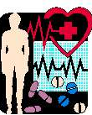
antibiotics n. 抗生素；抗菌素 energy n. 精力；活力
基础练习
根据短文内容，判断正（T）误（F）。
( ) 1. Kate sometimes has headaches.
( ) 2. May seldom has colds.
( ) 3. May doesn’t like fruit and vegetables.
( ) 4. Peter likes doing sports.
( ) 5. Peter broke his right arm yesterday.
拓展练习
根据表格内容，完成任务。
Name | Age | Comes from | What did he/she do yesterday | Illness
Kelly | 9 | America | went to bad late | the flu
Dave | 8 | Japan | ate lots of sweets | the toothache
Jason | 13 | Canada | stayed up late | the bad cold
Lily | 15 | England | played computer games all day | the headache
Task 1 读表格，把Kelly所缺的信息补充完整。

My name is Kelly. I’m nine years old. I come from __________. I __________ yesterday. I’ve got ___________.

Task 2 请从Dave, Jason, Lily三人中任选一个人物，将名字写在方框中。根据表格内容，以第一人称的口吻，为他/她写一段文字描述。（不少于4句）

难度：★★★★ 阅读所需时间： _________
个人评价： 家长签字：________________

Date: January ________ Day: ____________ Weather:___________
The hospital
5.
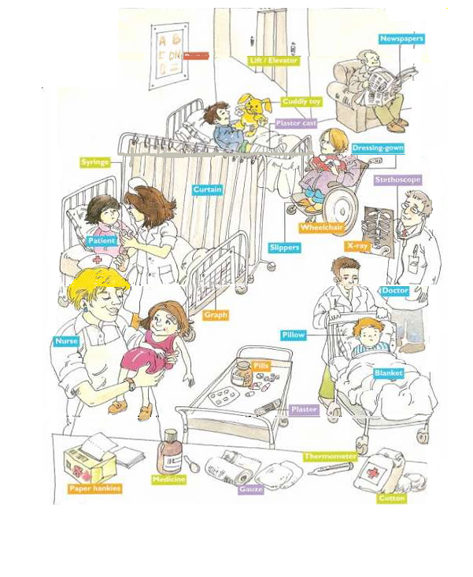

词汇积累
lying adj. 横卧的
基础练习
读图片，根据图片内容选择恰当的词汇填空。
X-ray newspaper poster dog doctor

I arrived at the hospital. There was a man reading the _________ and there was a ______ on a wall saying “SILENCE, PLEASE”. I went to see my cousin, who had broken his leg. He was lying on a bed. He was playing with a ______. There was also a ________ standing near him holding an _________.
拓展练习
根据表格内容，完成任务。
Name | Age | Comes from | What did he/she do yesterday | Illness
Joe | 15 | the USA | played computer game for nine hours | cold
Susie | 13 | Australia | ate lots of sweets | toothache
Candy | 8 | Singapore | went swimming outdoors | the flu
Steve | 9 | Britain | surfed the internet all day | the headache
Task 1 读表格，把Joe所缺的信息补充完整。
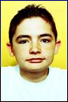
My name is Joe. I’m fifteen years old. I come from __________. I __________ yesterday. I’ve got ___________.

Task 2 请从Susie, Candy, Steve三人中任选一个人物，将名字写在方框中。根据表格内容，以第一人称的口吻，为他/她写一段文字描述。（不少于4句）

难度：★★★★ 阅读所需时间： _________
个人评价： 家长签字：________________

Date: January ________ Day: ____________ Weather:___________
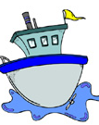
6.
Problems on a boat

John liked to travel the world. He liked to use different types or transport, but he didn’t like flying. One day he decided that he would go to Spain. He wanted to go by boat to Bilbao in the north of Spain. He got up at 4 o’clock in the morning, and caught a taxi to the port in Plymouth. The boat was on time, and John got on the boat at 5:30 am. It was a big old boat. John went to the restaurant on the boat to have some breakfast. He chose bread and tea, sat down and started to eat. John looked out of the window. He saw the boat leaving the port. A few minutes later John stood up to pay for his breakfast. He put his hand in his pocket, but his wallet wasn’t there! John looked at the waiter. Before he could speak, he heard an announcement. “ This is the captain. For your information we will arrive in Malaga in two days. Have a nice trip.“

词汇积累
1. transport n. 运输；交通工具 2. Spain n. 西班牙
3. Bilbao n. (西班牙港口名) 毕尔巴鄂 4. port n. 港口
5. Plymouth n. (英国港口名) 普利茅斯 6. announcement n. 公告；通告
7. captain n. 船长 8. Malaga（西班牙南部港口)马拉加

基础练习
把相同意思的内容用直线连接。
1. flying A. a message
2. on time B. the manager of the boat
3. the port C. travel by plane
4. pocket D. place where boats arrive and leave
5. wallet E. not early or late
6. announcement F. a place for wallet or cold hands
7. captain G. a holder for money and cards
拓展练习
- Where did John want to go?
______________________________________
2. How did he go there?
______________________________________
3. When did John get up?
______________________________________
4. When did John get on the boat?
______________________________________
5. What did he have for his breakfast?
______________________________________
6. What’s the problem with John?
____________________________________________________________
难度：★★★★ 阅读所需时间： _________
个人评价： 家长签字：________________

Date: January ________ Day: ____________ Weather:___________
Two Inventions
7.

Two Inventions

Jeans | Aspirin
Two Americans, Jacob Davis and Levi Strauss, made the first jeans in 1873. Davis bought cloth from Levi’s shop. He told Levi that he had a special way to make strong clothing for women. The first jeans were blue. In 1935 jeans became fashionable for women after they saw them in magazine. In the 1970’s, Calvin Klein earned $12.5 million a week from jeans. | 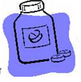  Felix Hofman, 1 29-year-old chemist who worked for the German company Bayer, invented the drug aspirin to his father. By 1930 it was the best-selling painkiller in the world, and in 1969 the Apollo astronauts took it to the moon. The Spanish philosopher called the 20th century “The Age of Aspirin.”

词汇积累
1. fashionable adj. 时尚的 2. chemist n. 药剂师；化学家
3. Bayer 德国拜耳公司 4. aspirin 阿司匹林（药物名称）

5. painkiller n. 止痛药 6. Apollo 阿波罗号宇宙飞船
7. philosopher n. 哲学家 8. century n. 世纪

基础练习
根据短文内容，判断对错。
( ) 1. Two Americans invented the first jeans.
( ) 2. The first jeans weren’t blue.
( ) 3. Calvin Klein earned a lot of money for selling jeans in the 1970’s.
( ) 4. Felix Hofman invented aspirin for his wife.
( ) 5. Aspirin was one of the most important inventions in 20th century.
拓展练习
根据表格内容，完成任务。
Inventor | Comes from | Inventions | Time
Thomas Edison | America | the light bulb | 1879
Graham Bell | America | the telephone | 1876
John Baird | England | the television | 1924
Carl Drais | Germany | the bike | 1817
Task 1 读表格，把所缺的信息补充完整。
Thomas Edison is an inventor. He comes from _____________. He invented ___________ in 1879. This invention makes our life easy and comfortable.
Task 2 请从后三个发明家中任选一个人物，为他写一段介绍。（不少于4句） ________________________________________________________________________________________________________________________________________
难度：★★★★ 阅读所需时间： _________
个人评价： 家长签字：________________

Date: January ________ Day: ____________ Weather:___________

Choose the right way of traveling
8.

1. Mr. Smith is going to visit Liverpool. It is a business trip. He wants to get there in the shortest possible time. He hasn’t much luggage; he takes just one suitcase with him. It is not heavy. The weather is fine. The sky is clear and there no clouds in it. How can he get to Liverpool?
2. Ann Williams likes long journeys. It is so enjoyable to make friends with other passengers. She likes to watch the countryside while traveling and take naps in a compartment from time to time. Next month she’ll travel to Pairs. What way of traveling will she use?

4. The Parkers are planning the family holiday. They don’t want to buy ticket or be in hurry catching their plane or train. They want to make a stop where they like. They want to visit any place they like. What way of traveling will be the best?
3. It is Sunday morning. James wants to go to his grandmother. She lives not far from his place; her house is in the village about 7 kilometers away. James’ hobby is riding a bike. The weather is pleasant. It is warm and sunny. James must be back by the evening. How can he go to Granny’s place？

词汇积累
- Liverpool 利物浦（城市名） 2. business n. 商业;生意
3. journey n. 旅行 4. passenger n. 乘客；旅客
5. take naps 打盹；午睡 6. compartment n. 车厢

基础练习
读短文，为短文中的人物选出合适的出行工具。

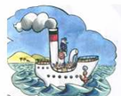
Mr. Smith
Ann Williams
James
The Parkers
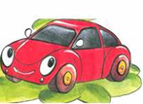
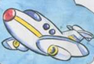

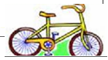
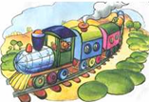

拓展练习
根据短文内容，判断正（T）误（F）。
( ) 1. Mr. Smith is going to Liverpool for a holiday.
( ) 2. Ann likes talking with other passengers during the trip.
( ) 3. James’ grandmother lives far from James’ home.
( ) 4. The Parks family enjoy traveling by air.
( ) 5. The four passages are all about how people travel.

难度：★★★☆ 阅读所需时间： _________
个人评价： 家长签字：________________

Date: January ________ Day: ____________ Weather:___________

9.

There are two kinds of Olympiad; the Summer and the Winter Olympic Games. They are each held every 4 years, with a gap of 2 years between both of them. Each one has its own different sports. In Year 2008, Beijing held the Summer Olympic Games; and In Year 2010, Vancouver held the Winter Olympic Games.

The ancient Olympic Games began in 776 BC, about 3000 years ago. And the modern Olympic Games began in 1896, about 1000 years ago. There was only one event in the first ancient Olympics: that was running. And there are more events in the modern Games than in the ancient Games.


词汇积累
- Olympiad n. 奥运会
- Vancouver n. 温哥华（加拿大城市名）
基础练习
根据短文内容，判断正（T）误（F）。
( ) 1. The Summer Olympic Games were held every two years.
( ) 2. The latest(最近的) Winter Olympic Games were held in Vancouver.
( ) 3. Beijing hosted the latest Summer Olympic Games.
( ) 4. There was more than one event in the first ancient Olympics.
( ) 5. The ancient Olympics had a history of about 1000 years.
拓展练习
根据表格内容，完成任务。
Name | Age | Comes from | Job | Favourite/Least favourite event in Summer Olympics
Lily | 24 | Canada | engineer | marathon / boxing
George | 27 | Australia | doctor | swimming / football
Mary | 30 | Germany | dancer | gymnastics / diving
Dave | 55 | Japan | professor | handball / table tennis

Task 1 读表格，把Lily所缺的信息补充完整。
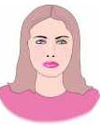
My name is Lily. I’m twenty-four years old. I am from __________. I am an ____________. My favourite event is __________ and my least favourite event is boxing.

Task 2 请从George, Mary, Dave三人中任选一个人物，将名字写在方框中。根据表格内容，以第一人称的口吻，为他/她写一段自我介绍。（不少于5句）

难度：★★★☆ 阅读所需时间： _________
个人评价： 家长签字：________________

Date: January ________ Day: ____________ Weather:___________

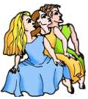
Fashion Models
10.
1. This model is wearing a brown blouse and a brown pair of trousers. This goes will with her brown cap.
2. This model is wearing a brown hoodie. He’s also wearing a pair of shorts and on his feet he has some nice flip-flops for the summer.
3. This model is wearing a red suit. Her brown scarf goes will with her brown hat.
4. This model’s got a fantastic suit. He’s got a black blazer and a black pair of trousers. He’s also wearing a white shirt and a red tie. They go well with his red boots.
5. This model is wearing a grey T-shirt and a jacket. Look at his black trousers with matching belt! He is gorgeous!
6. This model is wearing a purple dress and she is holding a purple umbrella. She has a pair of glasses.

词汇积累
- model n. 模特 2. flip-flop n. 夹脚拖鞋
3. blazer n. 运动夹克上衣 4. gorgeous adj. 绚丽的；漂亮的
基础练习
根据文字内容，把模特的编号写在图片的下面。
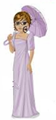
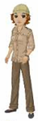
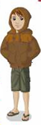
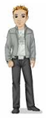



拓展练习
根据表格内容，完成任务。
Name | Age | Comes from | Job | Likes to wear
Karenna | 23 | England | teacher | her suits
Jacob | 25 | America | engineer | formal clothes
Sophie | 18 | New Zealand | student | her uniform
Ginger | 35 | Singapore | actress | casual clothes

Task 1 读表格，把Karenna所缺的信息补充完整。
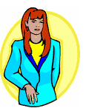
My name is Karenna. I’m ________________ years old. I am from __________. I am a teacher and I like to wear __________.

Task 2 请从Jacob, Sophie, Ginger三人中任选一个人物，将名字写在方框中。根据表格内容，以第一人称的口吻，为他/她写一段自我介绍。（不少于4句）

难度：★★★☆ 阅读所需时间： _________
个人评价： 家长签字：________________

