2013高考英语二轮书面表达（图文为主）训练（19）及参考范文

假设2008年2月12日是你父亲的生日，下面三幅图描绘的是你给父亲买完礼物后乘坐地铁回家时经历的一件事。请根据图示，用英语写一篇日记记叙这件事，并谈谈自己的感受。
注意：
1. 词数不少于100；
2. 可适当加入细节，以使行文连贯。
参考词汇：
地铁（列车）—subway train
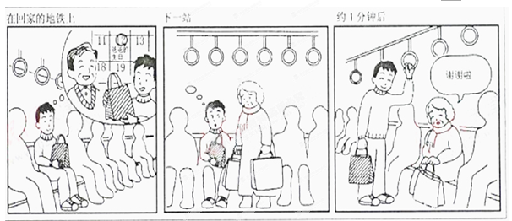
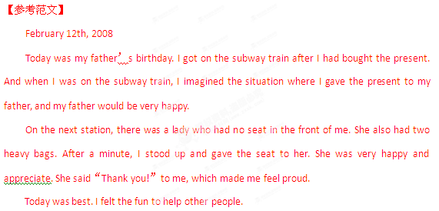

预测二十一：
假如牛津大学出版社要出版Daniel Gottlieb 编写的“Learning from the Heart: Lessons on Living, Loving and Listening”这本新书，请你根据下面的提示为该书写一篇100词左右的英文介绍。
1.作者的不幸：30岁时因车祸瘫痪（paralysed); 离过婚（divorce)且第二个妻子得了癌症；孙子有自闭症（autism)。
2.作者的生活态度：若不是有这些不幸，就不会有现在的成就。
3.该书的启示：我们要用心聆听他人和自己的心声。
【参考范文】
In most people’s eyes, Gottlieb, the writer of the book “Learning from the Heart: Lessons on Living, Loving and Listening”, might be uncomfortable with himself. He became paralysed due to an accident that happened when he was 30. He went through a terrible divorce and his second wife got cancer. What’s worse, he even had an autistic grandson.
Yet in his book, Gottlieb manages to see the bright side of the hardships. As he once wrote in the book, he might not have become the man he is today were it not for the misfortunes.
What the book tells us is that people should listen to the voices of others and their own hearts and learn to feel comfortable with who they are.
预测二十二：
假如你是明启中学（Ming Qi Middle School）的李明，想申请一个扶贫项目，帮助贫困地区的儿童。根据以下启事，写一封申请信（信中不能提到真实姓名和学校）。
启事国际儿童基金会将资助中学生开展扶贫项目，以帮助贫困地区的儿童。申请成功者将获得项目经费2 000元。
有意者请来信告知：
1）你个人的基本情况；
2）你对申请项目的基本设想；
3）项目经费的使用计划。
联系方式:2011hope@icf.org
【参考范文】
Dear Chairman,
I’m writing to you with reference to the project that helps the children in poor areas, and I want to apply for it.
First, I’ll introduce myself to you. I’m Li Ming, a Senior 2 student at Ming Qi Middle School. I’m a student of good character and fine scholarship. I’m ready to help others in daily life. I think this project will offer me an opportunity to help more children.
If I succeed in applying for it, first and foremost, I’ll keep in touch with the poor children frequently by writing letters, emails or meeting face to face; in the meanwhile, I’ll communicate with them not only in life but also in studies,and get to know more about them and help them in every aspect; last but not least, I’ll help them acquire a correct outlook on life, helping them exploit knowledge to change their fortune.
Taking the project fund into account, I’ll divide it into three parts. One part is used for their tuition and books; another part is for their daily life and the last part is for enriching their hobbies, aiming to help them develop in an all round way.
Such is my plan about the project. I’m looking forward to your reply at your earliest convenience.
Yours sincerely,
Li Ming

