海 淀 区 高 三 年 级 第 一 学 期 期 末 练 习
英 语 2014.01
本试卷共12页，共150分。考试时长120分钟。
注意事项：
1．考生务必将答案答在答题卡上，在试卷上作答无效。
2．答题前考生务必将答题卡上的姓名、准考证号用黑色字迹的签字笔填写。
3．答题卡上选择题必须用2B铅笔作答，将选中项涂满涂黑，黑度以盖住框内字母为准，修改时用橡皮擦除干净。非选择题必须用黑色字迹的签字笔按照题号顺序在各题目的答题区域内作答，未在对应的答题区域内作答或超出答题区域作答的均不得分。

第一部分：听力理解（共三节，30分）
第一节（共5小题；每小题1.5分，共7.5分）
听下面5段对话。每段对话后有一道小题，从每题所给的A、B、C三个选项中选出最佳选项。听完每段对话后，你将有10秒钟的时间来回答有关小题和阅读下一小题。每段对话你将听一遍。
1. What’s the weather like now?
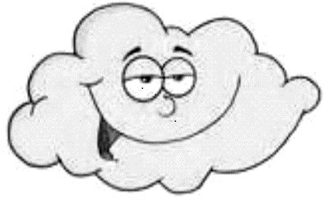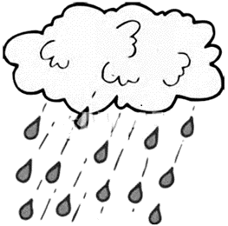
A. B. C.
2. Where are the two speakers?
A. In a hotel. B. In a bar. C. At home.
3. Why does the girl hurry home?
A. To join in a group discussion. B. To get something important. C. To have a quick meal.
4. What is the woman going to do?
A. Have a meeting. B. Get her son home. C. Go to the office.
5. When does the man leave?
A. Next Wednesday. B. Next Friday. C. This Sunday.

第二节（共10小题；每小题1.5分，共15分）
听下面4段对话或独白。每段对话或独白后有几道小题，从每题所给的A、B、C三个选项中选出最佳选项。听每段对话或独白前，你将有5秒钟的时间阅读每小题。听完后，每小题将给出5秒钟的作答时间。每段对话或独白你将听两遍。
听第6段材料，回答第6至7题。
6. What are they talking about?
A. Fixing the bike. B. Taking a trip. C. Taking some pictures.
7. What does the man remind the woman to take?
A. A cellphone. B. A guitar. C. A helmet.

听第7段材料，回答第8至9题。
8. What is the man unhappy about?
A. The service. B. The food. C. The manager.
9. How did the woman handle the matter?
A. She called in the manager.
B. She gave the man a discount.
C. She filled out a comment card.

听第8段材料，回答第10至12题。
10. How much does the Hawaii tour cost at least?
A. 199 pounds. B. 372 pounds. C. 400 pounds.
11. Which place is suggested for traveling near home?
A. Paris. B. Rome. C. Scotland.
12. How can customers get the brochure?
A. By going online. B. By making a call. C. By sending an e-mail.

听第9段材料，回答第13至15题。
13. How many dogs does the family keep?
A. 3. B. 4. C. 5.
14. What can we know about Randall?
A. He likes school very much.
B. He is hard to get along with.
C. He is crazy about video games.
15. What does the man decide to do next?
A. Share the dorm with his brother.
B. Move in to live with Randall.
C. Find another house to live in.

第三节（共5小题；每小题1.5分，共7.5分）
听下面一段对话，完成第16至20题，每小题仅填写一个词。听对话前，你将有20秒钟的时间阅读试题，听完后你将有60秒钟的作答时间。这段对话你将听两遍。

Satisfaction Survey Form
Personal Information | Membership number: 16
Personal Information | Occupation: 17
Personal Information | Types of classes: 18 & yoga
Opinions about Classes & Instructors | Classes: enjoyable  Instructors: 19 and supportive
Opinions about Classes & Instructors | Problems: 20 evening classes  Suggestions: running another class
第二部分：知识运用（共两节，45分）
第一节 单项填空（共15小题；每小题1分，共15分）
从每题所给的A、B、C、D四个选项中，选出可以填入空白处的最佳选项，并在答题卡上将该项涂黑。
21. —What do you think of your new Pad?
—Good. I don’t think I can find a ______ one.
A. worst B. best C. worse D. better
22. —I’ll be down in two minutes!
—OK. I’ll wait until you ______ ready.
A. will be B. are C. would be D. were
23. Don’t use your mobile phone while charging, ______ you may be shocked by electricity.
A. or B. and C. but D. yet
24. You can complain, but I doubt ______ it will make any difference.
A. that B. whether C. why D. when
25. —Have you heard of the accident on this road last night?
—Yes. And there ______ three accidents here so far this year.
A. are B. were C. have been D. had been
26. Doctors always advise us ______ plenty of water to stay healthy.
A. drunk B. drinking C. drink D. to drink
27. No matter how busy he is, Tom makes ______ a rule to see his parents every week.
A. this B. that C. it D. him
28. —Can I come over in an hour?
—Sorry, I ______ the house.
A. will clean B. am cleaning C. clean D. will be cleaning
29. This restaurant has an inviting, homelike atmosphere ______ many others are short of.
A. where B. when C. that D. what
30. —Can I smoke here?
—No. Go to the smoking section, if you ______.
A. must B. can C. shall D. may
31. —Have they got our car repaired?
—I don’t know. But it ______ when I called them yesterday.
A. would repair B. was repaired C. had repaired D. was being repaired
32. When ______ about the reason for winning the prize, the girl owed the success to her teachers.
A. asked B. asking C. being asked D. having asked
33. With our country entering an aging society, ______ the retirement age is probably unavoidable.
A. having delayed B. delaying C. being delayed D. to be delayed
34. The new policy allows a couple to have a second birth ______ either is an only child.
A. though B. if C. unless D. until
35. But for the mistakes he made, Li Ming ______ the entrance exam last year.
A. would have passed B. will pass C. would pass D. will have passed

第二节 完形填空（共20小题；每小题1.5分，共30分）
阅读下面短文，掌握其大意，从每题所给的A、B、C、D四个选项中，选出最佳选项，并在答题卡上将该项涂黑。
Music to My Ears
Robby was 10 for his first piano lesson in my class. Much as he tried, he __36__ even the basic rhythm. However, he dutifully reviewed the pieces that I required.
Over the months he tried and tried while I __37__ and encouraged him. At the end of each lesson he'd always say, "My mom's going to hear me play some day." __38__ it seemed hopeless.
I only knew his mother from a __39__as she waited in her aged car to pick him up. Then one day Robby stopped coming. I was secretly __40__ that he stopped because of his lack of ability.
Weeks later I informed the students, including Robby, of the coming recital（独奏）. To my __41__, Robby asked me if he could be included. I told him he really did not qualify because he had __42__ out. He said his mom had been sick and unable to take him to lessons but he was still __43__ .
“I've just got to play!" he __44__. Something inside me let me allow him to.
Then came the recital night. The gym was __45__ with parents. I put Robby up __46__, thinking that I could save his poor performance through my “curtain closer（谢幕）.”
The recital went off smoothly. Then Robby came up on stage. His clothes were wrinkled and his hair was __47__. "Why didn't his mother at least make him comb his hair for this special night?" I thought.
Robby pulled out the piano bench and began. I was not __48__ for what I heard next. His fingers were __49__ on the keys. Never had I heard Mozart played so well by people of his age. After he ended, everyone was __50__ their feet in wild applause.
In __51__ I ran up on stage and put my arms around Robby. "I've never heard you play like that, Robby! How did you __52__ it?"
Robby explained, "Well, Miss Hondorf…remember I told you my mom was sick? …__53__ she had cancer and passed away yesterday. She was born deaf, so tonight she could hear me play in heaven. I wanted to make it special."
There wasn’t a __54__ eye in the house. That night I felt he was the teacher and I was the pupil, for it was he who taught me the meaning of perseverance and __55__.
36. A. lacked B. had C. showed D. got
37. A. listened B. learned C. checked D. played
38. A. And B. But C. So D. Or
39. A. conversation B. performance C. distance D. picture
40. A. guilty B. sad C. anxious D. glad
41. A. relief B. surprise C. pleasure D. satisfaction
42. A. stepped B. worn C. run D. dropped
43. A. acting B. performing C. practicing D. recording
44. A. insisted B. suggested C. complained D. threatened
45. A. lined B. packed C. piled D. covered
46. A. least B. most C. first D. last
47. A. messy B. cool C. neat D. dull
48. A. eager B. concerned C. prepared D. grateful
49. A. hesitating B. dancing C. touching D. crawling
50. A. over B. under C. in D. on
51. A. chaos B. tears C. silence D. return
52. A. find B. feel C. make D. like
53. A. Gradually B. Suddenly C. Frequently D. Actually
54. A. dry B. curious C. bright D. wet
55. A. regret B. talent C. love D. courage

第三部分：阅读理解（共两节，40分）
第一节 （共15小题；每小题2分，共30分）
阅读下列短文，从每题所给的A、B、C、D四个选项中，选出最佳选项，并在答题卡上将该项涂黑。
A
The Great Barn Adventure
One morning when I was 11, I explored the town’s abandoned round grain barn（谷仓）. I found a chained sliding door that was wide enough for me to pass through.
Inside, there was a heavy smell of dead mice in the dark. After my eyes adjusted, I noticed a shaft (升降机井) that rose all the way to the top of the barn. On one side was a one-man elevator with a long rope and roller.
I stepped onto the platform and gave the rope a drag and the elevator began sliding up the shaft, but stopped halfway. After a brief panic attack, I noticed holes in the wall at regular intervals, forming a ladder. For reasons known only to an 11-year-old, I decided it would be better to go up than down. So, with shaking hands, I began climbing the wall.
After what seemed like forever, I reached the top of the shaft. I stood up, dusted myself off and found…absolutely nothing of interest. It was just an empty room with a ladder leading up to the roof. I climbed all the way up here for this? Then I noticed a fire extinguisher（灭火器）,which I’d always wanted to shoot off. So this was the chance of a lifetime. I tried it, and, much to my surprise, the thing worked! It shot out a thick cloud of powder that instantly filled the room. I couldn’t breathe. I was going to choke to death, and they’d probably never even find my body.
Luckily, I remembered the ladder to the roof. I climbed up, popped the straw roof and saw a bright blue sky.
I suddenly realized the dust and powder pouring out of the top could draw attention. So when the dust had settled, I climbed down and slipped out of the chained door. I’m not sure if I was more excited about being alive or about not being caught, but I ran all the way back home.
56. When the author got inside the barn, he _______.
A. noticed a man on the elevator
B. opened the chained sliding door
C. saw many dead mice in the dark
D. found a shaft leading to the top
57. Which of the following is the right order of the author’s adventure?
a. The elevator stopped halfway.
b. He entered the round grain barn.
c. He climbed to the top of the shaft.
d. He found a fire extinguisher and shot it off.
A. b-a-c-d B. a-c-b-d C. c-a-d-b D. b-c-a-d
58. After getting out of the chained door, the author might feel _______.
A. inspired B. relieved C. surprised D. disappointed
59. From the passage, we can learn that the author was probably a boy full of _______.
A. passions B. dreams C. curiosity D. imagination

B
As we enjoy the summer ocean waves along the beaches, we may think nervously about Steven Spielberg's Jaws and the great fear that sharks inspire in us. Yet we are happy to see global efforts to protect the declining number of sharks. The world has realized that we need the species, like sharks, to keep a balanced ecosystem.
Sharks, in particular, are “in” these days. Thanks to good public policy and famous stars such as Jackie Chan and Ang Lee, killing sharks for fin soup is no longer cool.
The demand for shark fins has been rising for decades, threatening sharks with extinction（灭绝）—up to 100 million sharks are killed each year just for their fins. But we have started to reverse the trend, particularly in many areas of the United States and overseas where restaurants once proudly provided delicious shark fins on the menu.
In California, a ban on the sale and possession of shark fin soup has gone into effect this year through the efforts of Wild Aid and other organizations.
Overseas marketing and public efforts featuring posters on public transportation systems and TV ads have been underway for the past few years. These efforts all show signs of success, on both the supply side and the demand side of trade in shark fins.
Actually, stopping the killing of sharks is part of a broader movement to stop the killing of wild animals and the buying and selling of wildlife products. These products come from hunting elephants, tigers and rhinos, besides killing marine life.
Whether it is shark fin soup or ivory piano keys, killing animals is big business. The hunting of elephants in search of ivory tusks for luxury（奢侈的）goods has become a full-scale war. The decrease of African elephant populations is alarming. Together with international partners, the United States is leading the worldwide effort to reduce demand for high-end products that rely on killing animals.

60. The underlined word “reverse” in Paragraph 3 probably means _______.
A. show B. keep C. follow D. change
61. From the passage, we know _______.
A. Jackie Chan and Ang Lee make fin soup popular
B. a lot of wild animals have been killed for products
C. Steven Spielberg's Jaws inspires us to protect sharks
D. the number of African elephants has been increased
62. What can we infer from the passage?
A. More animals for high-end products will be saved.
B. People have kicked the habit of having shark fin soup.
C. Shark fins will not be available any more in restaurants.
D. Global efforts have succeeded in stopping killing wild animals.

C
Dear David,
I’m glad you would like to share your feelings with me. It’s hardly surprising that your feelings of not being “grown up” have come on strongly at this point in your life, just before you’re about to become a father. You are asking: will I make a good father? How will I cope? Should I have brought another little person into the world? Can I provide for it? Heeelp! I think nearly every sensitive about-to-be-parent must have these occasional feelings of self-doubt and inadequacy（不适）before the birth and it would be most unusual if you didn’t share them.
It’s difficult, honestly, to feel grown-up unless you have something less grown-up to relate to. The boss with a hen-pecking wife may feel like a seven-year-old when he’s at home. But as he walks through the office door, and knows he’s going to be surrounded by staff looking to him for advice, he grows into a fully mature man. And I think it’s a mistake to imagine that we all feel, as we age, a kind of progression of states, from the baby to the adult. Most people feel, on Tuesday, about three years old, and on a Wednesday, around 80. I remember feeling very grown-up at eight, a time when I was weighed down with responsibility. These days, much older, I can, in the company of people I feel at ease with, feel like a young girl.
There’s a common remark that “all men are little boys”, but it’s not true. It’s more true that men often behave like little boys. But nearly all people, at some moments in their lives, are capable of great maturity.
Once your baby arrives, you’ll soon feel less childlike, or rather, less often. When your child tries to put its fingers into the electric plug, the adult in you will rise up to prevent it. You’ll see you have very little in common with a needy child, particularly if it’s looking to you for comfort and support.
Comfort yourself, David, with two truths. One is that your friends laugh when they talk about this subject because they, like you, feel frightened. And remember that people who haven’t grown up don’t go around talking about the fact that they don’t feel grown-up.
Hope my advice will be helpful and good luck to you and your little one.
Sincerely Yours,
Miss Advice
63. According to the passage, Miss Advice thinks David’s self-doubt _______.
A. valuable B. natural C. unusual D. bearable
64. From Paragraph 2, we can learn that people’s sense of maturity _______.
A. will increase with age
B. is obviously seen at home
C. changes with different situations
D. becomes stronger with familiar people
65. Miss Advice holds that _______.
A. all men behave like little boys
B. people tend to laugh at the subject
C. men with a baby feel more grown-up
D. people enjoy talking about their immaturity
66. Miss Advice wrote the letter to _______.
A. offer suggestions to a future father B. teach people how to grow up
C. encourage people to be responsible D. solve problems of the less grown-up

D
Does everyone want a challenging job? In spite of all the attention focused by the media, academicians, and social scientists on human potential and the needs of individuals, there is no evidence to support that the vast majority of workers want challenging jobs. Some individuals prefer highly complex and challenging jobs; others develop in simple, routine work.
The individual-difference variable（变量） that seems to gain the greatest support for explaining who prefers a challenging job and who doesn’t is the strength of an individual’s needs for personal growth and self-direction at work. Individuals with these higher-order growth needs are more responsive for challenging work. What percentage of ordinary workers actually desire higher-order need satisfactions and will respond positively to challenging jobs? No current data is available, but a study from the 1970s estimated the figure at about 15%. Even after adjusting for changing work attitudes and the growth in white-collar jobs, it seems unlikely that the number today exceeds 40%.
The strongest voice advocating challenging jobs has not been workers—it’s been professors, social science researchers, and media people. Professors, researchers, and journalists undoubtedly made their career choices, to some degree, because they wanted jobs that gave them autonomy, recognition and challenge. That, of course, is their choice. But for them, to force their needs onto the workforce in general is presumptuous (冒失的).
Not every employee is looking for a challenging job. Many workers meet their higher-order need off the job. There are 168 hours in every individual’s week. Work rarely consumes more than 30% of this time. That leaves considerable opportunities, even for individuals with strong growth needs, to find higher-order need satisfaction outside the workplace. So don’t feel you have a responsibility to create challenging jobs for all your employees. For many people, work is something that will never excite or challenge them. And they don’t expect to find their growth opportunities at work. Work is merely something they have to do to pay their bills. They can find challenges outside of work on the golf course, fishing, at their local pub, with their friends in social clubs, with their family, and the like.
67. What makes people choose challenging jobs?
A. Positive responses. B. Work attitudes.
C. Higher-order growth needs. D. Personal self-direction.
68. Who is the least likely to prefer a challenging job?
A. College professors. B. Construction workers.
C. Social researchers. D. Media journalists.
69. The passage is intended for _______.
A. job-hunters B. researchers C. graduates D. employers
70. Which is the best title for the passage?
A. Not Everyone Wants a Challenging Job
B. Complex Jobs Offer Growth Opportunities
C. Employers Should Create Challenging Jobs
D. Challenging Jobs Give a Sense of Recognition

第二节 （共5小题；每小题2分，共10分）
根据短文内容，从短文后的七个选项中选出能填入空白处的最佳选项。选项中有两项为多余选项。
How to Love Your Parents
Even if you think that your parents are mean-spirited at times, loving your parents is a normal and fulfilling part of life. You love them for the fact that they created you, raised you, and are in part a source of who you are. Here are some ways to love your parents.
____71____ A gentle “good morning” and “I love you” will warm a coldest heart. Remember that they brought you into this world. Without your parents, we might still wander at an unknown corner in an unknown world.
Respect them more and cherish these moments. You can use these moments to learn from them for when you're off on your own. It's OK to get angry but angry actions don't help you or your parents. Act calmly, cool off, journal about your feelings, or talk to a friend. ____72____
Obey their requests. It will make your attitude better and earn you more respect from them. It may seem like you are going through hell when you don’t get what you want or you have to clean. However, you had better remember they keep a roof over your head when it’s cold, raining, snowing, or too hot. Understand that parents are human beings and make mistakes.____73____ Since you can forgive your friends, why not forgive your parents?
Keep company with them. Do things with your parents like watching TV, or go somewhere with them. ____74____ Listen to their old stories and learn from them. You will find they are your teachers in this way or another.
Some people simply may not be able to love their parents. ____75____ Seek help if you are being abused in any way. Parents do not have a right to harm you.
A. Forgiveness is the key.
B. Tell them you love them every morning.
C. Parents will in turn express their love to you.
D. After this, share your feelings with your parents.
E. Anyway, spend as much time with them as you can.
F. Please remember parents are as important as friends.
G. There can be realistic reasons for this, family violence for example.

第四部分：书面表达（共两节，35分）
第一节（15分）
假设你是红星中学高三（1）班的学生李华，你校正在招募志愿者，为春节期间中外学生交流活动做准备。请根据下表提供的信息，用英语写一封e-mail，向学校外事办公室提出申请。
注意：1. E-mail的开头和结尾已为你写好。
2. 词数不少于50。
Name | Li Hua
Class | Class 1, Senior 3
Qualifications | - speak English fluently  - have similar experiences  - be willing to spread Chinese culture  …

Dear Sir，
I am writing to apply for a position as a volunteer.
…

I’m looking forward to your reply.
Yours Sincerely,
Li Hua

(请务必写在答题卡指定区域内)

第二节（20分）
假设你是红星中学高三（1）班的学生李华，经常看到 “中国式过马路（Chinese Style of Crossing Roads）”现象。请根据以下四幅图的先后顺序，用英语写一篇周记，记述你和同学们尝试改变这一现象的活动过程。
注意：1. 周记的开头已为你写好。
2. 词数不少于60。
提示词：人行横道 zebra crossing
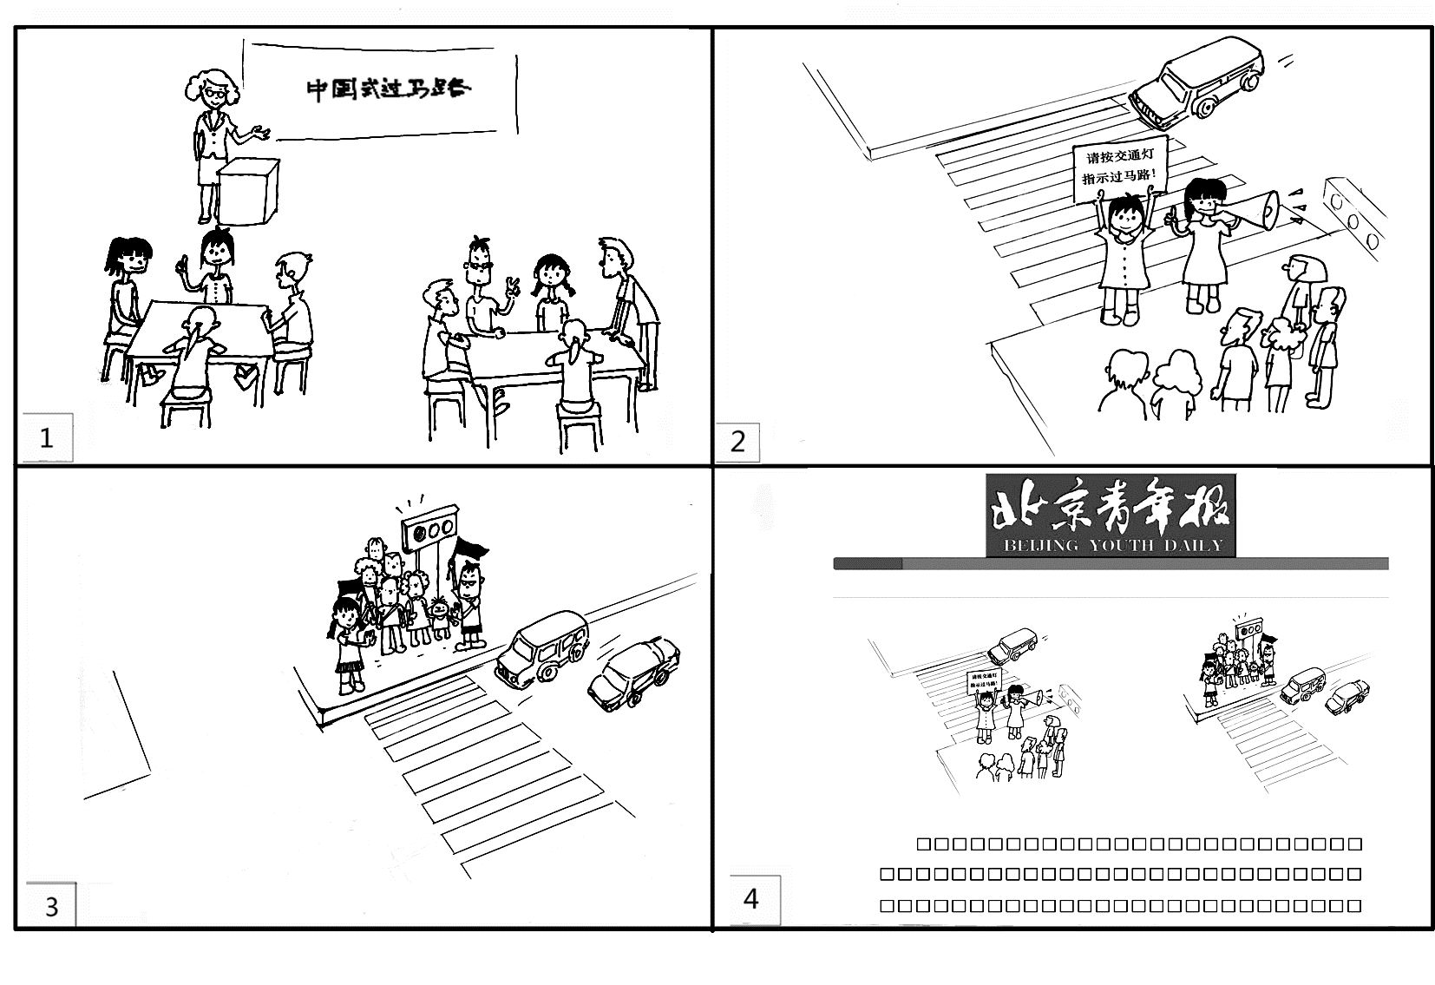

Last Monday,

(请务必写在答题卡指定区域内)

海淀区高三年级第一学期期末练习
英语参考答案及评分标准
2014.01
第一部分：听力理解（共三节，30分）
第一节（共5小题；每小题1.5分，共7.5分）
1. C 2. A 3. C 4. B 5. A
第二节（共10小题；每小题1.5分，共15分）
6. B 7. C 8. A 9. B 10. B 11. C 12. A
13. B 14. C 15. A
第三节（共5小题；每小题1.5分，共7.5分）
★每小题超过一个词不计分； ★拼写错误不计分； ★会员编号的英文字母部分要大写。
16. PTF78196 17. lawyer 18. tennis 19. professional 20. busy
第二部分：知识运用（共两节，45分）
第一节 单项填空（共15小题；每小题1分，共15分）
21. D 22. B 23. A 24. B 25. C 26. D 27. C
28. D 29. C 30. A
31. D 32. A 33. B 34. B 35. A
第二节 完形填空（共20小题；每小题1.5分，共30分）
36. A 37. A 38. B 39. C 40. D 41. B 42. D
43. C 44. A 45. B 46. D 47. A 48. C 49. B
50. D 51. B 52. C 53. D 54. A 55. C
第三部分：阅读理解（共两节，40分）
第一节 （共15小题；每小题2分，共30分）
56. D 57. A 58. B 59. C 60. D 61. B 62. A 63. B
64. C 65. C 66. A 67. C 68. B 69. D 70. A
第二节（共5小题；每小题2分，共10分）
71. B 72. D 73. A 74. E 75. G
第四部分：书面表达（共两节，35分）
第一节（15分）
一、评分原则：
1、本题总分15分，按4各档次给分。
2、评分时，先根据文章的内容和语言质量初步确定其档次，然后以档次的要求来衡量，确定或降低档次，最后给分。
3、评分时应考虑：内容是否完整，条理是否清楚，交际是否得体，语言是否准确。
4、拼写、标点符号或书写影响内容表达时，应视其影响程度予以考虑。英、美拼写及词汇用法均可以接受。
5、词数少于50，从总分中减去1分。
二、内容要点：
Name Li Hua
Class Class 1, Senior 3
speak English fluentlyλQualifications
have similar experiencesλ
be willing to spread Chinese culture
…（自由发挥）
2
3
4
5
6
（总结）
三、各档次的给分范围和要求：
分值 评分标准说明 期末评分要点
第一档
(13分--15分)
完全完成了试题规定的任务。
内容完整，条理清楚；
交际得体，表达时充分考虑到了交际的需求；体现出较强的语言运用能力。
完全达到了预期的写作目的。 要点齐全 条理清楚 语句顺畅自然小错误
some exciting improvement in the near future.

