九年级（下）期中试卷（一模）
英 语
注意事项：
1．本试卷分第Ⅰ卷（选择题）和第Ⅱ卷（非选择题）两部分，共14页，满分为96分，考试时间120分钟。
2．第Ⅰ卷的答案涂在答题卡上。用铅笔把答题卡上对应题目的答案标号涂黑，如需改动，用橡皮擦干净后，再选涂其他答案，不能答在试卷上。
3．第Ⅱ卷的答案必须写在答题纸上，做在试卷上无效。

第I卷 选择题（共45分）
一、单项填空 （共15小题；每小题1分，满分15分）
从A、B、C和D四个选项中，选出可以填入空白处的最佳选项。
- Nanjing, ________ old capital of the six dynasties, is becoming ________ more
beautiful city for the coming 2014 Youth Olympic Games.
A. a, a B. the, the C. the, a D. an, the
2. —You look so worried, what’s wrong?
—More and more people like me become to worry about the __________ pollution after the haze (雾霾) appeared in Beijing and some other cities in China.
A. water B. air C. noise D. soil
3. —Do you know that our school has been named Green Olympic Demonstration
School?
—Yes. We are all excited ___________ that.
A. at B. for C. about D. with
4. —You see, “Food Safety” receives thousands of Internet hits a day.
—Obviously, it has become one of the _________ topics recently.
A. interesting B. hot C. most interesting D. hottest
5. —Excuse me, Mum. When can we have dinner?
—Not until it in half an hour.
A. is prepared B. will be prepared
C. has been prepared D. was prepared
6. —What do you plan to do on the ___________ May Day holiday?
—I have no idea. Probably, I will spend it by doing many papers.
A. three-day B. three-days C. three days D. three day’s

7. —Have you got an iPhone 5?
—No, many young people began to say “No” to it because of _________ follow-up service. By the way, I am a supporter of Chinese products.
A. it’s B. its C. it D. itself
8. —Who is your favourite writer?
—Mo Yan. He is the first Chinese person _________ wins the Nobel Prize for Literature.
A. which B. where C. that D. whom
9. —Is there ___________interesting on the Internet?
—Yes. The First Lady Peng Liyuan attracts more attention than her husband on the visit to Russia and some African countries.
A. something B. anybody C. somebody D. anything
10. —Paul invited us to go on a trip to Jiming Temple tomorrow.
—______? Have the Flowering Cherries(樱花) on each side of the roads come out?
A. Why not? B. What for? C. What time? D. Who else?
11. —Hurry up, Mum. The lights are turned on. Dad has been back.
—It _________ be him. He has gone to Shanghai.
A. must B. can’t C. mustn’t D. may
12. —What do you usually do at the weekend?
—I ________ the program “If You Are The One” (非诚勿扰) with my family.
A. used to watch B. was used to watching
C. am used to watch D. get used to watching
13. —Sorry, Mr. Wang. I _________ my homework at home again.
—That’s OK, but never __________ it next time.
A. remember; forget B. left; remember
C. forget; left D. left; forget
14. —Could you tell me ____________________?
—I don’t know. It seemed to be unimaginable.
A. why “Gangnam style” is known to all in China
B. when was “Gangnam style” so popular in China
C. where “Gangnam style” is popular[来源:Z,xx,k.Com]
D. how was “Gangnam style” well-known in China
15. —Let’s watch the popular TV program “I am a Singer”, shall we?
—_________________. It has been over for some time.
A. Sounds great B. Yes, we shall
C. I’m afraid not D. No, we shan’t

二、完形填空（共10小题；每小题1分，满分10分）
阅读下面短文，从各题所给的A、B、C和D四个选项中，选出可以填入空白处的最佳选项。
It was unusually quiet in the emergency room on December 25.
I was the nurse on duty that day. I didn't think there would be any patients. Just then five bodies 16 at my desk, a pale woman and four small children.
“Are you all sick?” I asked.
“Yes,” she said 17 , lowering her head.
But when they described their problems, things got a little strange. Two of the children had headaches, but they didn’t show any 18 of headaches at all. Two children had earaches, but only one could tell me which ear was affected. The mother 19 of a cough but seemed to produce it.
I didn't say anything, 20 I explained that they might wait for a little while before a doctor saw her. She answered, “Take your time; it's warm here.”
I checked the chart after another nurse had finished registering(登记) the family. No 21 —they were homeless. The waiting room was warm.
I looked at the family by the Christmas tree. The littlest one was pointing at the television and saying something to her mother. The oldest one was looking at lights on the Christmas tree.
I went back to the nurses' station and mentioned we had a homeless family in the waiting room. The nurses who felt bored with 22 Christmas, turned to compassion((怜悯) for the family just trying to get warm on Christmas. The team went into action. We began to prepare a party for our Christmas 23 . We needed presents. We put together oranges and apples in a basket. We collected from different departments candies, crayons and other things available that could be presents.
24 , as the family walked to the door to leave, the four-year-old child came running back, gave me a hug and 25 , “Thanks for being our angels today.”
16. A. set up B. put up C. cheered up D. showed up
17. A. excitedly B. loudly C. weakly D. strongly
18. A. systems B. signs C. symbols D. secrets
19. A. explained B. expressed C. complained D. compared
20. A. and B. but C. or D. so
21. A. address B. age C. name D. money [来源:学科网]
22. A. amazing B. working C. interesting D. surprising
23. A. nurses B. doctors C. guests D. patients
24. A. Soon B. Suddenly C. Later D. However
25. A. screamed B. jumped C. whispered D. replied
三、阅读理解（共20小题；每小题1分，满分20分）
A

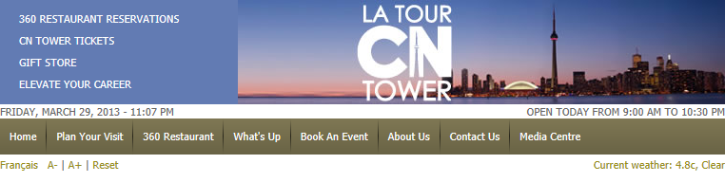
CN Tower Hours
Due to(由于) construction around the CN Tower, the only access for visitors who may require help with strollers(婴儿车) or wheelchairs, is Bremner Blvd.
The CN Tower is open 364 days a year (closed on Christmas Day). Hours of Operation are adjusted(调整) from time to time.
Please call (416) 86-TOWER to confirm the hours for the date of your visit.
Tower Hours
Information Desk opens at 8:30
Observation Levels
Sunday through Thursday Friday & Saturday
LookOut 9:00am - 10:00pm 9:00am - 10:30pm
Glass Floor 9:00am - 10:00pm 9:00am - 10:30pm
SkyPod 9:00am - 10:00pm 9:00am - 10:30pm
Attractions
Himalamazon motion theatre ride 10:00am - 9:00pm
Film 10:00am - 9:00pm (last show 9pm)
360 Restaurant
Lunch 11:00am - 2:00pm
Sunday Lunch 10:30am - 2:00pm
Dinner (Sunday -Thursday) 4:30pm - 10:00pm
Dinner (Friday & Saturday) 4:30pm - 11:00pm
Marketplace Retail Store
Marketplace Gift Shop Sunday through Thursday Friday & Saturday
8:30am - 10:00pm 8:30am – 10:30pm
26. What does “Bremner Blvd” refer to on this website?
A. A person. B. A road. C. A building. D. A shop.
27. What can’t you do when you visit CN Tower?
A. Watch a film. B. Have dinner. C. Buy gifts. D. Go cycling.
28. Which of the following statements is WRONG?
A. You can have lunch at 10:50am at 360 Restaurant on Sunday.
B. You can enjoy the beauty of the city from SkyPod at 9:50pm on Wednesday.
C. You can go to Information Desk for help at 8:40am.
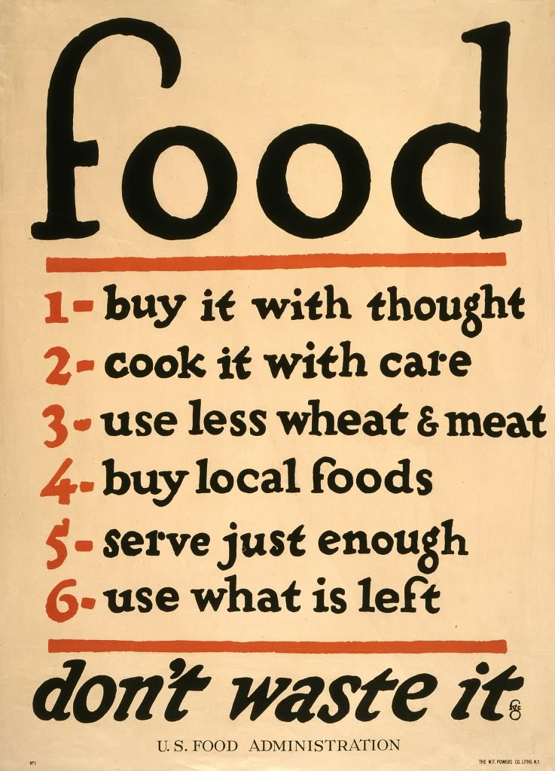
D. You can visit CN Tower every day.

B
Food waste has become a big problem in China.
Zhou Jinsong, a canteen(食堂) manager at Central South University, said that students produce over 12 barrels(桶) of leftovers every day — each barrel stands at one meter in height. Zhou’s canteen is just one of several on the campus.
According to Xinhua News Agency, the food wasted by Chinese people equates to about 50 million tons of grain every year, or 10 percent of the country’s total annual grain production. This food could feed another 200 million people. What students waste every year could feed over 10 million people. Students nowadays are well protected by their families and hardly know how hard farmers work to provide them with the food they eat.
“Since the 1980s, when Chinese gradually became richer, food waste has been a subject of debate. But things have hardly changed over the years,” said Yu Changjiang, a sociologist at Peking University. “It’s the Chinese way of showing respect to friends, often referred as Mianzi.”
But rather than tradition, huge public spending on government banquets(宴会) is also causing food waste, said Zhou Xiaozheng from the sociology department at Renmin University of China. “It’s the result of widespread reception meals at government levels. It is also important that everyone thinks about how they can do their best to reduce food waste.”
29. Which of the following statements is not the reasons for food waste?
A. Students hardly know farmers’ hard work on the farm.
B. The government spends a large amount of money on government banquets.
C. Leaving some food after a banquet is the Chinese way to show respect to guests.
D. The food in the college canteen is not delicious.
30. Where can we probably read this passage?
A. In a newspaper. B. In a traffic report.
C. On a health website. D. In a story book.

C
(One day Alice runs after a strange rabbit and comes into a deep hole. She becomes smaller when she wakes up the next day. She finds herself in a wonderland with many amazing things inside.)
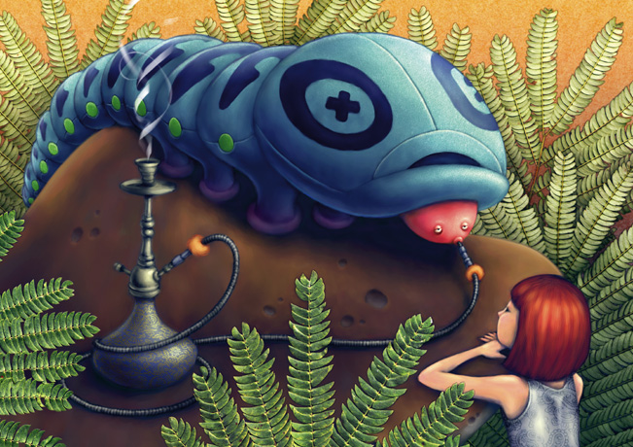
The Caterpillar(毛毛虫) and Alice looked at each other for some time in silence. At last the Caterpillar took the pipe out of its mouth, and said to her in a tired, sleepy voice.
“Who are YOU?” said the Caterpillar.
This opening for a talk couldn’t make Alice at ease. Alice replied, rather shyly, “I----I hardly know, sir, just at present ----at least I know who I was when I got up this morning, but I think I must have been changed several times since then.”
“What do you mean by that?” said the Caterpillar, “Explain yourself!”
“I can’t explain MYSELF. I’m afraid, sir.” said Alice, “because I’m not myself, you see.”
“I don’t see.” said the Caterpillar.
“I’m afraid I can’t put it more clearly.” Alice replied very politely, “for I can’t understand it myself. And being so many different sizes in a day is very puzzling.”
“It isn’t.” said the Caterpillar.
“Well, perhaps you haven’t found it so yet.” said Alice. “But when you have to turn into a chrysalis(蛹，茧)----you will some day, you know ----and then after that into a butterfly, I think you’ll feel it a little stranger, won’t you?”
“Not a bit.” said the Caterpillar.
“Well, perhaps your feelings may be different.” said Alice. “All I know is, it would make ME feel very strange.”
“You!” said the Caterpillar scornfully. “Who are YOU?” The question brought them back again to the beginning of the talk. Alice felt a little angry because the Caterpillar was making such VERY short sentences. She drew herself up and said very seriously, “I think you ought to tell me who YOU are first.”
“Why?” said the Caterpillar.
Here was another puzzling question. As Alice could not think out any good reason, and as the Caterpillar seemed to be very unpleasant, she turned away.
“Come back!” the Caterpillar called after her. “I’ve something important to tell you!”
This certainly gave Alice some hope. Alice turned and came back again.
31. Where may their talk take place?
A. In a wonderland. B. In the field. C. In the tree. D. Outside the hole.
32. Alice didn’t feel __________ during her talk with Caterpillar.
A. shy B. sad C. angry D. strange
33. Why did Alice think she was not herself?
A. Because she was too young to understand the changes.
B. Because being changed several times in a day made her feel puzzled.
C. Because she didn’t like her changes
D. Because she didn’t feel very well.
34. Put the following statements in the correct order according to the story.
① Alice drew herself up.
② Alice used an example to explain the changes to herself.
③ Alice couldn’t explain herself.
④ Alice turned away.
⑤ Alice looked at Caterpillar for some time in silence.
A. ⑤②③④① B. ⑤②③①④ C. ⑤③②④① D.⑤③②①④
35. Which of the following sentences can be added to the end of the story?
A. “Don’t be silly. You are still yourself.” said the Caterpillar.
B. “Don’t be angry. You think you’re changed, do you?” said the Caterpillar.
C. “Don’t be sad. You’ll grow bigger again.” said the Caterpillar.
D. “Don’t be afraid. You can go home now.” said the Caterpillar.
D
You either have it, or you don’t－a sense of direction. But why is it that some people could find their way across the Sahara without a map while others can lose themselves in the next street?
Scientists say we’re all born with a sense of direction, but it is not properly understood how it works. One theory is that people with a good sense of direction have simply worked harder at developing it. Research being carried out at Liverpool University supports this idea and suggests that if we don’t use it, we lose it.
“Children as young as seven have the ability to find their way around,” says Jim Martland, research director of the project. “However, if they are not allowed out alone or are taken everywhere by car, they never develop the skills.”
Jim Martland also emphasizes that young people should be taught certain skills to improve their sense of direction. He makes the following suggestions:
- If you are using a map, turn it so that it relates to(与……有联系) the way you are facing.
- If you leave your bike in a strange place, put it near something like a big stone or a tree－something easy to recognize. Note landmarks on the route as you go away from your bike. When you return, go back along the same route.
- Simplify(简化) the way for finding your direction by using lines such as streets in a town, streams, or wells in the countryside to guide you. Count your steps so that you know how far you have gone and note any landmarks such as towerblocks or hills which can help to find out where you are.
Now you will never get lost again!
36. Children have the ability to find the way around when they are ______ years old.
A. 5 B. 6 C. 7 D. 8
37. Which of the following things cannot be used as landmarks?
A. Tower blocks. B. Hills. C. Wells. D. Bikes.
38. What does the underlined word “emphasize” mean in the passage?
A. To give special importance to something.
B. To express thanks for somebody.
C. To understand or become aware of a fact.
D. To admire somebody.
39. Scientists believe that __________.
A. some babies are born with a sense of direction
B. people learn a sense of direction as they grow older
C. people never lose their sense of direction
D. everybody has a sense of direction from birth
40. What may be the best title of the passage?
A. A research on direction.
B. A sense of direction.
C. People’s ability of finding the way.
D. Scientists’ research on skills.
E
As you are soon on your way to Eastern Europe, here are a few tips on what you should pack. In general, pack lightly, with only the most basic clothes. People dress casually(随便地) in Eastern Europe, so you don’t need to bring along your smartest clothing.
Batteries: If your camera, flash, or other appliances run on batteries, bring enough supply along. Certain types of batteries don’t exist in Eastern Europe, and those that do often don’t last very long.
Cash: We have found it good to have supply of small-unit U.S. bills($1and $5) to use in hard–currency stores, to buy international train tickets, etc. The hard–currency stores never seem to have the right change.
Electric Current Adapter(转换器): If you bring any appliances, remember that the electricity in Eastern Europe uses 220 volts A.C., not the standard 110 volts of North America. A 110 volts appliance will soon burn out when attached to an unchanged 220-volt plug.
Language Tools: One of Europe’s biggest challenges is communicating with the local people since their languages are so different from our own. To help overcome difficulties, you might buy phrasebooks before you go — you won’t find them once you are in Eastern Europe.
Money Belt: A money belt is especially helpful when you have many documents to carry around ( as you always do in Eastern Europe). The best one we find is made by Eagle Greek Travel Gear, 143 Cedros Ave. (P. O. box 651), Solona Beach, CA 92075 (tel. 619/755 – 9399, or toll free 800/874 – 9925) outside California.
Traveler’s Checks: These are necessary. Bring your traveler’s checks in small to medium unit ($10, $20, or $50) to change a little bit at a time, so as not to be left with a lot of local money. To be on the safe side, be sure to copy down the check numbers in two places, just in case something happens to the checks.
41. How many tips are mentioned in the passage?
A. 6 B. 7 C. 8 D. 9
42. Which of the following things may be the biggest challenge in Eastern Europe?
A. Appliances. B. Money. C. Language. D. Clothes.
43. Which of the following statements is NOT a fact according to the passage?
A. No shop in Eastern Europe accepts hard currency.
B. Travelers may need to carry many documents in Eastern Europe.
C. The electricity in Eastern Europe uses 220 volts A.C.
D. Eastern European languages can be a problem to foreign travelers.
44. What’s the writer’s purpose of writing this passage?
A. To tell you it’s not easy to stay in Eastern Europe.
B. To give you some advice on what you should pack when you’re in Eastern Europe.
C. To tell you something about the life in Eastern Europe.
D. To show you the life in Eastern Europe is different from that in your country.
45. What do the underlined words “change” and “check” probably mean according to the given dictionary entries(词条)?
change
1. [V] to become different 改变；变化
2. [V] to exchange money into the money of another country 兑换
3. [U] the money that you get back when you have paid for sth giving more money than
the amount it costs 找给的零钱；找头
check
1. [V] to examine sth to see if it is correct, safe or acceptable 检查；审查
2. [C] an act of making sure that sth is safe, correct or in good condition by examining it 检查；查看
3. [C] a printed form that you can write on and sign as a way of paying for sth instead of using money 支票
A. 1; 3 B. 3; 3 C. 2; 3 D. 2; 2
第II 卷 非选择题 （共51分）
四、填空（共16小题；每小题1分，满分16分）
A) 根据括号中所给的汉语写出单词，使句子意思完整正确。
46. Though the Grade 9 students are busy with their study, they should still do sports _________ (两次) a day.
47. The hall is ____________ (空的). There is nobody left.
48. Zhang Guorong has been away for ten years. But he will be my _________(偶像) forever.
49. When the film ended, the audience couldn’t stop _______ (鼓掌) for a long time.
50. If you like to go to Hong Kong for shopping, you can go there in any ___(季节).
B) 根据句子意思，用括号中所给单词的适当形式填空。
51. My little cousin, Jimmy, was born on a cool (cloud) morning.
52. Come and enjoy ___________(you), dear! It’s my honor to invite all of you here.
53. When the students read the exciting advertisement, they shouted with________
(excite) at once.
54. Who will be the _________( four ) speaker? Get ready, please.
55. When I have problems with study, my English teacher always ______(encourage) me.
56. _________(luck), they didn’t win the basketball final,though they put all their effort into it.
C) 根据短文内容，选用方框中所给的单词或词组填空，使短文内容完整正确。
winners; made a difference; among; sends a different message; developing
In a society where people always pay their attention to bad news, the 2012 year’s "Touching China" award definitely 57 . The award honors ten of China’s inspirational role models in 2012.
58 the ten are public faces who did good deeds like Luo Yang, the late Commander of the program for 59 the J-15 fighter, who died from overwork. And Lin Junde, a scientist who devoted his whole life to China’s nuclear course. There are also common people who have 60 , like Zhang Lili. She was called "China’s Most Beautiful Teacher" after she saved two students, but lost both her legs in the effort.
The award 61 are carefully selected to represent a true moral epic of 2012 in China. The "Touching China" award has been held yearly since 2003.

五、阅读短文 (共20小题；每小题1分；满分20分)
A)根据短文内容，完成文后任务。注意：每个空格只填一个单词。
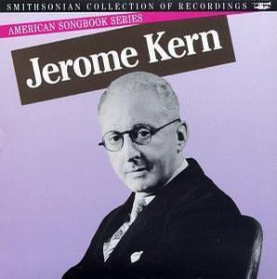
Jerome Kern is often called the father of American musical theater. Kern is remembered for the hundreds of songs he wrote for musical plays and movies. Music historians say that Kern gave artistic importance to American popular music for the first time. And, they say, he led the development of the first truly American theater music.[来源:学科网]
Jerome Kern was born into a middle-class family in New York City in 1885. Jerome's mother, Fanny, loved the piano. She began to teach Jerome how to play when he was very young.
Jerome was a quiet boy and not a top student. When he completed high school, his father said he would have to work in the family's store. But he later came to believe that Jerome might do better in music than in business after all. So he let the boy go to Europe to study music, as almost all serious young musicians did at the time.
Jerome Kern began his career as a songwriter in theaters in London and New York City. Success came quickly. By the early nineteen twenties, Kern was a successful young composer for Broadway musical comedies. In one three-year period alone, he wrote music for nineteen shows.
Kern wanted to try something completely new. He thought a musical play should be a real work of art, not just a collection of songs and dances. Kern wanted to do a truly American musical, with real American characters and real situations.
In 1927, he found the story he wanted. It was the book "Show Boat" by American writer Edna Ferber. "Show Boat" takes place in the 1880 on a passenger steam boat that travels along the Mississippi River.
Kern died in 1945 at the age of sixty. But "Show Boat" has been performed thousands of times all over the world.
Title: The 62 of American musical theater
He wanted to make his music 67 from others.

He wanted to make a real-life event into a truly American musical play.

His thoughts
He came from a middle-class family in New York City and his mother was his 63 music teacher.

He showed no 64 in business so his father had to send him to Europe to study music after he left high school.

highool

hschool.

His childhood
and youth
He 65 a songwriter in theatres in London and New York City.

He 66 music for Broadway musical comedies in one three-year period alone.

His career
It’s Kern that gave artistic importance to American popular music for the first time.

He 71 the first truly American theater music.

His achievement
The book “Show Boat” was 69 into a musical play by Kern.

“Show Boat” is still popular now although he died
70 years ago.

His 68
B) 根据短文内容和首字母提示，填写所缺单词。
You may not realize it, but you are doing much more than just studying when you are at school. School is a 72 the place where you learn to get along well with people. But this is not always easy. What can you do if you just don’t like one of your classmates?
If you d 73 that you have problems getting along with your classmates or friends, the most important thing to learn is tolerance(宽容). Tolerance is the ability to realize and respect the differences in others. We cannot change the w 74 that other people do, so it is important to learn to live h 75 with them.
Tolerance will make everyone get on better with each other. K 76 others constantly(不断地) makes us understand others’ differences.
Something different does not exactly mean that it is bad. Tolerance t 77 us to keep an even temper(温和的脾气) and an open mind.
You need to remember an old saying, “Treat others h 78 you want to be treated.” You would like to be treated kindly by your classmates, so it is important to treat them kindly too. If you tolerate something, it does not mean that you have to like it. No one is asking you to change who you are or what you believe in. Tolerance just means that you s 79 respect the differences in others and not to try to make them change.
It is important to practice tolerance, because it will make e 80 life easier. Learn to accept people for t 81 different abilities and interests. The world is very different, and practicing tolerance in your own school and city can help make things better.
72.a | 73.d | 74.w | 75.h | 76.K
77.t | 78.h | 79.s | 80.e | 81.t
六、书面表达(满分15分)
自你进入初中学习以来已近三年。现在的你与三年前相比一定发生了不小的变化吧。你能试着从以下几个方面进行回顾，并谈一谈你对自己这些变化的感受。
A．请根据自己的实际情况，用单词或短语完成下列表格。
 | Appearance | Hobbies | Study | Abilities
In the past
At present
Feelings

B.根据表格中所填内容，以 “The Changes to Me” 为题，写一篇小短文。
注意：
1、语言通顺，意思连贯，书写规范；
2、词数100左右，必须涵盖你在表格中所填写的所有信息,并作适当发挥。
3、文中不得出现真实的人名和校名。
The Changes to Me
______________________________________________________________________________________________________________________________________________________________________________________________________________________________________________________________________________________________________________________________________________________________________________________________________________________________________________________________________________________________________________________________________________________________________________________________________________________________________________________________________________________________________________________________________________________
九年级（下）期中试卷
英语参考答案
- 单项选择
1-5 CBCDA 6-10 ABCDB 11-15 BDDAC

二、完形填空
16-20 D C B C B 21-25 A B C C C

三、阅读理解[来源:Z|xx|k.Com]
26~30 B D D D A 31~35 A B B D B 36~40 C D A D B 41~45 B C A B B

四、填空
A. 46. twice 47. empty 48. hero 49. clapping 50. season
B. 51. cloudy 52. yourselves 53. excitement 54. fourth/4th
55. encourages 56. Unluckily
C. 57. sends a different message 58. Among 59. developing
60. made a difference 61. winners

五、阅读短文
A. 62. father 63. first 64. interest 65. became/was 66. wrote 67. different
68. works 69. made/changed 70. 68 71. developed
B. 72. also 73. discover 74. way(s) 75. happily 76. Knowing
77. teaches/tells 78. how 79. should 80. everyone’s/everybody’s/everyday 81. their

六、书面表达
评分标准建议：
1. 评分原则：
（1）本题总分15分，按5个档次给分。
（2）评分要求：先读文章，再定档次，最后评分。
（3）短文内容：过去和现在的变化每个要点各1分（共8分）；感受2分；开头2分，结尾2分。
（4）书写、词数：书写（1分）。如书写较差，影响信息传递，将分数降低一个档次。词数少于80或多于120的，从总分中减去1分。
（5）评分时应注意内容表达、词汇和语法结构的使用是否准确、上下文是否连贯及语言表述是否得体。
2. 各档次的给分范围和要求：[来源:Zxxk.Com]
第五档（13～15分）：能写明全部要点，语言基本无误或有少量拼写错误，行文流畅，表达清楚。
第四档（10～12分）：能写明大部份要点，语言有一些错误（句子结构或动词时态错误1～2处），但行文基本流畅，表达基本清楚。
第三档（7～9分）：能写明一些要点，语言错误较多（句子结构或动词时态错误3～4处）但意思基本连贯，表达基本清楚。
第二档（4～6分）：能写明少数要点，语言错误多，意思不连贯，影响意思表达。
第一档（1～3分）：只能写出若干单词，无可读的句字。

