2008年福建省福州市中考英语试题
(满分l 50分，考试时间l 20分钟)
第1卷(选择题，共75分)
听力测试(30分)．
一、听句子，选择与句子情景相关的图。每小题念一遍0(每小题1分。共5分)
1.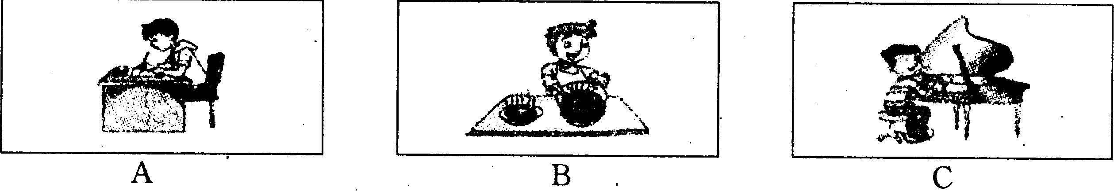
2.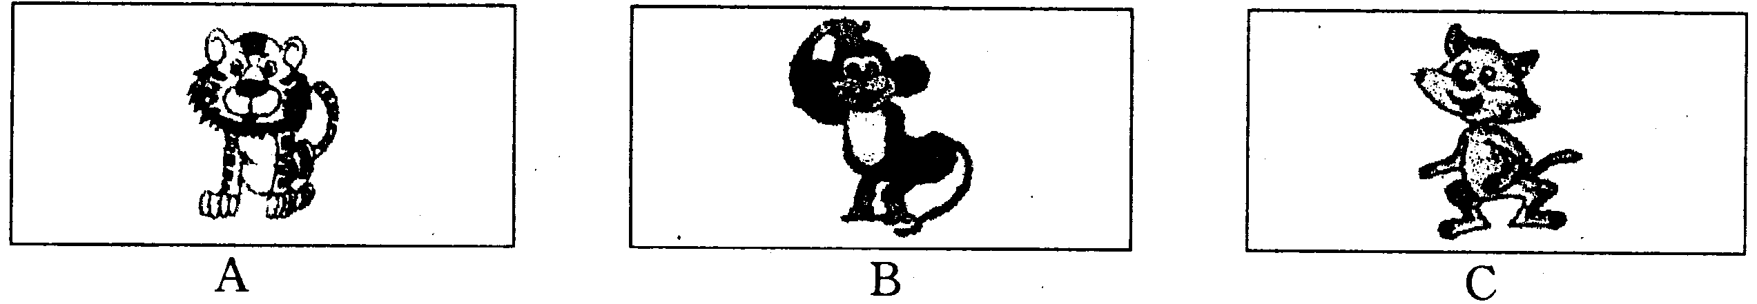
3.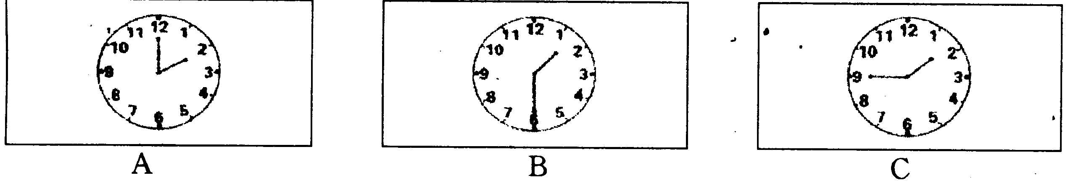
4.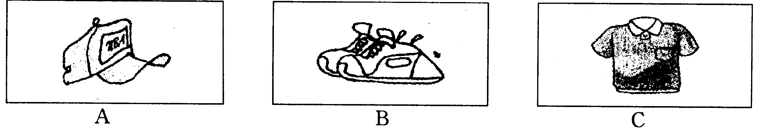
5.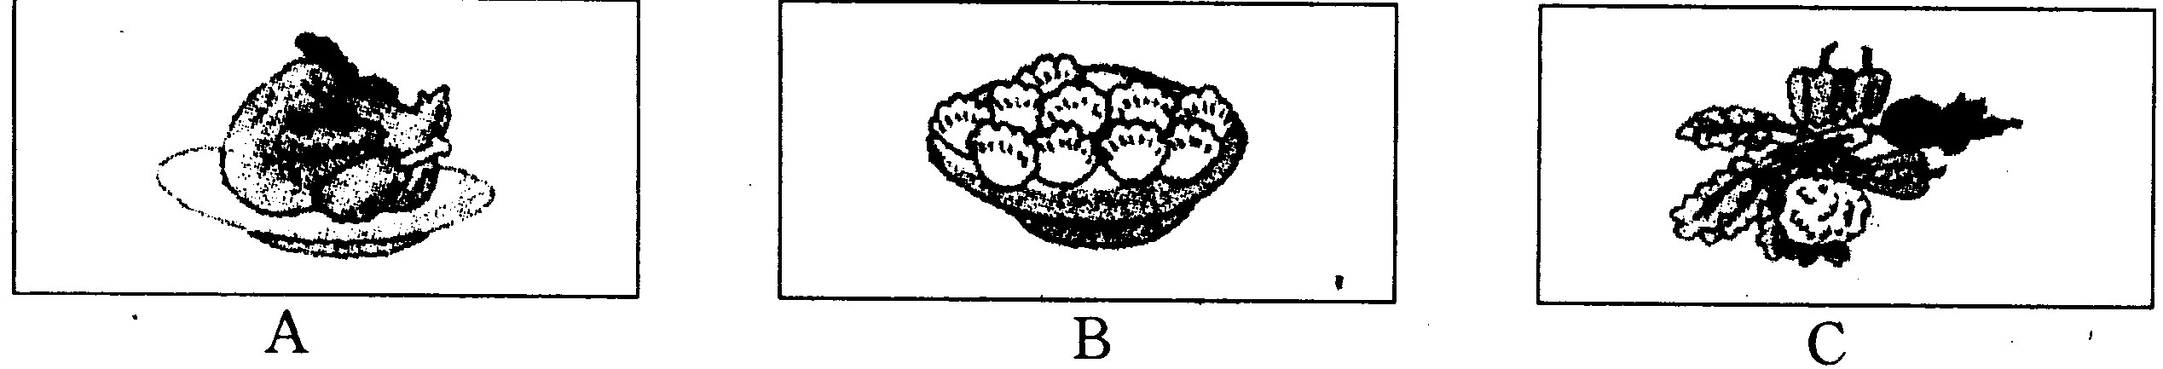
二，呃句子，选择恰当的答语。每小题念一遍。(每小题1分，共5分)
6. A. Good night. B. Bye-bye. C. Nice to see you, too.
7. A. My pleasure. B. It doesn't matter. C. It's very kind of you.
8. A. I like apples. B. I'm hungry. C. Well done.
9. A. Not at all. B. Thank you. C. That's right.
10. A. I'm Ann. B. I don't agree. C. This is Ann speaking.
三、听对话，选择正确的答案。对话念两遍。(每小题1分，其10分)
听第l段对话，完成第11小题。
11. Whose ruler is this?
A. Betty's. B.Lily's. C.Lucy's.
听第2段对话。完成第12小题。
12. When will Jane go to the party?
A. Next Saturday. B. This Saturday. C. Tomorrow evening.
听第3段对话，完成第13小题。
13. What color is Mary's hair?
A. Red. B. Yellow. C. Black.
听第4段对话，完成第14小题。
14. What does Kate's father do?
A. A driver. B. A teacher. C. An office worker.
听第5段对话，完成第15至17小题。
15. What did Bruce use to do during the summer vacation?
A. Go fishing. B. Go shopping. C. Go camping.
16. Where is Bruce's house?
A. Near the lake. B. Near the sea. C. Near the river.
17. What does the woman think of Bruce?
A. Silly. B. Clever. C. Friendly.
听第6段对话，完成第18至20小题。
18. What is Sam doing?
A. Flying a kite. B. Making a kite. C. Mending a plane.
19. Who is the present for?
A. Sam's mother. B. Sam's sister. C. Sam's friend.
20. What's the relationship between the two speakers?
A. Mother and son. B. Father and daughter. C. Brother and sister.
四、听短文，选择最佳答案。短文念两遍。(每小题1分，共5分)
21. Where is Rose now?
A. In Hainan. B. In Shanghai. C. In Nanjing.
22. Which subject does Rose like best?
A. Math. B.Chinese. C.English.
23. When does Rose go to the English corner?
A. On weekends. B. On Saturday morning.
C. On Tuesday afternoon.
24. How often does Rose go to the school library?
A. Every day. B. Once a week. C. Twice a week.
25. How is Rose's school life?
A. Hard. B. Busy. C. Interesting.
五、听对话。完成下面表格。每空一词。对话念两遍(每小题1分。共5分)
When to go | This 26 _________
What to do | Go 27 _________
Where to go | The 28 _________
How to go | By 29 _____
Weather | 30 _________
语言知识运用(25分)
一、选择填空(每小题1分，共15分)
31. —Do you have_________pen?
—Yes. I have one.
A. a B. an C. the D. /
32. —When did the Olympic Torch Relay start in Fujian? —_________May 11th, 2008.
A. In B. At C. On D. From
33.—Kate, _________you dance the disco?
—Yes, I can.
A. may B. can C. must D. need
34.—What do you think of the TV sitcom Home With Kids？
—It's very_________. Many children like watching it.
A. boring B. funny C. surprising D. terrible
35. —What a nice model ship!
—Thank you. It_________me three days to make it.
A. paid B. spent C. took D. wasted
36. -—Peter jumps_________than any other boy in our school.
—I'm sure he will be the winner in the high jump.
A. higher B. longer C. faster D. farther
37. — you ever_________Chinese mooncakes, Diana?
—No, never, But I have had noodles.
A. Do; try B. Will; .try C. Did; try D. Have; tried
38. —Do you know the girl______ is standing under the tree?
—She is my little sister.
A. who B. whom C. whose D. which
39. —What is your brother going to be when he_________?,
— He is going to be a doctor.
A. wakes up B. grows up C. stands up D. hurries up
40. —Which do you like better, skating or skiing?
—_________of them. I like running.
A. All B. Both C. Either D. Neither
41. —_________has your brother studied in New York?
—For tow years.
A. How far B. How old C. How often D. How long
42. —_________the soldiers are very tired, _________they keep on working.
—They are great. We must learn from them.
A. Because; / B. Though; / C. Because; so D. Though; but
43. —John, my computer doesn't work. —Why not ask Mr Liu_________it?
A. to buy B. not to buy C. to check D. not to check
44. —Excuse me, could you tell me_________?
—Certainly. Go straight ahead and you'll see it oti your left.
A. where the post office is B. when you will visit the museum
C. where is the post office D. when will you visit the museum
45. Which of the following is NOT a traffic sign?

二、完形填空(每小题1分，共10分)
阅读下面短文，然后从各题所给的四个选项中选出最佳选项。
Leonardo da Vinci was a great artist. He lived in 46 in the fifteenth and sixteenth centuries. He painted some of 47 pictures in the world. Mona Lisa is a good example of his works. He 48 painting Mona Lisa in 1503.
Da Vinci loved science and 49 . He used darkness and light in a clever way in the painting. And a person can 50 see that there is a lot of geometry(几何学) in Mona Lisa. The face of Mona Lisa is 51 many circles and round shapes like balls. Even her 52 can be seen as a small part of a large circle.
The woman in the painting is 53 on a balcony ( 阳台) » and mountains can be seen behind her. Da Vinci loved to study rocks and mountains, 54 we can see these in his other paintings.
The woman is sitting with her knees to the side. He hands are held together 55 her. This way of sitting is now used by many artists when they are painting a picture of a man or woman.
46. A. China B.Italy C. Japan D. Canada
47. A. less famous B. more famous
C. the least famous D. the most famous
48. A. forgot B. began C. allowed D. remembered
49. A. math B. music C. English D. chemistry
50. A. early B. easily C. safely ' D. happily
51. A. used for B. worked out C. put away D. made of
52. A. cry B. tears C. smile D. sadness
53. A. lying B. walking C. sitting D. reading
54. A. so B. but C. or D. until
55. A. under B. behind C. next to D. in front of
阅读理解(20分)
一、阅读下啬材料。根据内容选择最佳答案。(每小题2分，共10分)
A Xia Chimei ,51, has become both classmate and granny of kids at Xiping Primary School in Xuan'en county, Hubei Province. By far the oldest student at the school enrolled (入学) in first grade earlier this year. She is now learning pinyin with children just six and seven years of age. Her husband and children encouraged her to go to school when the new term began early this year. She had never been to school in her life.
B A dog owner in Dalian, Liaoning Province, was very surprised when his 4-year-old dog picked up a 5-yuan note and gave it to him on Monday on their way to a market.
Days earlier, Mr Ye had dropped a 10-yuan note on his sofa and let the dog pick it up for him. He then showed the pet other notes and told it how to use money. He did that just for fun. But he never thought the animal would take to (喜欢) dealing with money so naturally.
C Wang Xiaoyan, a farmer in Duanjiawan village, Shanxi Province, has carried his daughter, who suffers from polio(小儿麻痹症) » to school every day over the past 10 years.
Wang's daughter, Wang Dan, lost the use of her legs after catching polio in 1995, at the age of three. Three years later when it was time for Wang Dan to go to school, Wang Xiaoyan decided he would carry her. the girl has repaid him by her excellent studies.
56. How old did Xia Chimei begin her study in Passage A?
A. 6. B. 7. C. 15. D. 51.
57. What's the best title for Passage A?
A. Practice makes perfect. B. It' s never too old to learn.
C. Clothes don't make the man. D. The early bird catches the worm.
58. In which province did the story happen in Passage B?
A. Liaoning. B. Hubei. C. Fujian. D. Shanxi.
59. What does the underlined word * repaid" mean in Passage C?
A．付款 B．赔偿 C．报答 D．贷款
60. Which of the following is TRUE according to the passages above?
A. Xia Chimei came to school with her husband and son.
B. The dog was so clever that it taught itself to borrow money.
C. Wang Dan lost the use of her legs because of polio when she was three.
D. Mr Ye picked up a 5-yuan note and gave it to the dog on the way home.
二、根据短文内容，判断下列句子的正误，正确的用“T"，错误的用“F"。(每小题2分，共10分)
Can you imagine keeping an alien dog as a pet?
This is what happens in CJ7—the so-called "first Chinese sci-fi (科幻) mo vie". It came out in January, 2008. The movie is about a poor man Ti, his son Dicky and
their alien dog CJ7.
Dicky, a 10-year-old boy, lives a poor life with his father Ti, a worker. One day, his father discovers a ball is the trash (垃圾) and he gives it to Dicky. The ball becomes a cute alien dog. It's a small dog with big eyes and green hair. It can talk and do magic. Soon the dog comes to love Ti and his son. It goes to school with Dicky. It makes him laugh, but it makes trouble, too.
When Ti falls off a building and dies, CJ7 saves his life. Because the dog loses all its power, it becomes a doll. But Dicky still wears the dog around his neck. He hopes that CJ7 will come back to life one day.
61. The movie CJ7 came out in January, 2008.

62. Dicky's father is so rich that he buys an alien dog for him.

63. CJ7 is a cute alien dog with small eyes and gray hair.

64. CJ7 can not only make Dicky laugh but also make trouble.

65. At last Ti comes back to life because his son and CJ7 save him.

第Ⅱ卷(非选择题，共75分)
语言知识运用(20分)
一、词汇(10分)
用方框中所给单词的适当形式填空。(每小题1分，共5分)
go milk plant careful strong
66. —Will you please bring me some_________, Sally?
—All right.
67. We have _________hundreds of trees in the park recently.
68. The wind is blowing_________ now. I have to stay at home.
69. Be_________, or you will make mistakes in your English exam.
根据中文提示，用词组的适当形式填空。每空一词。(每小题1分，共5分)
70. China's first moon satellite Chang‘e I _____ into space in October, 2007.
71. —Would you mind___________________(关掉)the radio?
—Of course not. I'll do it at once.
72. Li Lei is___________________(擅长)playing chess.
73. It's cold outside. You'd better___________________(穿上)your coat.
74. I___________________(等候)you at the school gate, but you didn't come.
75. There are many wild animals___________________(处于危险中)，» such as pandas and tigers.
二、综合填空(每小题1分，共10分)
用方框中所给单词的适当形式填空，使短文正确、通顺。每词限用一次。
be paper sail spare enjoy in many coin prefer while
A hobby is an interesting way of spending your free time. There are so 76________different hobbies for different people to choose. Some hobbies are very popular, 77_________others are quite unusual. You may choose one that you are interested 78_________. You may enjoy collecting things such as stamps, stones, foreign 79_________and so on.
If you like to work with your hands, you may enjoy model making and 80_________cutting, which both need great attention in detail. Or you may 81_________ creative hobbies, like painting and writing. Many people 82 _________ outdoor activities to indoor activities. They get great pleasure from 83_________，cycling and so on. which they can enjoy with others.
Wherever you live, there 84_________always a hobby for you to choose. The hobby can help you relax after your daily work. The hobby can give you many hours of pleasure and make your 85_________time interesting and creative. The hobby can bring you happiness, knowledge and friendship.
口语应用(15分)
一、从Ⅱ栏中选出l栏中每句话的正确答语(每小题1分，共5分)
I  86. Hou are you?  87. Happy New Year!  88. May I have your name?  89. How much is the dictionary?  90. Why didn't you come yesterday? | II  A. Me, too. B.I'm fine.  C. I hope so.  D. Bob Smith.  E. It's 100 yuan.  F. The same to you.  G. Because I was ill.

二、根据对话内容，选择恰当的句子补全下列对话。(每小题1分，共5分)
A:Hi, Tony. 91_____________
B:A lot of people were badly hurt in the Wenchuan earthquake.
A. What else can we do?
B. I'm glad to hear that.
C. Can you do me a favor?
D. You look so sad, why?
E. Let's do something to help them.
F. I'll buy some with my lucky money.
G. What about raising some money for them?
A: Yes, I feel so sorry about that. 92______________
B:What shall we do?
A:93_____________
B:Good idea! Money must be a problem.
A:94_____________
B：We can also collect school things for the students there.
A:Right! 95______________
B.You are so kind.
三、用恰当的词语填空。完成对话。每空一词(每小题1分，共5分)
D = doctor P = patient
D: What's the matter with 96_________, young man?
P:I cough day and night. I can't sleep well.
D:Let me see. Open your 97_________and say "Ah".
P:Is there anything wrong with my throat?
D:No, 98_________serious. Do you smoke?
P: Yes, These days I am smoking a lot.
D:Don't smoke too much. It may 99 _________ cancer.,
P:I see. I'll try to give up smoking.
D: Well, take this medicine three 100_________a day and have a good rest. You'll be all right soon.
P: Thank you very much.
D: You're welcome.
阅读理解(20分)
一、匹配题(每小题1分，共5分)
The Chinese Red Cross  honestly invites financial aid from worldwide to support  people in the earthquake-hit area.  Online donations:  Red Cross Society of China website  www.redcross.ora.cn | The Same Song Come to Fuzhou  • Want to spend a wonderful evening?  • Want to enjoy exciting hip hop?  • Want to see your favorite pop singer?  Come on!  PLACE Sports Center TIME:7:30 p.m.Sep.16 TICKET:¥50
Tour Guide Wanted  * Age between 20-30  * Good health  *k Two foreign languages Apply to: Red Rose Travel Agency Tel: 0591-22333666 | A Basketball Game  Class One  VS Class Six  Place: School Playground Time: 3:50 p.m. this Friday Please come and watch it!
Sunny Seafood Restaurant
• Fresh
• Tasty
• Reasonable price
Add: Haibin Road Tel: 0591-82223578

请将上面五条信息与下面各小题匹配。
101. Mike is fond of music. Sometimes he goes to the concert.
102. Father's Day is coming. Linda wants to invite her father to dinner.
103. Tom is a sports fan. He often watches ball games with his classmates.
104. Judy will graduate from a college next month. She's looking for a job.
105. Mr Chen is a kind-hearted man. He's always ready to help others.
二、阅读下列语段。把它们组成一篇连贯的短文。(每小题1分。共5分)
(A)An old horse has three sons. One day the father horse says to them, "It's time for you to learn some skills. " So the three horses all leave their home.
(B)In three months, the youngest son comes back home, too. He learns nothing. Only his hair looks different.
(C)Soon, the eldest son comes back home. He learns the skill of running from a leopard(豹). He can run very far without stopping. His father is happy with him.
(D)Why is this? Because he sees a lion. The lion's hair is curly. He thinks that it is very cool. So he makes his hair curly, too. He also dyes it red. He feels happy with his hair.
(E)The old horse is very angry. He whips(鞭打) the youngest son and tells him to get out of the house. People see the marks of the whip on the youngest son' s body, and call him "Zebra".
(F)In two months, the second son also comes back home. He learns to carry things on his back from the elephants. He feels OK even if he carries many things on his back. His father is happy with him, too.
The right order is： | 第一语段：A | 106． | 107． | l08. | 109． | 110．

三、阅读短文-完成下面的句子，每空一词。(每小题2分。共l0分)
The Development of China's Sports
Sports have developed fast in our country these years.

In 1974, our country first came to the Asian Games. In 1978, in the 8th Asian Games, our country won the second place. Our country has won the largest number of gold medals in the past six Asian Games since 1982.
In 1984, China competed in the Olympic Games, and won the fourth place with 15 gold medals. In 1988, China won five gold medals in the 24th Olympic Games. In the 25th and 26th Olympic Games, we both won 16 gold medals and ranked fourth. In 2000, for the first time, we ranked third with 28 gold medals. In 2004, we won 32 gold medals and ranked second in the Athens Olympic Games. We felt very proud of our great country.
At the same time, our country tries to improve the ability of hosting international games. In 1990, we hosted the 11th Asian Games successfully. To our pride, the 29th Olympic Games will be held in Beijing and the 16th Asian Games will be held in Guangzhou in 2010. It shows our success in sports is accepted by the world.
Clearly, our country has become a powerful country in sports.
111. Our country has won the largest number of_________medals in Asian Games_________1982.
112. In 1984, our country_________ part in the 23rd Olympic Games and won the_________ place.
113. In 2004, we won gold medals_________as many_________we did in the 25th Olympic Games.
114. We'll hold the 16th _________ Games in Guangzhou in two_________.
115. From the passage, we know that China has_________great progress in_________so far.
书面表达(20分)
一、作文A(每小题2分，共8分)
最近你的朋友Leo情绪低落，请你提四条建议，帮他调整心态。所给提示词必须全部用上。
提示词
should; exercise; every day 116.___________________________________
be; important; sleep well - 117.___________________________________
need; eat; healthy food 118.___________________________
should; tell. .. about; feelings 119.____________________________________
．120．根据下列表格中的信息，用英文写一篇值日报告，介绍你．的家乡——福州。
报  告  内  容 | 日期：2008年5‘月6 日 |  | 天气：晴 | 出勤情况：满勤
报  告  内  容 | 福州  概况 | ◆位于福建东部，风景优美；  ◆历史悠久，人口6700000；  ●这些年发生巨大变化，新建了许多高楼、道路等；  ●有很多名胜，如：鼓山、三山两塔等。
报  告  内  容 | 其他 | 一句祝福的话
要求：1．必须用上所有的信息，语句通顺，书写规范；
2．词数80左右，已给出的句子不计入总词数。
提示词: history; population; places of interest; Mount Gu; Three Hills and Two Pagodas
Good morning , everyone! I'm on duty today.________________________________
That’ s ail. Thank you!

