黑龙江省龙东地区2014年初中毕业学业统一考试
英 语 试 题
考生注意：
本考场试卷序号
（ 由监考填写）
1、考试时间120分钟
2、全卷共五道大题，总分120分
题号 | I | II | III | IV | V | 总分 | 核分人
得分
第一部分 语言知识运用(共计65分)
得分 | 评卷人
Ⅰ.Multiple choice (本题共30分,每小题1分，)
Choose the best answer from A, B or C according to the meaning of the sentence.
( ) 1.－Your handwriting looks so good. －Really? ________
A. Thank you. B. Don’t mention it. C. No, not good.
( ) 2. Mum, it’s so hot. Could I have some ________?
A. hamburgersB. breadC. ice-cream
( ) 3.－Is this ________iPhone5?
－No, it isn’t ________. It belongs to Alex.
A. yours; mineB. your; mineC. your; my
( ) 4. Write_______ and try not to make any mistakes.
A. as carefully as you can B. as careful as possible C. more careful
( ) 5.－Will you get there by ________bike?
－No, I will take ________bus.
A. the; aB. a; theC. /; a
( ) 6.－________will Eric’s aunt be back?
－In half an hour.
A. How soonB. How oftenC. How long
( ) 7.－Of the three TV programs, which one do you think is ________?
－I think A Bite of China is.
A. interesting B. more interestingC. the most interesting
( ) 8.－Excuse me, Mr Li, where is the Fishing Island?
－Let me show you on the map. It’s ________the east of China.
A. inB. onC. to
( ) 9. How time flies! Three years ________since I ________ you last time.
A. have passed; metB. has passed; metC. passed; have met
( ) 10.－It’s our duty ________our city clean and beautiful.
－Yes. We should do something for it.
A. to keepB. keepC. keeping
( ) 11.－I have read the book Sense and Sensibility. －________.
A. So have IB. Neither have IC. So I have
( ) 12. Tom, a ________ boy, can speak English quite well.
He wants to learn________ language next term.
A. twelve-years-old; second B. twelve year old; the second
C. twelve-year-old; a second
( ) 13.－Does your son ________an hour________ his homework after school?
－No, shorter than that now, about half an hour.
A. spend; doB. spend; doingC. spends; to do
( ) 14.－Must I get up at 6 o’clock?
－No, you ________.You can get up at 7 o’clock.
A. mustn’tB. needn’tC. can’t
( ) 15. Miss Black is a friend of ________, she always looks after my sister.
A. Mary’s mother’sB. Mary’s mother’C. Mary mother’s
( ) 16. Shirley is the girl ________ taught me how to use Wechat(微信).
A. whomB. whichC. who
( ) 17.－Excuse me .Could you please tell me ________ my car?
－Sure. Park it right here. I’ll help you.
A. how to stopB. where to parkC. when to park
( ) 18. Wang Yaping and Liu Yang are our ________ in China. We’re proud____ them.
A. women astronauts; ofB. woman astronauts; ofC. women astronauts; in
( ) 19. To make our dreams come true, we should have aims ________ then try our best to
achieve it.
A. andB. butC. or
( ) 20.－You look too tired. Why not ________ a rest ?
－Sounds good.
A. stop havingB. to stop havingC. stop to have
( ) 21.－Tom, why are you in such a hurry?
－Oh, my bike is broken, I’m going to have it ________.
A. repairingB. repairedC. to repair
( ) 22. Mr Bridges, my primary school teacher, used to tell us that practice _______ perfect.
A. makeB. madeC. makes
( ) 23. Don’t throw away the waste paper. It needs ________.
A. to recycleB. recyclingC. recycle
( ) 24.－What can you see in the garden?
－Flowers. ________ beautiful they are!
A. WhatB. HowC. How a
( ) 25.－Jack, your room is dirty. It should ________ right away.
－Sorry, I’ll do it right now.
A. be cleanedB. be cleaningC. cleaned
( ) 26.－Henry, please call us as soon as you________ Hawaii.
－OK. I’ll do that, Mom.
A. arrive inB. are arriving inC. will arrive at
( ) 27.－Alice, what kind of food would you like for lunch, beef noodles or fried rice?
－ ________ is OK. I don’t mind.
A. EitherB. BothC. Neither
( ) 28. ________fans would like to go to Brazil to watch the World Cup.
A. Million ofB. Millions ofC. Millions
( ) 29. I don’t think they can make everything good enough, ________?
A. do IB. can theyC. can’t they
( ) 30. Mike is looking for ________ in the cinema. He has drunk too much water.

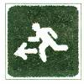
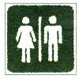
A. B. C.

Ⅱ.Close test (本题共15分,每小题1分，请将正确选项前的字母填在题前的括号中)
得分 | 评卷人
Choose the best answer to complete the passage.
Everyone likes gifts. Some little kids think they 31 enough gifts. Some old people think they get too many gifts. Different people like different 32 gifts. Some presents are never too small. A little child may give his mother 33 from a tree. It is enough 34 her happy.
Gift giving is 35 in different countries. In Japan, people sometimes give special gifts. But they 36 . Later, the same gift may be given away to 37 .Many people have enough things and don’t want more gifts 38 .In Canada, many people 39 big gifts to other people. They will 40 a park bench or a tree to help remember a person.
In the USA, some people ask their families and friends 41 money to charity rather than 42 them gifts. In Sweden, doing 43 for someone is the best gift. People don’t need to spend 44 money. Instead, 45 is enough
( ) 31.A. don’t get
( ) 32.A. kind of
( ) 33.A. a leaf
( ) 34.A. made
( ) 35.A. the same
( ) 36.A.aren’t opened
( ) 37.A. someone else
( ) 38.A. himself
( ) 39.A.will give
( ) 40.A.cost
( ) 41.A. to donate
( ) 42.A. buy
( ) 43.A. everything
( ) 44.A. too much
( ) 45.A. making meal
B. don’t give
B. kinds of
B. a card
B. make
B. different
B. are opened
B. else someone
B. themselves
B. haven’t given
B. pay for
B. donate
B. to buy
B. nothing
B. much too
B. make a meal
C. don’t like
C. kind
C. a toy
C. to make
C. difficult
C. didn’t open
C. everyone else
C. yourselves
C. will not give
C. take
C. donating
C. bought
C. something
C. too many
C. making a meal

Ⅲ. Communication (本题共20分, 每小题2分)
得分 | 评卷人
(A) Choose the best choice from A to F to finish the dialogue. You have one more answer. Each choice should be used only once.
A: Hi, Peter. I see you wearing a pair of glasses. But you didn’t wear it before, did you?
B: (46) But I’m afraid I have to wear it now.
A: (47)
B: Because I get screen sightedness（近视症）and (48)
A: (49) What happened?
B: My doctor said that I watched movies or played games on my iPad quite a lot.
I suggest you not to do that like me.
A: (50) Peter.
B: You’re welcome.
A. Why ? B. I’m sorry to hear that.
C. No, I didn’t. D. Thank you for your advice.
E. Yes, I did. F. I can’t see things clearly.

46 47 48 49 50
(B) Complete the dialogue with proper words or sentences.
A: Hi, Frank. Where did you go this morning?
B: (51) .
A: Why did you go to the railway station?
B: You know National Day is coming. I went there to buy a train ticket.
A: But you look upset now. (52) ?
B: I got up very early this morning in order to buy a train ticket.
(53) .
A: What a pity!
B: Have you bought the train ticket to go home?
A: Yes, (54) .
B: Online?
A: Yes, it’s more convenient. (55) .
B: OK. I will have a try. Thank you a lot.
A: You’re welcome.
第二部分 阅读理解(共计40分)
Ⅳ. Reading comprehension (本题共40分, A, D每小题1分, B, C, E每小题2分)
得分 | 评卷人
( A )
Nestwatch is a program to monitor nests（观察鸟巢).It was developed by the Smithsonian Migratory Bird Center.

( )56. Environmental problems are one of the things that cause the decline(减少) in the number of the kinds of birds. Nestwatch can help us to better understand the causes of the decline of the kinds of birds and give possible solutions to it. It aims to provide a nest-monitoring plan to follow the breeding patterns(繁殖模式) of all North American birds.
( )57. Nestwatch teaches people about the breeding of birds and encourages them to collect information on nests. The information includes where nests are, the kinds of nests and the number of eggs in them.
( )58. Anyone can check information on Nestwatch freely. Nestwatch makes it easy for people both to deal with their information on nests and to see other people’s information on nests.
( )59. We invite people of all ages who are interested in the natural world. Anyone is welcome to help monitor the success of the breeding of birds and better understand the danger they face.
( )60. The information from lots of people will be put together for people to learn more about the breeding of birds and the things that influence their populations across different places.
Choose the best topic from A to F according to the meaning of the passage.

A. People to take part in Nestwatch B. Nestwatch is important.
C. Ways of using the information. D. Things involved (包括)in Nestwatch
E. Nestwatch is amazing. F. Aim to put the information together.
( B )
Want to say “hello” from Disneyland? Send a post card！
Beautiful scenes of paradise(乐园), wild animals, silly pictures—you can find them all in one place. Where? On a post card! Have people always sent post cards? No. Before post cards, people liked sealed(密封的) letters.
The idea for the first decorated(装饰) post card came to John P. Charlton in 1861.He thought a simple card with decorations would be a great way to send a note. Then in the late 1800s, post cards with pictures appeared. By law, people had to write their note on the front—on the picture! The back was only for the address. Several years later, England allowed a divided-back post card. Then people could write their note on the back left side and put the address on the right. During the early 1900s, the golden age of post cards, picture post cards became a craze of the world. In 1908, Americans alone mailed over 677 million post cards. Today, post cards are the third most popular collection in the world after stamps and coins.
Judge the following sentences true (T) or false (F) according to the passage.
( ) 61. We can see some silly pictures on the post cards.
( ) 62. Post cards were produced before sealed letters.
( ) 63. In 1861, the first decorated post card appeared.
( ) 64. Post cards were the most popular during the early 1900s.
( ) 65. Stamps, coins and post cards are the most popular collections in the world.
( C )
Choose the best choice from A, B or C according to what you read.
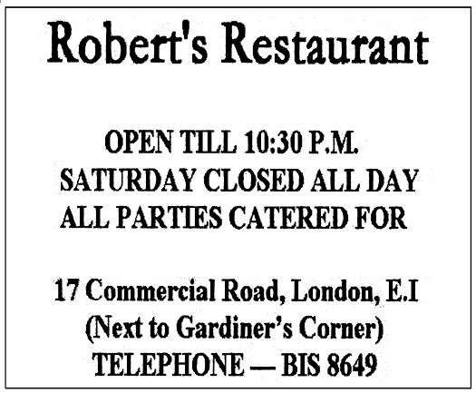


( )66. If the Jacksons want to have dinner together this week, they can go to _______.
A. Anchor on Tuesday B. Robert’s Restaurant at 10:30 pm
C. Anchor on Saturday
( )67. You can go to Robert’s Restaurant when you are in _______.
A. Australia B. Britain C. France
( )68. Which of the following information can NOT be found in the two pictures?
A. Which day Anchor is closed? B. Anchor ’s phone number.
C. Robert’s Restaurant’s opening time.
( )69. Anchor is known for _______.
A. its homemade meals B. its service for parties
C. the Gardiner’s Corner
( ) 70. What are these two pictures?
A. Tickets B. Menus C. Advertisements
( D )
Once a wicked wizard(邪恶的巫师)was on a visit to a city and stole the tongues(舌头)from the sleeping people and cast a spell(施一个咒语)on them. The spell meant that these tongues could only say bad things about people. Then the wizard returned these tongues to their owners. In very little time, that city was filled with the sound of people saying bad things about each other.
On seeing all this, the good wizard decided to do something. She cast a spell on the ears of the city people. Under this spell, no matter when the ears heard people saying bad things, they would close up so that nothing could be heard. Later, the tongues started to feel completely useless. When they realized this, they began to change by saying good things to each other.
Until today, the wicked wizard goes on casting the spell on tongues all over the world. But thanks to the good wizard, now people all realize that the best way to end something bad is to pay no attention to it.
Fill in the blanks according to the passage .Only one word for each blank.
Long ago, a wicked wizard (71) a city and stole the tongues from the sleeping people and cast a spell on them. The spell meant that these tongues could only say bad things about people. Then the wizard returned these tongues to their owners. In very little time that city was (72) of the sound of people saying bad things about each other. A good wizard knew this and she cast a spell on the ears of the city people. Under this spell, (73) the ears heard people saying bad things, they would close up and nothing could be heard.
Until today, the wicked wizard (74) casting the spell on tongues throughout the world. But because of the good wizard, now (75) realizes that the best way to end something bad is to pay no attention to it.
71 72 73 74 75
( E )
A TV program has become popular in China recently. It has made people all over China become interested in writing Chinese characters(汉字).
The increasing use of computers and smart phones has left most young people hardly able to write by hand. Many of them are even unable to remember the 10,000 characters used in daily life without electronic help.
CCTV started the Chinese Character Dictation Competition to improve the population’s handwriting skills. Contestants（参与者）on the show were school pupils, but it was found that 70 % of adults in the audience（观众）were unable to remember how to write the word “chan chu”.
Because computers allow people to type characters simply by entering pinyin, they don’t
need to remember how to write them. “The keyboard age has had a big influence on the handwriting of Chinese characters.”Guan Zhengwen, who designed and directed the show said.
He added that he hoped to encourage people to keep it alive as an art form.
Hao Mingjian, an editor of a magazine, putting his heart into Chinese characters, said,“Learning Chinese characters goes on throughout your life. If you stop using them for a long time, it is very likely that you will forget them.”
Answer the questions according to the passage.
76. Are Chinese people interested in writing Chinese characters now?

77. What has left most young people hardly able to write by hand?

78. Why did CCTV start the Chinese Character Dictation Competition?

79. How do computers allow people to type characters simply?

80. What can you learn from the passage?
第三部分 书面表达 (共计15分)
得分 | 评卷人
Ⅴ.Writing ( 本题共15分，其中81题5分，82题10分)
（注意：文中不能出现考生真实姓名、校名和师名，否则不得分）
81.假如你叫Bill,昨天游泳后患了感冒，今天早上觉得头疼。妈妈给你量了体温后，发现你发烧，便带你去看医生。医生说你需要卧床休息两天，特向老师请假。请给老师写一张请假条。
June 12 th, 2014
Dear Mrs. White,
I’m sorry to tell you that I can’t go to school today.

With best wishes.
Your student,
Bill
82. (A). 话题作文：即将到来的假期，你打算怎样度过呢？是去旅游，去放松玩乐还是去做一些其它有意义的事情？请以“Doing Something _________ in Summer Holiday”为题写一篇英语短文，谈谈你的想法。（提示：先将题目补充完整，可用meaningful，relaxing, interesting等。）
(B). 图示作文：仔细观察下列三幅图片，展开合理想象，写一篇短文。
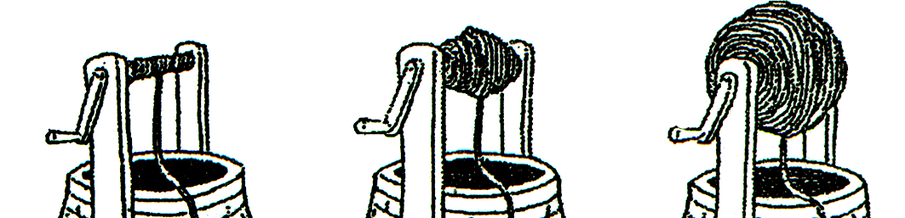
grandfather’s well father’s well son’s well
提示词：rope 绳子 broadcast 宣传 call on 号召 make contributions to 为…做出贡献
要求：1. 话题作文或图示作文任选其一。2. 词数在80～100词之间。
3. 要求字迹工整，语法正确，意思连贯，合乎逻辑，可适当发挥。

