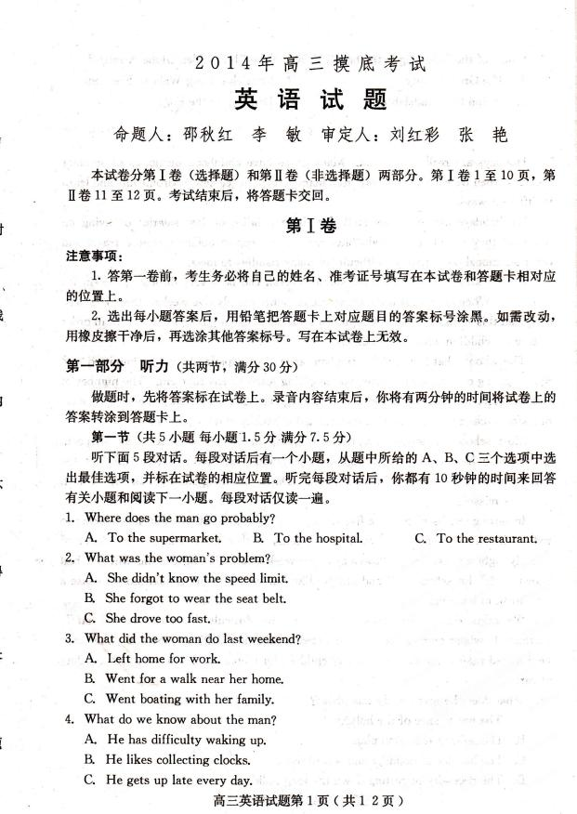
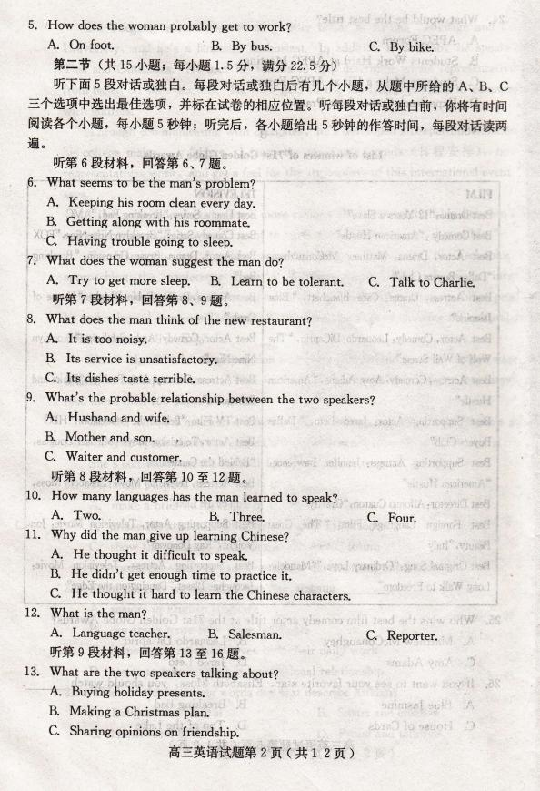
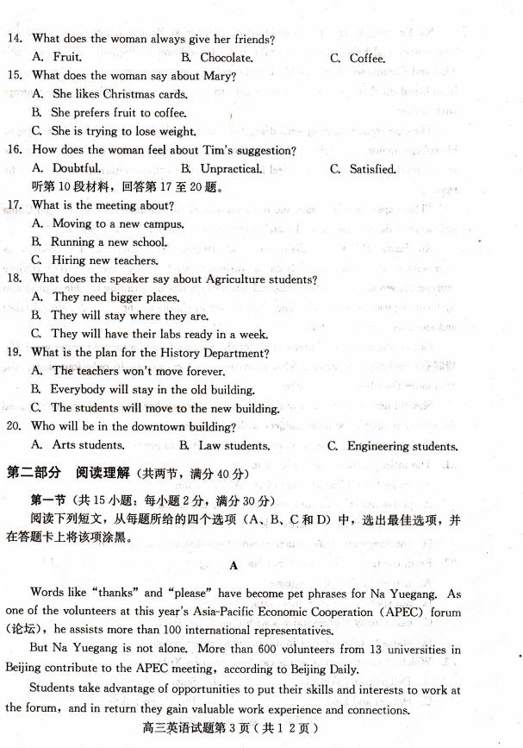
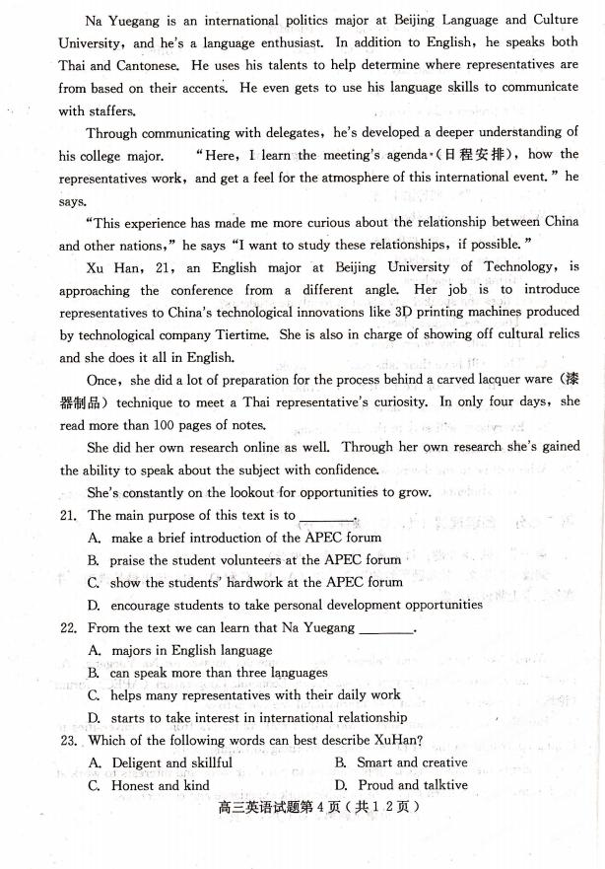
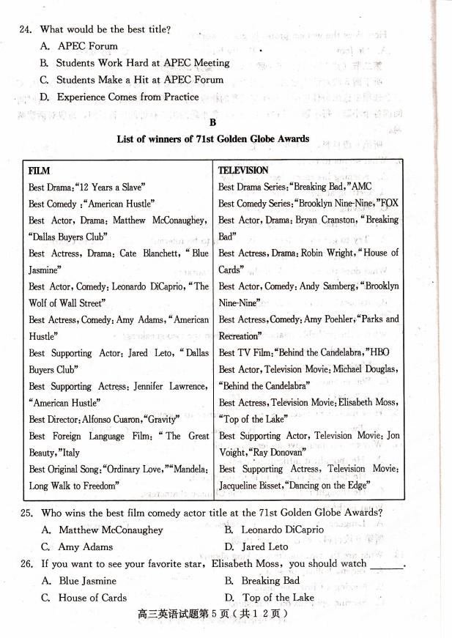
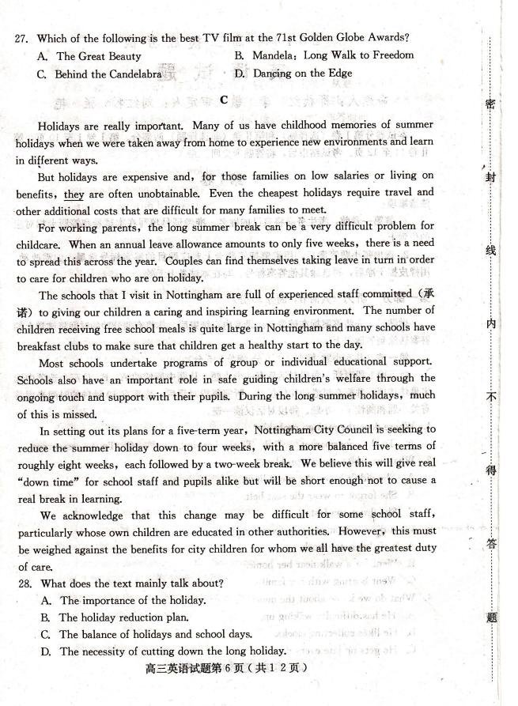
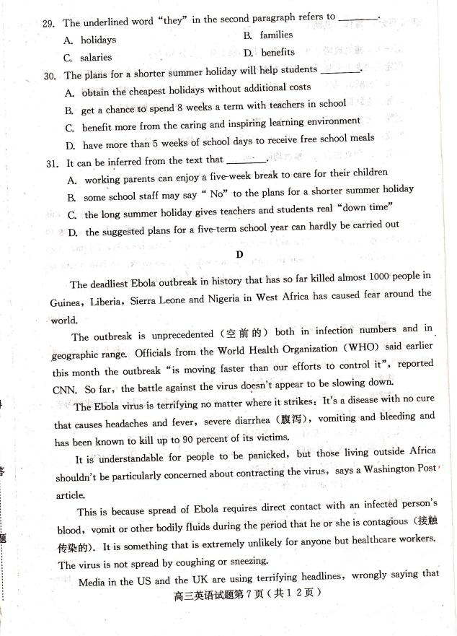
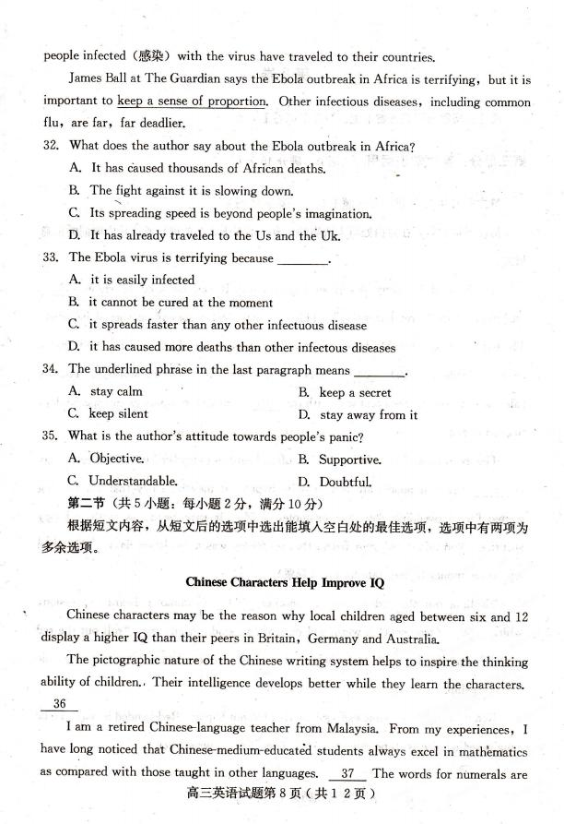
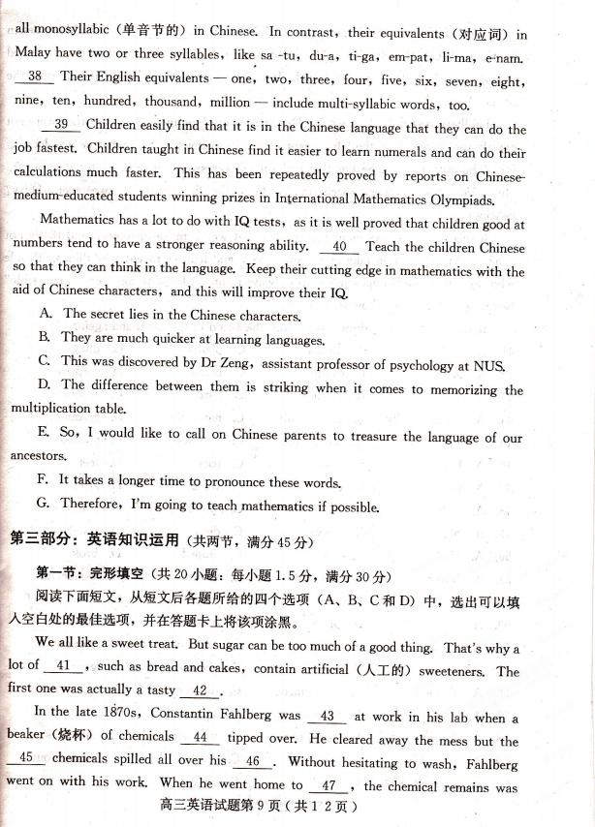
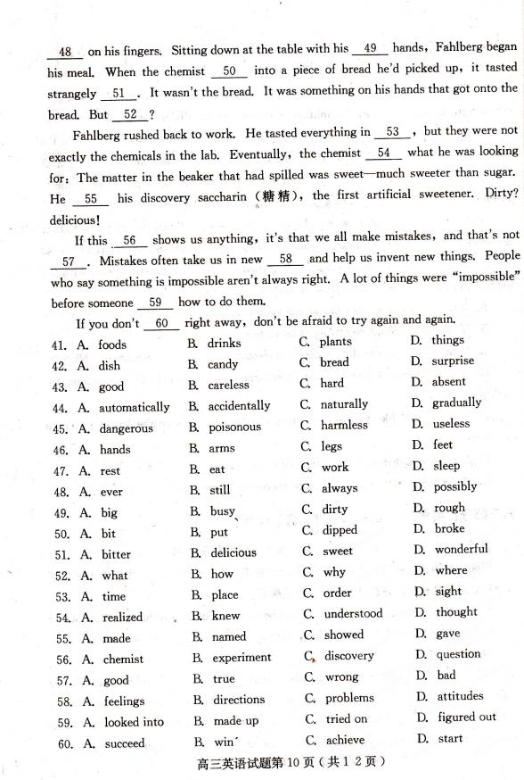
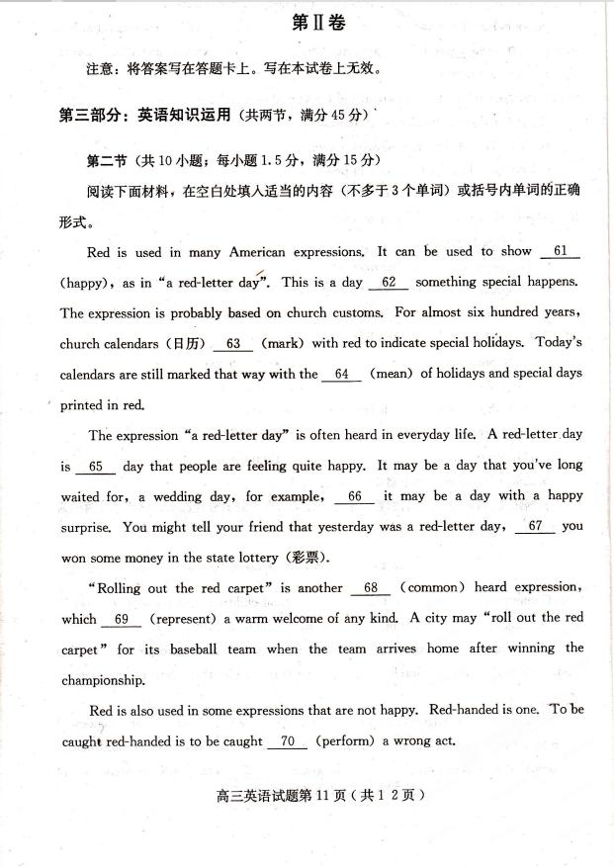
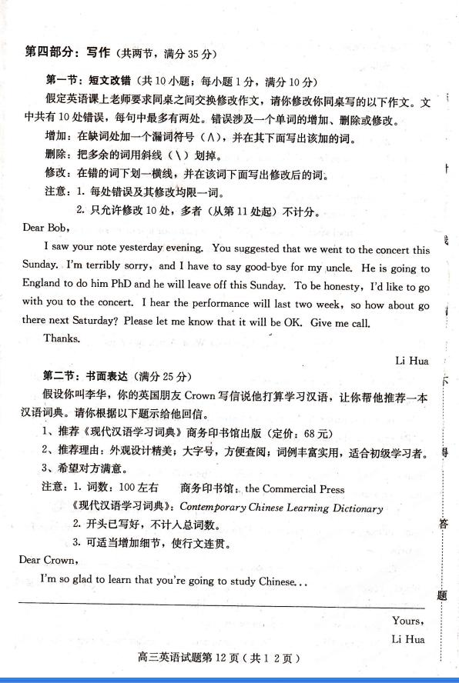
2014年高三摸底考试英语试题参考答案

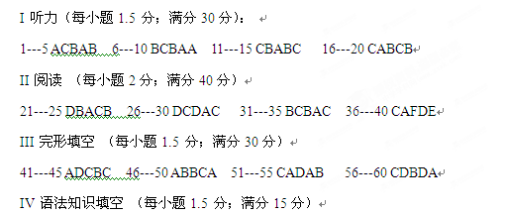
61.happiness 62. when 63. have been marked 64. meanings 65. a 66.or
67. because/when 68. commonly 69. represents 70. performing
V: 短文改错 （每小题1分；满分10分）
Dear Bob,
I saw your note yesterday evening. You suggested that we went to the concert this Sunday.
go
I’m terribly sorry, and I have to say good-bye for my uncle. He is going to England to do him PhD
but to his
and he will leave o\ff this Sunday. To be honesty, I’d like to go with you to the concert. I hear the
honest
performance will last two week, so how about go there next Saturday? Please let me know that it
weeks going if/whether
will be OK. Give me ^call.
a
Thanks.
Li Hua
VI 书面表达 （满分25分）
Possible version:
Dear Crown,,
I'm so glad to learn that you're going to study Chinese. First of all, I should recommend you the Contemporary Chinese Learning Dictionary, which is published by the Commercial Press. For it is intended for Chinese learning beginners and it will suit you fine.Its beautiful design in big letters makes it convenient for you to look up the words. More importantly, the entries are abundant and practical. Last but not the least it is cheap at a price of 68 RMB. I hope the Contemporary Chinese Learning Dictionary will meet your needs and be of great help to you.
Best wishes.
Yours,
LI Hua
Text1
M: I’m leaving now. What would you like me to bring you?
W: Please get me some apples.

Text 2
W: Is there a problem, officer? I wasn’t speeding, was I?
M: I’m afraid you were. The speed limit here is 40 miles per hour.

Text 3
M: Did you have a nice weekend? The weather was lovely.[来源:学科网][来源:Z,xx,k.Com]
W: Yes, we did. I went for a walk in the park near our home, and my husband and the children went boating on the lake.

Text 4
W：Hey，you have so many clocks in your bedroom．Are you crazy or what?
M：No，I’m a heavy sleeper．I want to make sure I can wake up in the morning．

Text 5
M：If I were you，I’d ride a bike to school．Taking a bus during rush hours is really terrible．
W：Thanks for your advice，but my bike has just been stolen.．
Text 6
W：What’s going on between you and Charlie? Did you have a fight or something?
M：No，but I can’t stand him anymore．He is the worst roommate I’ve ever had．He never cleans up and he is always listening to loud music when I try to get some sleep．
W：Why don’t you have a heart-to-heart talk with him?
M：I’ve tried，but it didn’t work．Maybe you can talk to him．After all，you are his good friend．
W: All right. I’ll try.
Text 7
M: Oh, I am starving.
W: Me too. Shall we eat out? There is a new restaurant down the street.
M: Oh, forget about it. I went there with a friend last week. I should say the dishes are tasty but the poor service made me annoyed.
W: Then how about the JingJiang restaurant on the next block?
M: Well. I ate out almost every day last week. Let's just eat in today.
W: But I am not in the mood to cook.
M: I will cook then. In fact, I am sick of the restaurant. I just want home-cooked meal.
Text 8
W: Having visited so many different countries, you must be able to speak several different languages.
M: I wish I could, but French and English are the only ones I have ever learned to speak.
W: Have you ever tried Chinese?
M: Yes, but I gave up halfway. The Chinese characters are too difficult to practise.
W: How about Japanese?
M: I had studied in a Japanese class for three months, but the more I learned, the more difficult the grammar became.[来源:学,科,网Z,X,X,K]
W: Do you like traveling?
M: No, I don’t, but I have to. I work in the sales department.
Text 9
M：Hi，Susan．How are you? I’ve been wondering when I’d run into you．What are you busy with?[来源:Z+xx+k.Com]
W：Nice to meet you here，Tim．I’m buying some Christmas gifts for those who work with me，but it’s really a headache．
M：Maybe I could give you some advice．Firstly，you’d better divide them into different groups--who were the people that are your friends as well as your workmates and who are the people you do not know well but you see pretty much daily．
W：OK，then what should I do?[来源:Z,xx,k.Com]
M：For the friends，you want to get them personal gifts．Do they like chocolate?
W：This is what I always give，but I know Mary is on a diet．
M：Does she like fruit or coffee? Anyway，think of the gift that you know your friend likes．
W：Well，I think fruit is helpful to keep fit．What about the rest of them?
M：Leave cards in their mailboxes or on their desks．
W：Christmas cards?
M：Yes，you can afford that．More importantly，it’s true of them that you’re thinking of them．
W：Thank you for your suggestion，Tim．You really have saved me and my money as well．
