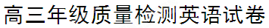

（时间：120分钟 总分：120分）

第一部分：听力（共两节，满分20分）
第一节（共5小题；每小题1分，满分5分）
听下面5段对话。每段对话后有一个小题，从题中所给的A、B、C三个选项中选出最佳选项，并标在试卷的相应位置。听完每段对话后，你都有10秒钟的时间来回答有关小题和阅读下一小题。每段对话仅读一遍。
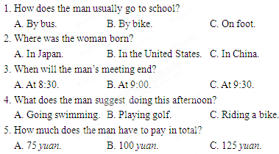

[来源:学科网]

第二节（共15小题；每小题1分，满分15分）
听下面5段对话或独白。每段对话或独白后有几个小题，从题中所给的A、B、C三个选项中选出最佳选项，并标在试卷的相应位置。听每段对话或独白前，你将有时间阅读各个小题，每小题5秒钟；听完后，各小题给出5秒钟的作答时间。每段对话或独白读两遍。
听第6段材料，回答第6、7题。
6. Why did the man go to Italy?[来源:Zxxk.Com]
A. To travel. B. To work. C. To shop.
7. What does the man think of his time in Italy?
A. Busy but interesting. B. Happy and relaxing.
C. Hard but enjoyable.
听第7段材料，回答第8、9题。
8. What day is it today?
A. Friday. B. Thursday. C. Wednesday.
9. How many people are going to the restaurant?[来源:Zxxk.Com]
A. Three. B. Four. C. Five.
听第8段材料，回答10至12题。
10. Who is the man probably?
A. A foreign student. B. Kate’s boyfriend. C. The woman’s friend.
11. What is Kate doing now?
A. Watching a film. B. Reading a book. C. Making a phone call.[来源:Z.xx.k.Com]
12. Why is the man asking so many questions tonight?
A. To know more about the family.
B. To improve his spoken English.
C. To get close to Kate.
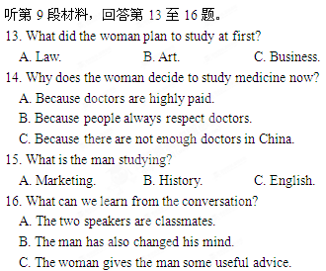

听第10段材料，回答第17至20题。
17. What does Sean do?
A. A farmer. B. A student. C. A businessman.
18. What did Sean do recently?
A. He bought a land. B. He did some research. C. He created a website.
19. How long did it take twenty volunteers to turn a grassy land into a farm?
A. Six weekends. B. Two weeks. C. Within a week.
20. What is the text mainly about?
A. How to run a farm well. B. A new type of farming. C. Starting a farm.

第二部分：英语知识运用（共两节，满分35分）
第一节：单项选择（共15小题；每小题1分，满分15分）
21. The police including an officer searching for the murderer in the area the other day.
A. was B. are C. were D. is
22. —I just can’t stop worrying about the result of the English examination.
—___________.There’s nothing you can do but wait..
A. Take your time B. Take it easy
C. Don’t mind D. Don’t mention it[来源:学科网ZXXK]
23. Mr. White is a careful and experienced engineer, so he is often to finish some challenging tasks.
A. appreciated B. approached C. appointed D. agreed
24. to life imprisonment, Bo xilai lost all hope.
A. Be sentenced B. Sentencing C. To sentence D. Having been sentenced
25. — Tom is planning to buy a car.
— I know. By next month, he enough for a used one.
A. saved B. has saved C. would save D. will have saved
26. Once you do it, you will feel that it comes easy.
A. by and by B. feet of clay
C. kill the fatted calf D. garbage in, garbage out
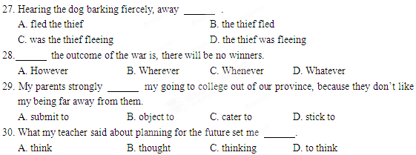
31. Windows 7 was created in 2009, many computer lovers were interested and excited.
A. when B. where C. why D. which
32. The boss refused to sell the car for he thought was not satisfactory.
A. what B. that C. which D. how
33. Can you tell me the difference between the words “require” and “request” ? I sometimes get puzzled by their meanings.
A. arbitrary B. clumsy C. apparent D. tentative
34. I ran all the way to school yesterday, otherwise I late for the annual talent show.
A. was B. had been C. would be D. would have been
35. —I heard Tom was badly injured in the football match.
— , let’s go and see him.
A. If ever B. If so C. If not D. If any
第二节：完形填空（共20小题；每小题1分，满分20分）
阅读下面短文， 从短文后各题所给的四个选项（A、B、C和D）中，选出可以填入空白处的最佳选项。
On a sunny spring morning, a seven-year-old girl was sharpening(削) a beautiful pencil. 36 , the wind was so strong as to blow open the door. The girl stood up to 37 it, but then fell on the floor. The sharpened pencil pierced (刺入) directly into the girl’s chest into her heart, and only a small part of the pencil could be seen.
The girl’s mother was so 38 that she dialed the emergency number and put the girl flat on her back. The girl 39 and asked her mother to pull the pencil out of her heart 40 it was particularly painful. The mother hesitated for a while but 41 her daughter. She told her daughter not to pull out the pencil without her permission.
In the end, the girl was 42 successfully! She had a very serious 43 but she didn’t lose too much blood. If the pencil were pulled out, the blood would have poured out from the wound, and doctors couldn’t have saved her! 44 , the measures taken by her 45 were totally correct.
The mother’s comments afterwards were quite 46 : “I really didn’t know what to do. My daughter was especially obedient (听话的) and she 47 my decision not to pull out the pencil. I knew she was in great pain, and her obedience was what I 48 . I thought if I had pulled out the pencil, she would have believed she was 49 and might fall asleep and lose consciousness (意识). In the emergency vehicle, I simply kept asking her if it was 50 . She nodded her head, which gave me great 51 because she was conscious and still felt pain. She was struggling for 44. A. Otherwise B. Instead C. Though D. Thus
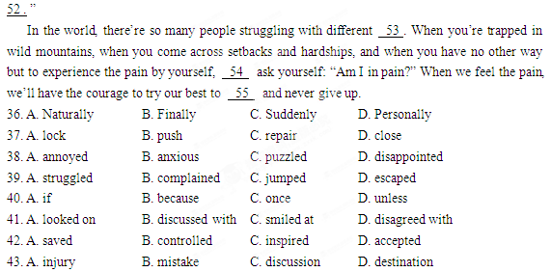
45. A. friend B. teacher C. doctor D. mother
46. A. challenging B. surprising C. exciting D. worrying
47. A. made B. changed C. followed D. recognized
48. A. realized B. promised C. respected D. needed
49. A. safe B. tired C. brave D. lucky
50. A. thankful B. painful C. powerful D. careful
51. A. courage B. comfort C. freedom D. hope
52. A. life B. glory C. peace D. power
53. A. techniques B. qualities C. difficulties D. performances
54. A. still B. just C. again D. even
55. A. laugh B. explain C. survive D. relax
第三部分：阅读理解（共15小题；每小题2分，满分30分）
A
People have been listening to music to get in the mood for hundreds of years. Recently, there is scientific research to back up what we have always known about music. The studies have shown that when people are excited or happy they are more helpful. The opposite happens when people feel aggressive(好斗的) or under stress. The use of music can influence how helpful people can be.
Dr Adrian North made a study with 256 university students. Half the group took exercise in the gymnasium listening to music which can bring happiness and the other half exercised to aggressive music. When leaving the gym, the students were asked to hand out flyers (传单) in support of the local disabled athlete’s foundation.
The results showed that nearly half of the group that listened to happy music were willing to hand out flyers. But in the group that heard the aggressive music, less than 20% were willing. This study suggests that our choice of music can influence our willingness to cooperate(合作).
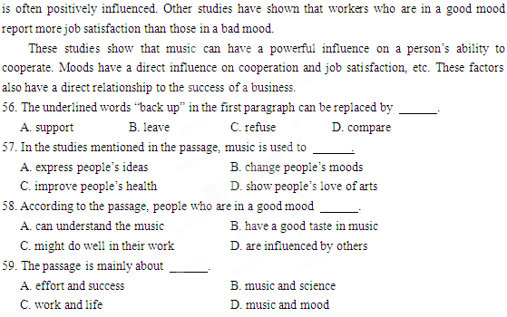
While a study also shows that productivity (生产效率) can increase with the right choice of background music in the workplace. As music stimulates (刺激) workers’ minds, job satisfaction B
You can mail a letter or package under 16 oz. (unit of weight, 454g) in a mailbox, a blue box found on many street corners in U.S. cities and towns. Each mail box should have pick-up times clearly posted on top.
!Packages over 16 oz. placed in a mailbox will not be sent. Bring the package to the post office or retail (零售的) mailing shop instead. The clerk will process if for you.
The Post Office
In the larger cities, when you go to the post office you must take a number and wait in line. Post offices tend to be extremely crowded around Christmas. Try to go as early in the morning as possible. Post office branches open at 9 a.m. and close at 5 p.m. while main branches close at 6 p.m.
Buying Stamps
! The cost of a first-class postage stamp to mail a letter is currently 39 cents, although rates tend to change often.
Stamps are sold individually or in booklets (小册子) of 10 (US$3.90) or 20(US$7.80) or in rolls of 100(US$9.00). You can buy stamps at the following locations:
·online, if you have a computer.
Link to the U.S. Postal Service website (http://www. usps.com) and click on “stamps online”.
·at your local post office
·at some ATMs (automated teller machine)
·at some supermarkets
·by mail
·retail mailing stores(you may have to pay extra for stamps and to mail packages through the U.S. Postal Service)
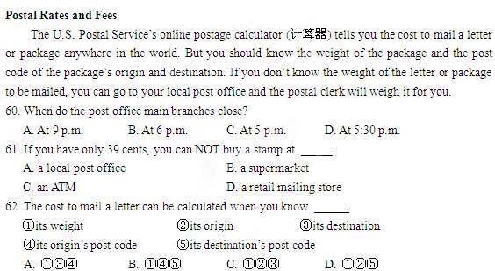
C
JIUQUAN, China—China’s Shenzhou-9 spacecraft blasted off(点火升空)at 6:37 pm Saturday, from a remote desert in western China, sending a crew of three, including the country’s first female astronaut, into space.
The successful launch, powered by a Long March 2F rocket, was shown live on state television Saturday from the Jiuquan Satellite Launch Center in the Gobi Desert in western China.
The Chinese astronauts will complete the country’s first manned space docking mission(载入太空对接任务), an important step in Beijing’s ambitious plan to build a permanent space station by 2020. Possible future missions could include sending a man to the moon.
The crew is expected to spend more than 10 days in space and dock with the Tiangong-1 space lab module, which China launched in September 2011. Two of them will live and work inside the module to test its life-support systems, while the third will remain in the capsule to deal with any unexpected emergencies.
China first launched a man into space in 2003, followed by a two-man mission in 2005 and a three-man trip in 2008 that featured the country’s first spacewalk. In November 2011, the unmanned Shenzhou-8 successfully docked twice with Tiangong-1 by remote control. The manned docking would be considered a milestone for China’s space program.
China is hoping to join the United States and Russia as the only countries to send independently maintained space stations into orbit(轨道). It is already one of just three nations to have launched manned spacecraft on their own.
The program is a source of enormous national pride for China, reflecting its rapid economic and technological progress and ambition to rank among the world’s leading nations.
63.From the passage, we know that .
A. China plans to build a permanent space station on the moon in the near future
B. the Shenzhou-9 will dock with Tiangong-1 for the third time
C. the success launch of Shenzhou-9 is a milestone for China’s space program
D. plenty of people had the opportunity to watch the live broadcast o the launch on TV
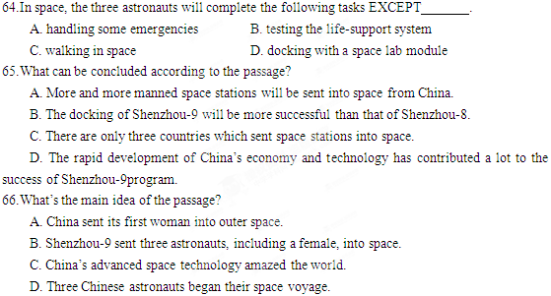
D
When we talk about intelligence, we do not mean the ability to get good scores on certain kinds of tests or even the ability to do well in school subjects. By intelligence we mean a way of living and behaving, especially in a new or upsetting situation. If we want to test intelligence, we need to find out how a person acts instead of how much he knows what to do.
For instance, when in a new situation, an intelligent person thinks about the situation, not about himself or what might happen to him. He tries to find out all he can, and then he acts immediately and tries to do something about it. He probably isn’t sure how it will all work out, but at least he tries. And if he cannot make things work out right, he doesn’t feel ashamed that he failed; he just tries to learn from his mistakes. An intelligent person, even if he is very young, has a special outlook on life, a special feeling about life, and how he fits into it.
If you look at children, you’ll see a great difference in what we call “bright” children and “not bright” children. They are actually two different kinds of people, not just the same kind with different amounts of intelligence. For example, the bright child really wants to find out about life, and he tries to get in touch with everything around him. But the unintelligent child keeps more to himself and his own dream world; he seems to have a walk between him and life in general.
67.According to the passage, intelligence is the ability to .
A. get high scores in some tests B. do well in school subjects
C. deal with life D. know what to do
68.In a new situation, an intelligent person .
A. knows more about what might happen to him
B. is sure of the result he will get
C. is ready to face and fit himself in the situation
D. cares more about himself
69.If an intelligent person failed, he would .
A. feel ashamed
B. learn from his experiences
C. try to find all he could

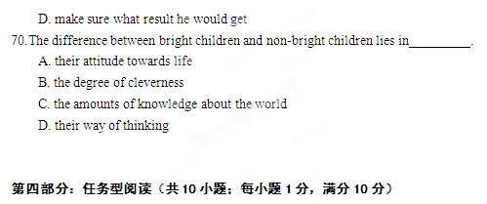

请认真阅读下面短文，并根据所读内容在文章后表格中的空格里填入一个最恰当的单词。
注意：每个空格只填1个单词。
Do you want to be the perfect you? When you are ready to improve yourself, give yourself a challenge. Challenge is the key to one’s growth. Try doing something that you are afraid of. When you get over your fears, the feeling of confidence in yourself can push you to new heights.
It is important to realize that habits are not easy to break. Just because setting your mind to do something does not mean you will be able to change it right away. Sometimes you may find yourself going back to what you’re used to. Don’t let this stop you from making the change you want.
If you aren’t sure where to start or what to change, imagine that you have to explain to someone in authority(权威) what you would need to do to develop or progress. If you have to, write it down and think about what you would say to make someone else believe that you are on the right path. This will help you be clearer about what you want to accomplish.
Figure out what you want to do with yourself. This doesn’t mean that you need to map out your entire life in advance. Consider the next five years. Where do you want to be? What does your life look like? If you evaluate(评价) yourself properly, you can decide on the best course of action to get where you want be.
Learn to value what is the best in your life. When value something, you naturally want to do whatever you can to achieve it. What you value influences the choices you will make in life. So if you value the best in your life, the activities that you choose will work toward achieving the best in your life.
Increasing your personal satisfaction with life is sometimes as easy as learning to give back to the community(社区)around you. Giving selflessly and donating charitably(慷慨地) is an excellent way to increase your own feelings of self-worth. Moreover, giving selflessly is an excellent way of proving your worth in your community.
Hopefully with all of the information you have just learned, you can start taking some serious steps toward your personal development. Remember that it is one thing to want to do something, but it is another thing to actually do it, so trying your best to do what you think is going to be right for you in your personal development goals.
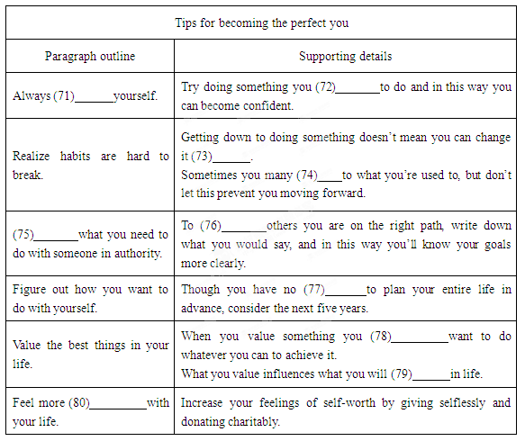
第五部分： 根据首字母或汉语提示完成句子（共10小题，每题1分，满分10分）
81.The government needs to a such concerns in a positive manner.
82.O , we had intended to go to Italy, but then we won the trip to Greece.
83.Before you can attend classes, you must first r for school on the Internet.
84.C he’s only just started, he knows quite a lot about it.
85.You have done so much work—you are b to pass the net exam.
86.In (努力对付或解决) with the dilemma of worldwide hunger, the United Nations set up an agency called the world Food Programme in 1963.
87.The results are entirely (一致的，相符的) with our earlier research.
88.His questions at the press conference (强调、突出) his ignorance of the matters being discussed.
89.I was deeply impressed by his (评估、看法) of the international situation.
90.Although the two friends apologized to each other, there was still some (摩擦、分歧) between them.
第六部分： 书面表达（满分25分）
假如你是高三学生李华，近期你们学校组织一次关于“有烦恼向谁说”的调查活动，调

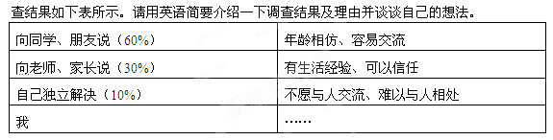
注意：
1、词数150左右；开头已给出，不计入总词数；
2、可适当增加细节，以使行文连贯。
Recently a survey—Who Do You Turn to When You Are in Trouble?
—was carried out in our school.
____________________________________________________________________
_______________________________________________________________________________________________________________________________________________________________________________________________________________________________________________________________________________________________________________________________

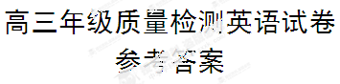

一、听力
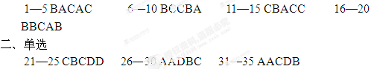

三、完形
36—40 CDBAB 41—45 DAADD 46—50 BCDAB 51—55 DACBC
四、阅读理解
56—59 ABCD 60—62 BDB 63—66 DCDB 67—70 CCBA

五、任务阅读
71. challenge 72. fear 73. immediately 74. return
75. Share 76. convince 77. need 78.naturally
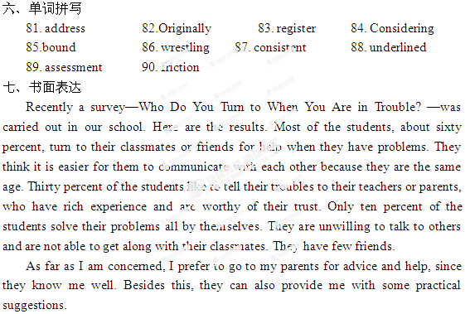
79.choose 80. satisfied

