二、单项填空（本题有10小题，每小题1分，共10分）
请从A、B、C、D四个选项中，选出可以填入空白处的最佳选项。
【2012浙江湖州】16. — Do you enjoy your stny in China* Jim?
— Yes. I've had ______ wonderful time.
- J B. a C. the D. an
【答案】B
【2012浙江湖州】17. How many ______ do we need to make fruit salad?
— Two should be enough.
- cabbage B. potatoes C bananas D. lemon
【答案】C
【2012浙江湖州】18. — Excuse me. could you tell me ______?
—In the supermarket.
A. where 1 can buy this kind of CD player B. where can I buy this kind of CD player
C. if I can buy this kind of CD player D. if can I buy this kind of CD player
【答案】A
【2012浙江湖州】19. We have to ______ our sports meeting till next week because of the heavy rain.
- take off B. get off C put off D. set off
【答案】C
【2012浙江湖州】20.— Jack is a(n) _ _____young man.
—That's true. He always feels nervous when he speaks before people
- friendly B shy C. honest. D. lively
【答案】B
【2012浙江湖州】21.—What kind of movies do you like?
. —I like the move ______ are about Chinese history.
A. who B. whom C. whose D which
【答案】D
【2012浙江湖州】22. —Sixteen-year-olds ______ to drive in China.
—But in America, they can.
A. is allowed B. is not allowed C. are allowed D. are not allowed
【答案】D
【2012浙江湖州】23.We ______ be careful when we are walking across the road. There are too many cars now.
A. can B. may C. must D. could
【答案】C
【2012浙江湖州】24.—May I borrow your dictionary, Sanday?
—______. But you have to return it this afternoon.
A. No problem B. I’m sorry C.I hope not. D. I’m not sure.
【答案】A
【2012浙江湖州】25.If we see the sign “______” in public, we can’t park our cars there.
A. B. 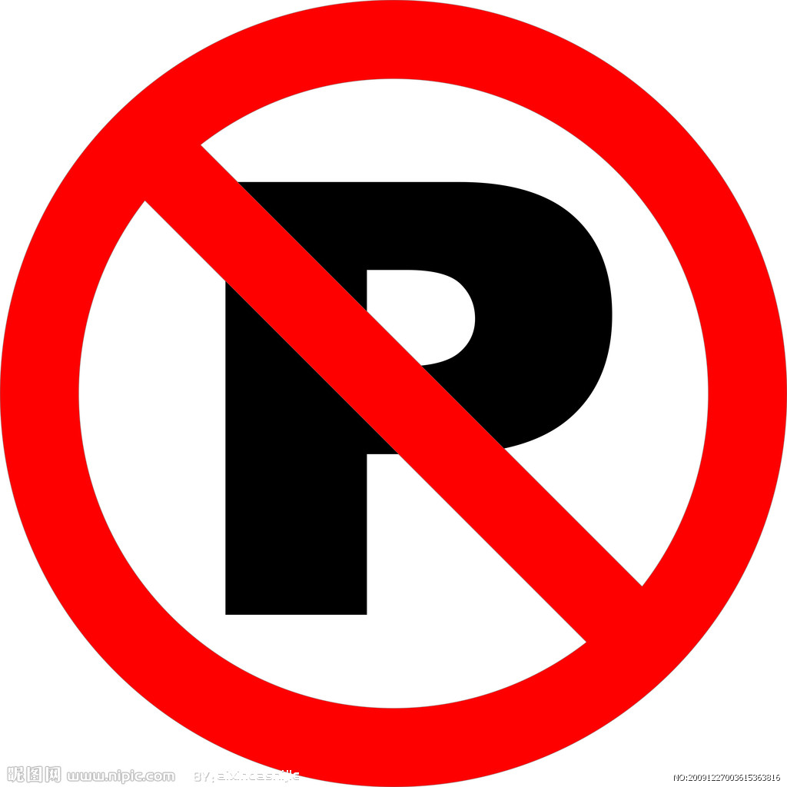 C.  D. 
【答案】B

