二、完型填空（每小题2分，共30分）
A
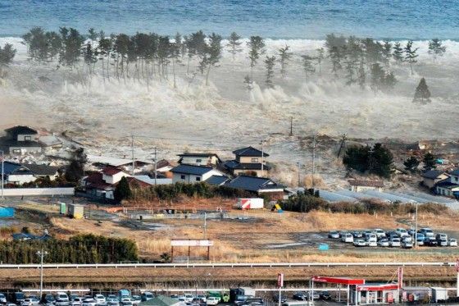
The largest earthquake in Japanese history 16 in northern Japan at 2:46 pm of March 11, 2011. A tsunami (海啸) followed, causing major flooding in 17 areas of Japan, as well as many strong aftershocks(余震). So far more than 13,000 people
18 with about 14,000 people missing. When news of this disaster(灾难) 19 China, many Chinese people expressed their20 for Japan and the Japanese, remembering that Japan helped the Chinese during China’s 2008 Sichuan Earthquake.
( )16. A. was happened B. happened C. had happened D. happening
( )17. A. many B. much C. a lot D. lots
( )18. A. lost their life B. lose their lives C. have lost their lives D. have been died
( )19. A. reaches B. is reached C. got D. reached
( )20. A. support B. pride C. pleasure D. prediction
B
Tom is the son of a farm owner. One New Year’s Day, when he was 15, his father asked him 21 on the farm for one year when he was free. Tom was 22 with his father’s idea.“That isn’t my job. I have 23 school work to do.” Hearing this, his father said, “I promise to give you the best present if you 24 finish one year’s work.” Tom thought for a while and 25 .
Starting one Saturday, the boy got up early and worked hard until evening, just like 26 farmer. Time passed quickly. Tom’s crops(庄稼) grew well. 27 the last day of the year, the father called his son to him. “I’m happy to see that you have worked very hard the whole year,” said the father. “Now, tell me 28 you want.”
The boy smiled and showed his father a big piece of bread 29 his wheat. I’ve already got the best present: No pain, no gain. I think this is what you wanted me to know.” His father was 30 to hear that.
( )21 A. works B. work C. to work D. working
( )22. A. happy B. excited C. exciting D. unhappy
( )23. A. much too B. too much C. a lot D. many
( )24. A. can B. need C. must D. should
( )25. A. said B. answered C. agreed D. asked
( )26. A. other B. the others C. any else D. any other
( )27. A. On B. At C. In D. From
( )28. A. where B. what C. which D. why
( )29. A. made by B. made of C. made in D. made from
( )30. A. pleased B. unpleased C. unsatisfied D. sad

