C
films in Feiyang Cinema this week
A WORLD WITHOUT TYHIEVES  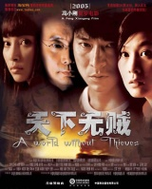  • Chinese film (2004)  • Dircected (导演) by Feng Xiaogang  • Mainly acted by Liu Dehua, Liu Ruoying,  Ge You,Li Bingbing  • From Monday to Wednesday, at 8 : 00 p. m.  • Ticket Price:RMB¥35 | 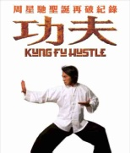  KUNGFU HUSTLE  • Chinese Hong Kong film (2004)  • Directed by Zhou Xingchi  • Mainly acted by Zhou Xingchi,Yuan Hua, Liang Xiaolong  • From Wednesday to Friday, at 8 : 00 p. m.  • Ticket price:RMB¥40
Films In Feiyang Cinema This Week  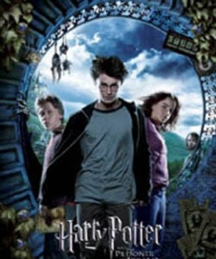  HAPPY POTTER (III)  • American film (2004)  • Directed by Alfonso Cuaron  • Mainly acted by Daniel Radcliffe, Rupert Grint. Emma Waston  • From Friday to  Sunday,at 7 : 30 p. m. • Ticket Price: RMB¥30 (Half on Sunday for children) | TROY  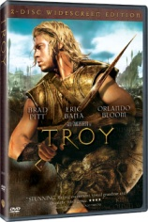  • American film (2004)  • Directed by Wolfgang Peters-en  • Mainly acted by  Julian Glover, Brian Cox, Nathan Jones, Adoni Maropis  • From Tuesday to Thursday, at 8 : 00 p. m.  • Ticket Price:RMB¥45
( )38. You can see________foreign films in Feiyang Cinema this week.
A. one B. two C. three D. four
( )39. If you want to see the film which was directed by Feng Xiaogang, go to the cinema on________.
A. Monday B. Thursday C. Friday D. Saturday
( ) 40. You can see the film________on Saturday.
A. Troy B. Harry PotterC. A World Without Thieves D. Kungfu Hustle

( )41. Which of the following is TRUE?
A. All the films start after 8 o'clock in the evening.
B. The ticket price of the four films is the same.
C. Liu Dehua acted in the film A WORLD WITHOUT TYHIEVES
D. The four films were released (发行) in the same year.

