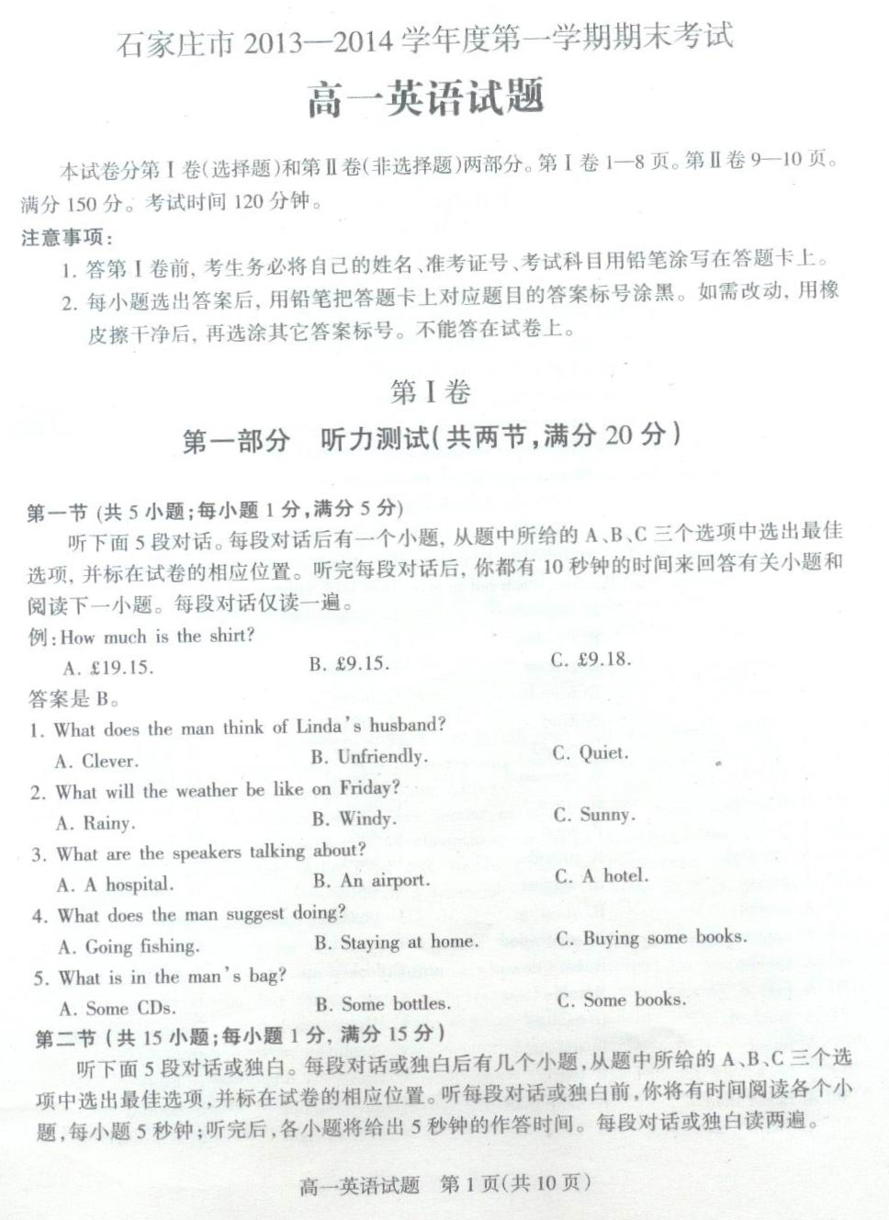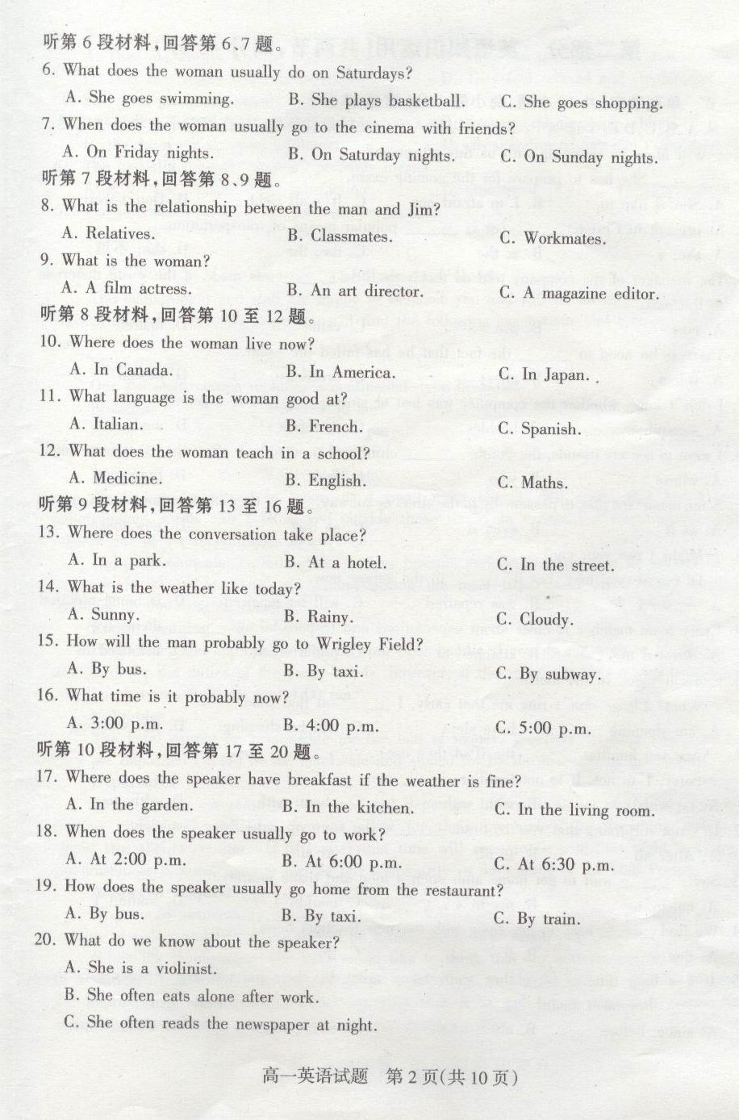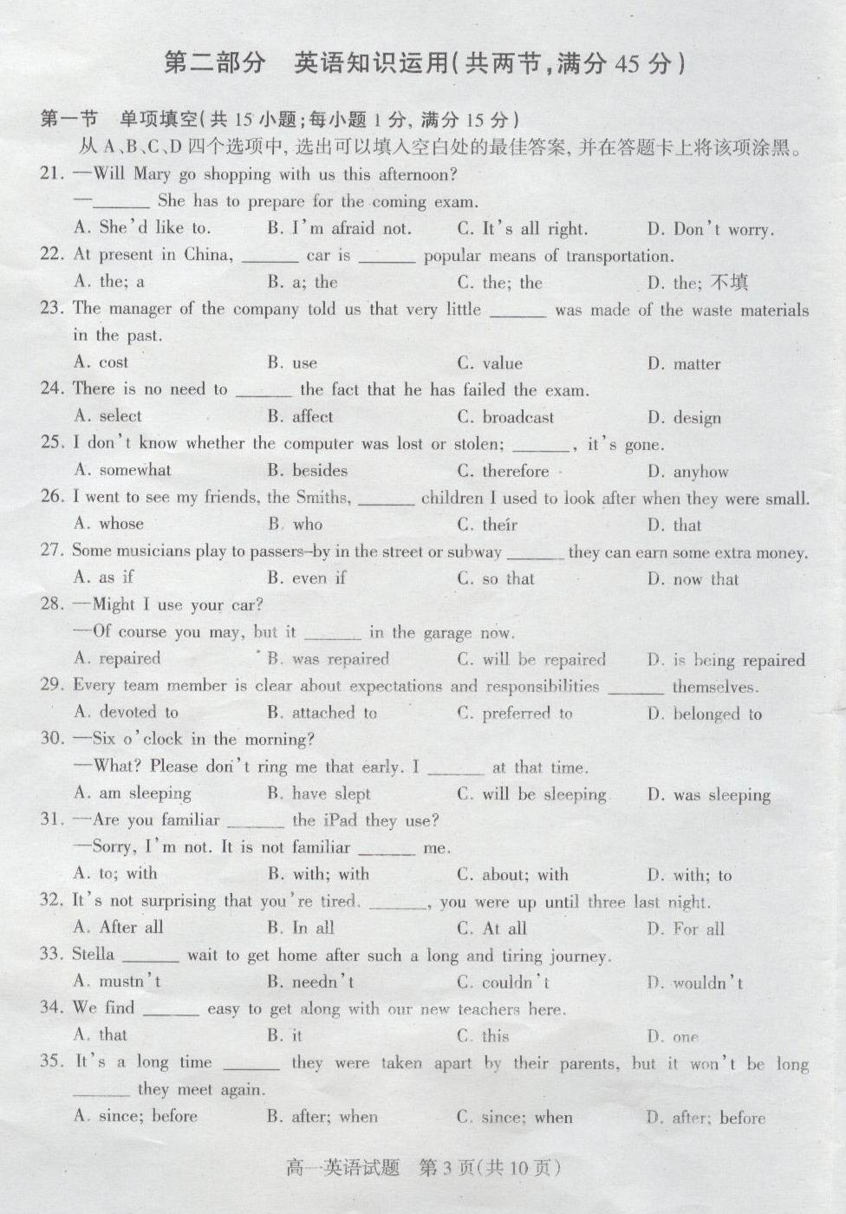

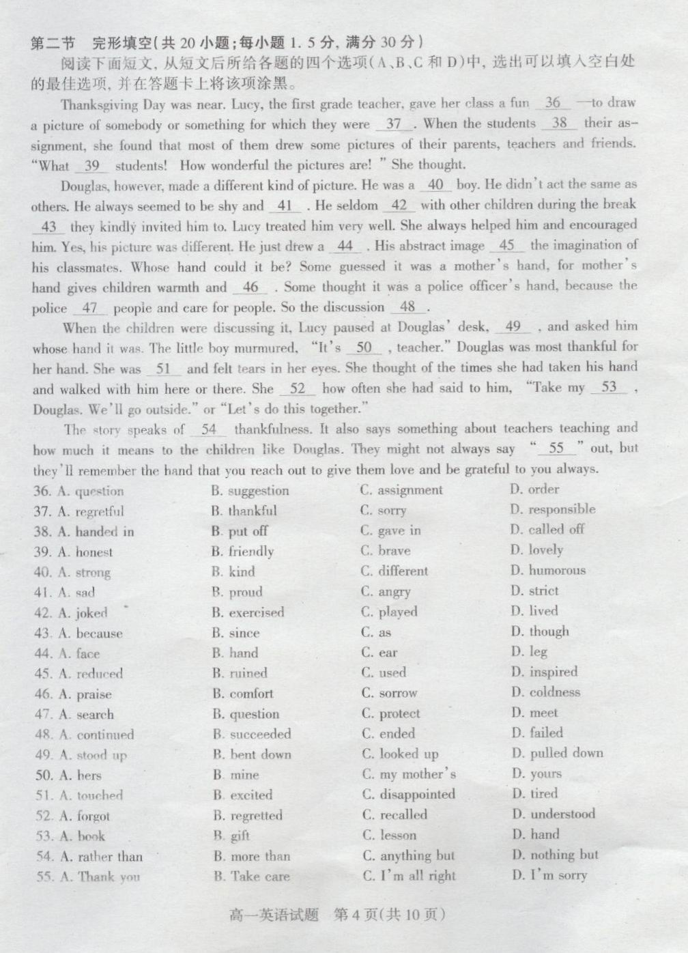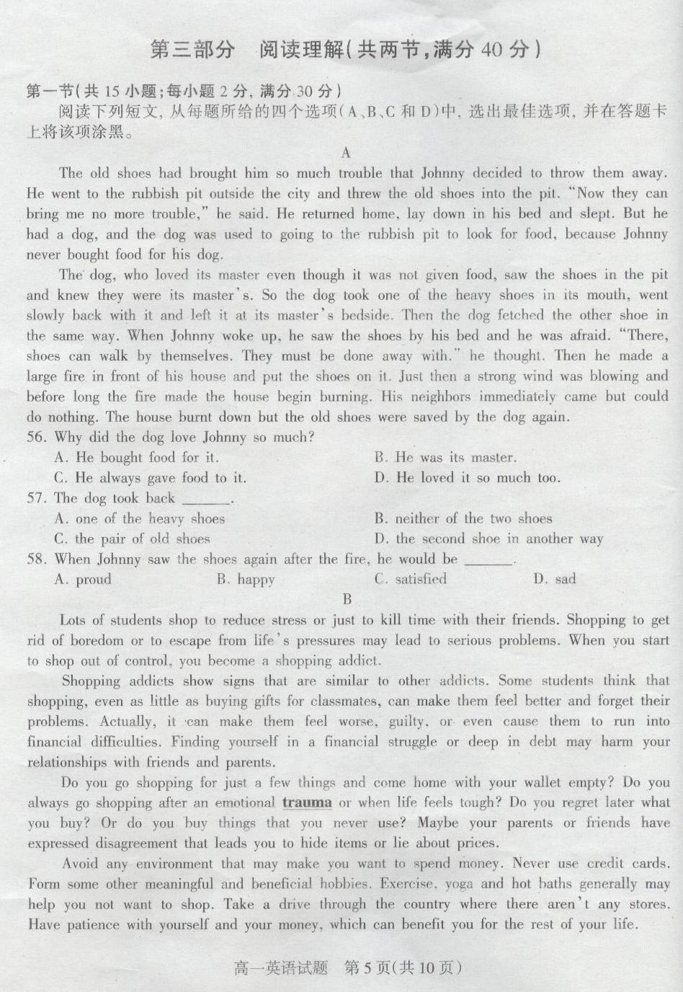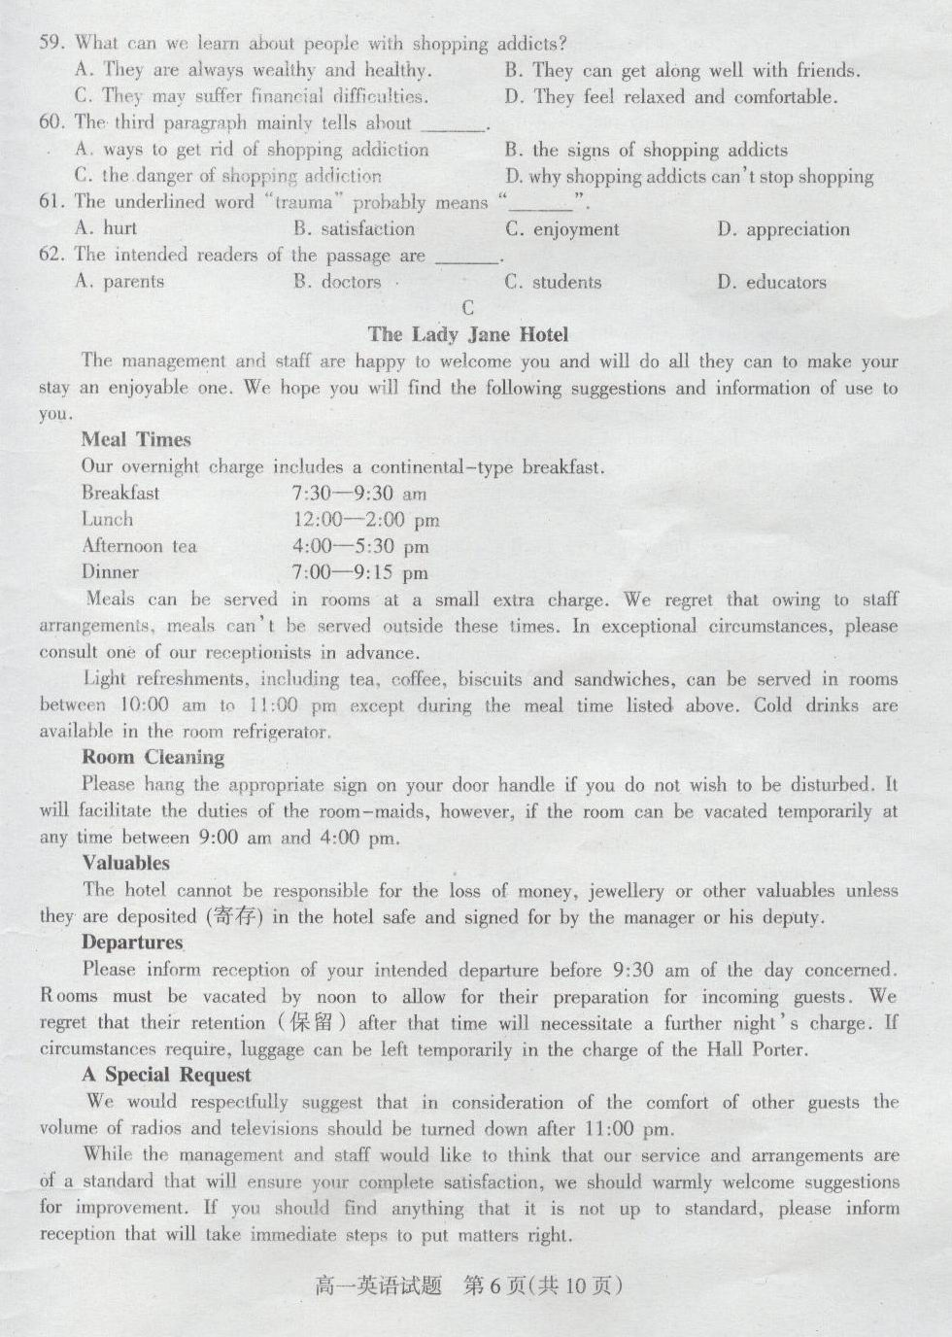
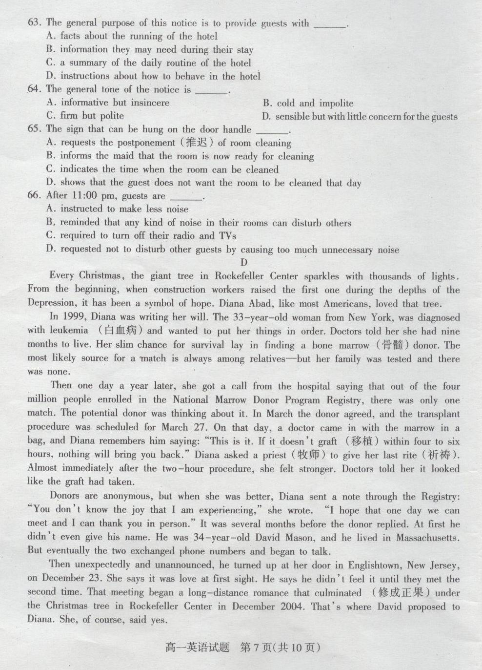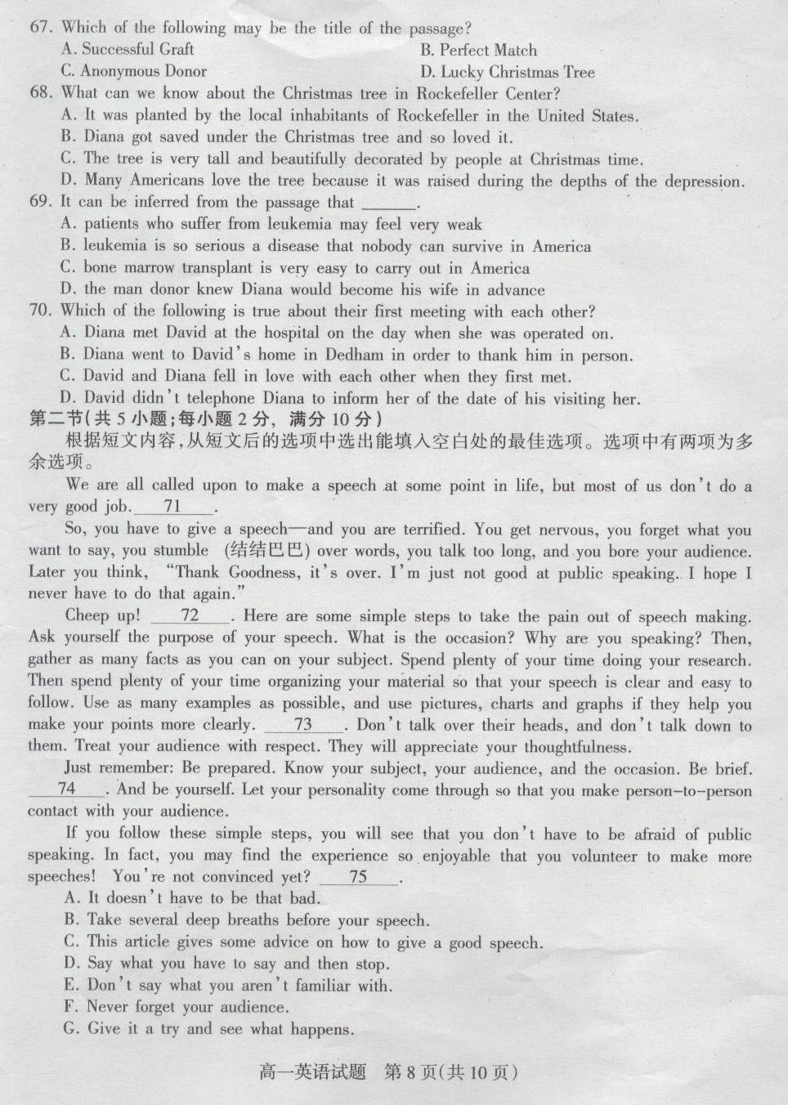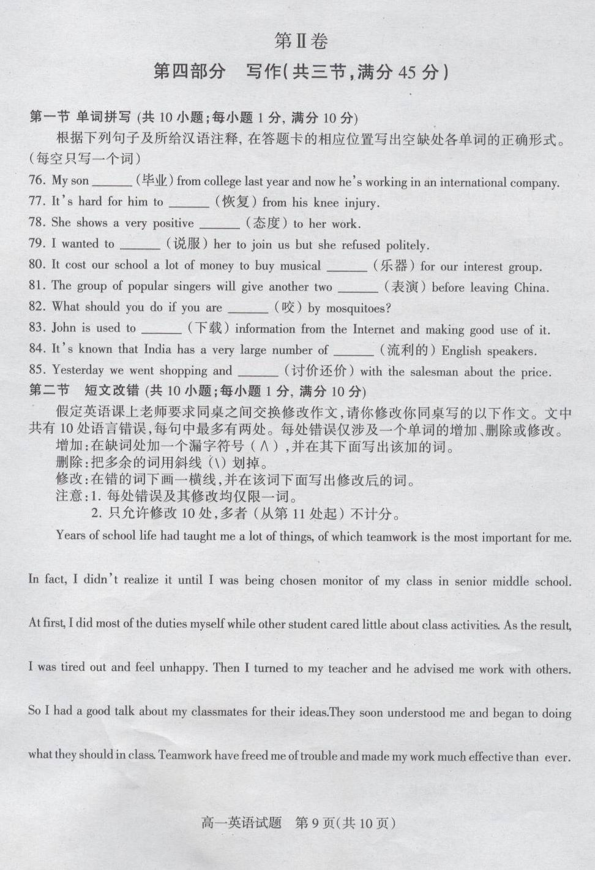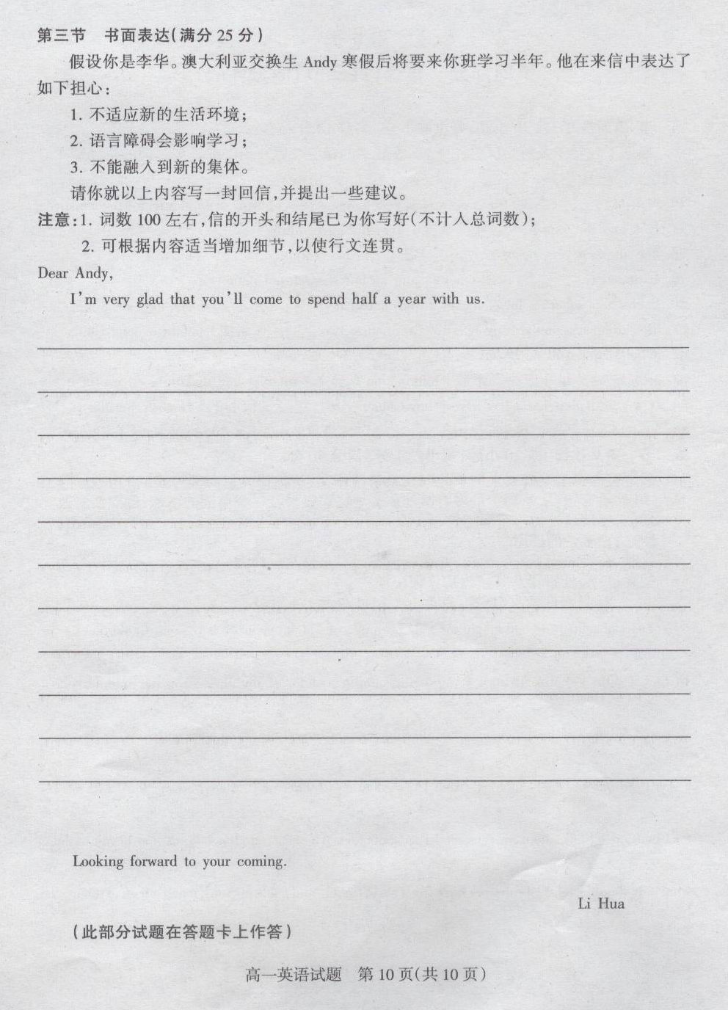
2013—2014学年度第一学期期末考试
高一英语 参考答案

听力 (20x1=20分)：1—5 BCABC 6—10 CAABA 11—15 BABAC 16—20 AACBA
单选 (15x1=15分)： 21—25 BABCD 26—30 ACDBC 31—35 DACBA
完形 (20x1.5=30分)：36—4 0 CBADC 41—45 ACDBD 46—50 BCABD 51—55 ACDBA
阅读 (20x2=40分)：56—58 BCD 59—62 CBAC 63—66 BCAD 67—70 BCAD 71—75 CAFDG
单词拼写 (10x1=10分)：76. graduated 77. recover 78. attitude 79. persuade 80. instruments
81. performances 82. bitten 83. downloading 84. fluent 85. bargained
改错(10x1=10分)：
Years of school life had taught me a lot of things, of which teamwork is the most important for me.
has
In fact, I didn’t realize it until I was being chosen monitor of my class in senior middle school.

At first, I did most of the duties myself while other student cared little about class activities. As the result,
students a
I was tired out and feel unhappy. Then I turned to my teacher and he advised me ∧work with others.
felt to
So I had a good talk about my classmates for their ideas．They soon understood me and began to doing
with do或去掉to
what they should in class. Teamwork have freed me of trouble and made my work much effective than ever.
has more

书面表达 (25分)：
One possible version:
Dear Andy,
I’m very glad that you’ll come to spend half a year with us.
Our school has arranged everything for all the exchange students. You’ll live in an apartment on the campus and western food is provided in one of the school dining halls. I believe you can get used to the life here pretty soon.
Chinese classes have been planned twice a week for students like you. Besides, some students in the class speak good English. Language will not be a barrier but a good opportunity for you to improve your learning as well as make new friends.
All the students and teachers here are very friendly. Join in classroom discussions, sports and after-class activities, and you are sure to fit in soon. (110 words)
Looking forward to your coming.
Li Hua
书面表达评分细则
1、本题总分为25分，按5个档次给分。
2、评分时，先根据文章的内容和语言初步确定其所属档次，然后以该档次的要求来衡量，确定或调整档次，最后给分。
3、词数少于100和多于120的，从总分中减去2分。
4、评分时，应注意的主要内容为：内容要点、应用词汇和语法结构的数量和准确性及上下文的连贯性，根据表达内容的层次适当分段及语言的得体性。
5、拼写与标点符号是语言准确性的一个方面。评分时，应视其对交际的影响程度予以考虑。英、美拼写及词汇用法均可接受。
6、如书写较差，以至影响交际，将分数降低一个档次。
各档次的给分范围和要求
0分：信息未能传达给读者。
第一档：（1—5分）：未完成试题规定的任务。
第二档：（6—10分）：能表达观点，但不够充分，很少句子可读，未恰当完成试题规定的任务。
第三档：（11—15分）：能表达观点，但欠充分，语言错误较多，基本完成了试题规定的任务。
第四档：（16—20分）：观点观确，陈述合理，有部分语言错误，较好地完成了试题规定的任务。
第五档：（21—25分）：观点观确，陈述合理，极少语言错误，很好地完成了试题规定的任务。

附: 听力材料
Text 1
W: Linda is very quiet, but her husband talks too much.
M: Yes, you are right and he isn’t friendly either.
Text 2
M: I’m really tired of this weather. Rain, rain, rain.
W: Don’t worry. The weather report says it will be sunny on Friday. Don’t forget to bring your umbrella today.
Text 3
M: They may be proud of their new equipment, but I’m disappointed. Their nurses are not friendly and everything seems to be running behind schedule.
W: Not to mention the fact that it’s noisy because no one observes visiting hours.
Text 4
W: Do you want to go fishing today?
M: It’s raining. Let’s stay at home.
W: What can we do at home?
M: Let’s just relax and read some good books.
Text 5
W: What’s in your bag? It’s so heavy.
M: Nothing. Just some books. I like to read on the plane.
W: That’s all? You must at least have some CDs in there.
M: No, I hate music. I just like to read.
Text 6
M: So, when do you usually do housework, shopping, things like that?
W: Hmm, on Mondays I usually clean the house in the morning. Early, from seven to eight.
M: How about the shopping?
W: I usually do that on Saturdays, before work.
M: You seem pretty busy with school, work and housework! Do you have time for anything else?
W: Yeah. Sure. I swim and play basketball in the mornings on Tuesdays and Thursdays, and I usually go out to see a movie with friends on Friday nights.
M: And how about Sundays?
W: I sleep all day.
Text 7
W: Hi. My name’s Alex.
M: Alex. Oh, you’re Jim’s friend.
W: Yeah. We worked in the same office ... until he moved to Hawaii. You look a lot like Jim. Are you related?
M: Yeah, we’re cousins. His mum and my mum are sisters.
W: Do you live here? Around here?
M: No, I live in San Francisco. I just came for the wedding.
W: San Francisco? Me, too. I just came for the wedding, too.
M: Oh. Great. What do you do in San Francisco?
W: I’m an art director in a fashion magazine. How about you?
M: Well, I’m sort of an artist, too. I make films.
Text 8
M: Excuse me, madam, have you got a moment? I’m doing a survey on TV watching habits. Could I ask you a few questions?
W: Certainly. Go ahead.
M: Well, I need some basic information about you. First of all, what is your name?
W: Anne.
M: Are you a Canadian citizen?
W: Actually, I am American. I have been living here in Canada for more than 15 years. But I was born in the US.
M: What is your first language? ... Or the language you wish to use in the survey?
W: You may ask the questions in either language. I am good at French, but my mother language is English.
M: What is your job?
W: I am a doctor working for the General Hospital. I also consider myself a medical science researcher. I teach medicine in a school, too. That is why I am very busy.
Text 9
M: Excuse me, madam?
W: Yes, sir. How can I help you?
M: I’m a guest in Room 514. I have some free time this afternoon, so I want to go to see a park, a landmark, something like that. What would you suggest?
W: Uh ... Wrigley Field on a sunny day like today is nice.
M: Wrigley Field? Don’t the clubs play baseball there?
W: That’s right. In fact, they have a game there at 4:00. If you want to see a building with history, I think Wrigley Field is the Chicago landmark for you to see.
M: Great. How do I get there?
W: Go north one block and take the subway. Nothing gets you in or out of Wrigley faster than it.
M: Well, the game starts in one hour, so I’d better go now. Thanks for your help.
W: Have a good time!
Text 10
W: My daily routine ... Well, I get up at about ten o’clock, and I usually have breakfast in the garden if it’s a nice day. I love sitting in the garden reading the newspaper. I have lunch at about two, and then practise my violin in the afternoon. Concerts in Liverpool usually start at eight, so I go to work at half past six and get the train to the city centre. After the concert ... er ... well, I finish work at about half past ten, then have dinner in a restaurant with some friends from the orchestra. I usually take a taxi from the restaurant, and get home at about half past twelve. Then I watch TV or read a book, and go to bed at about two o’clock in the morning. And, that’s my day.

