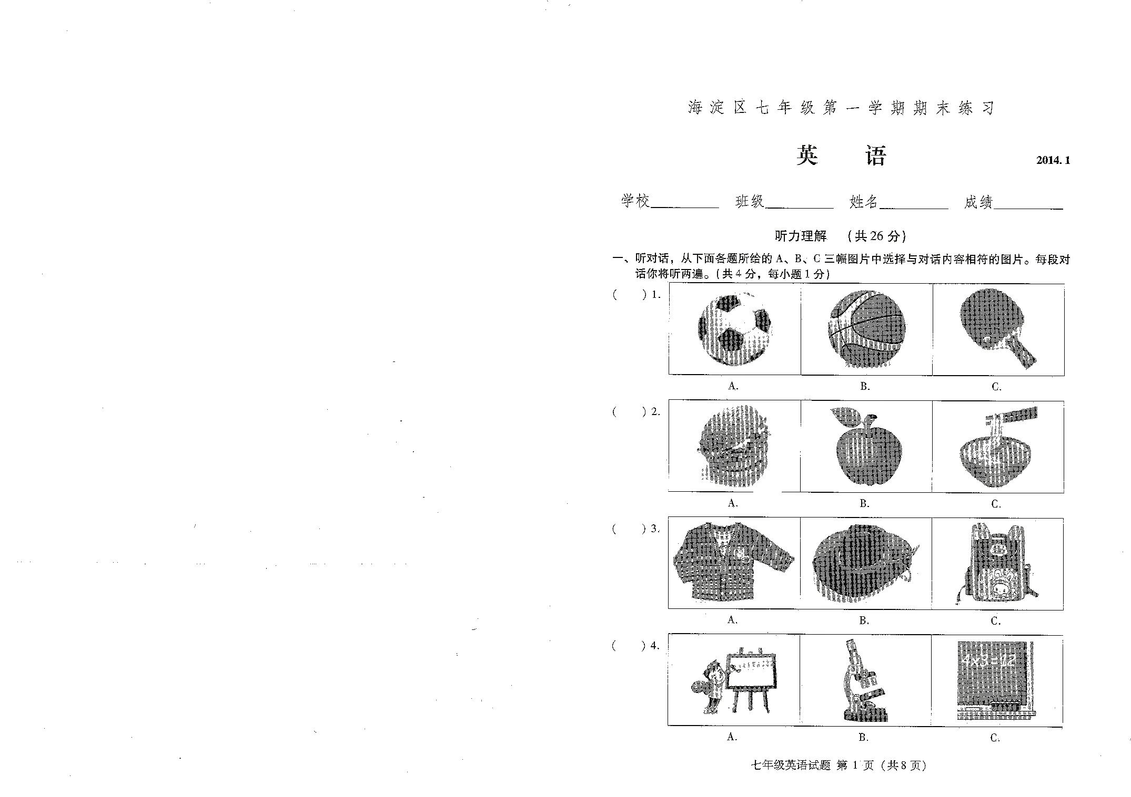
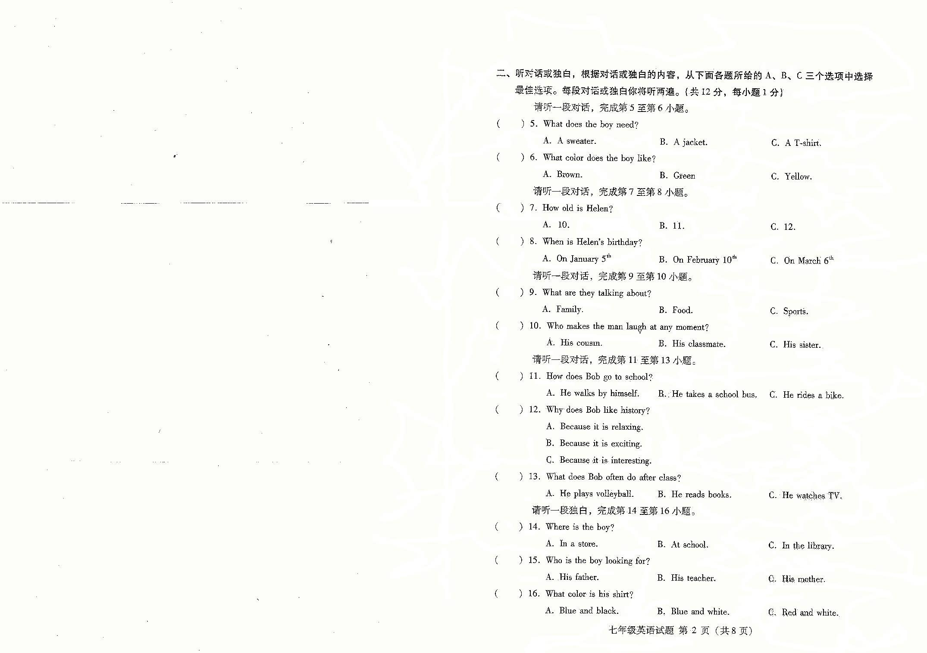
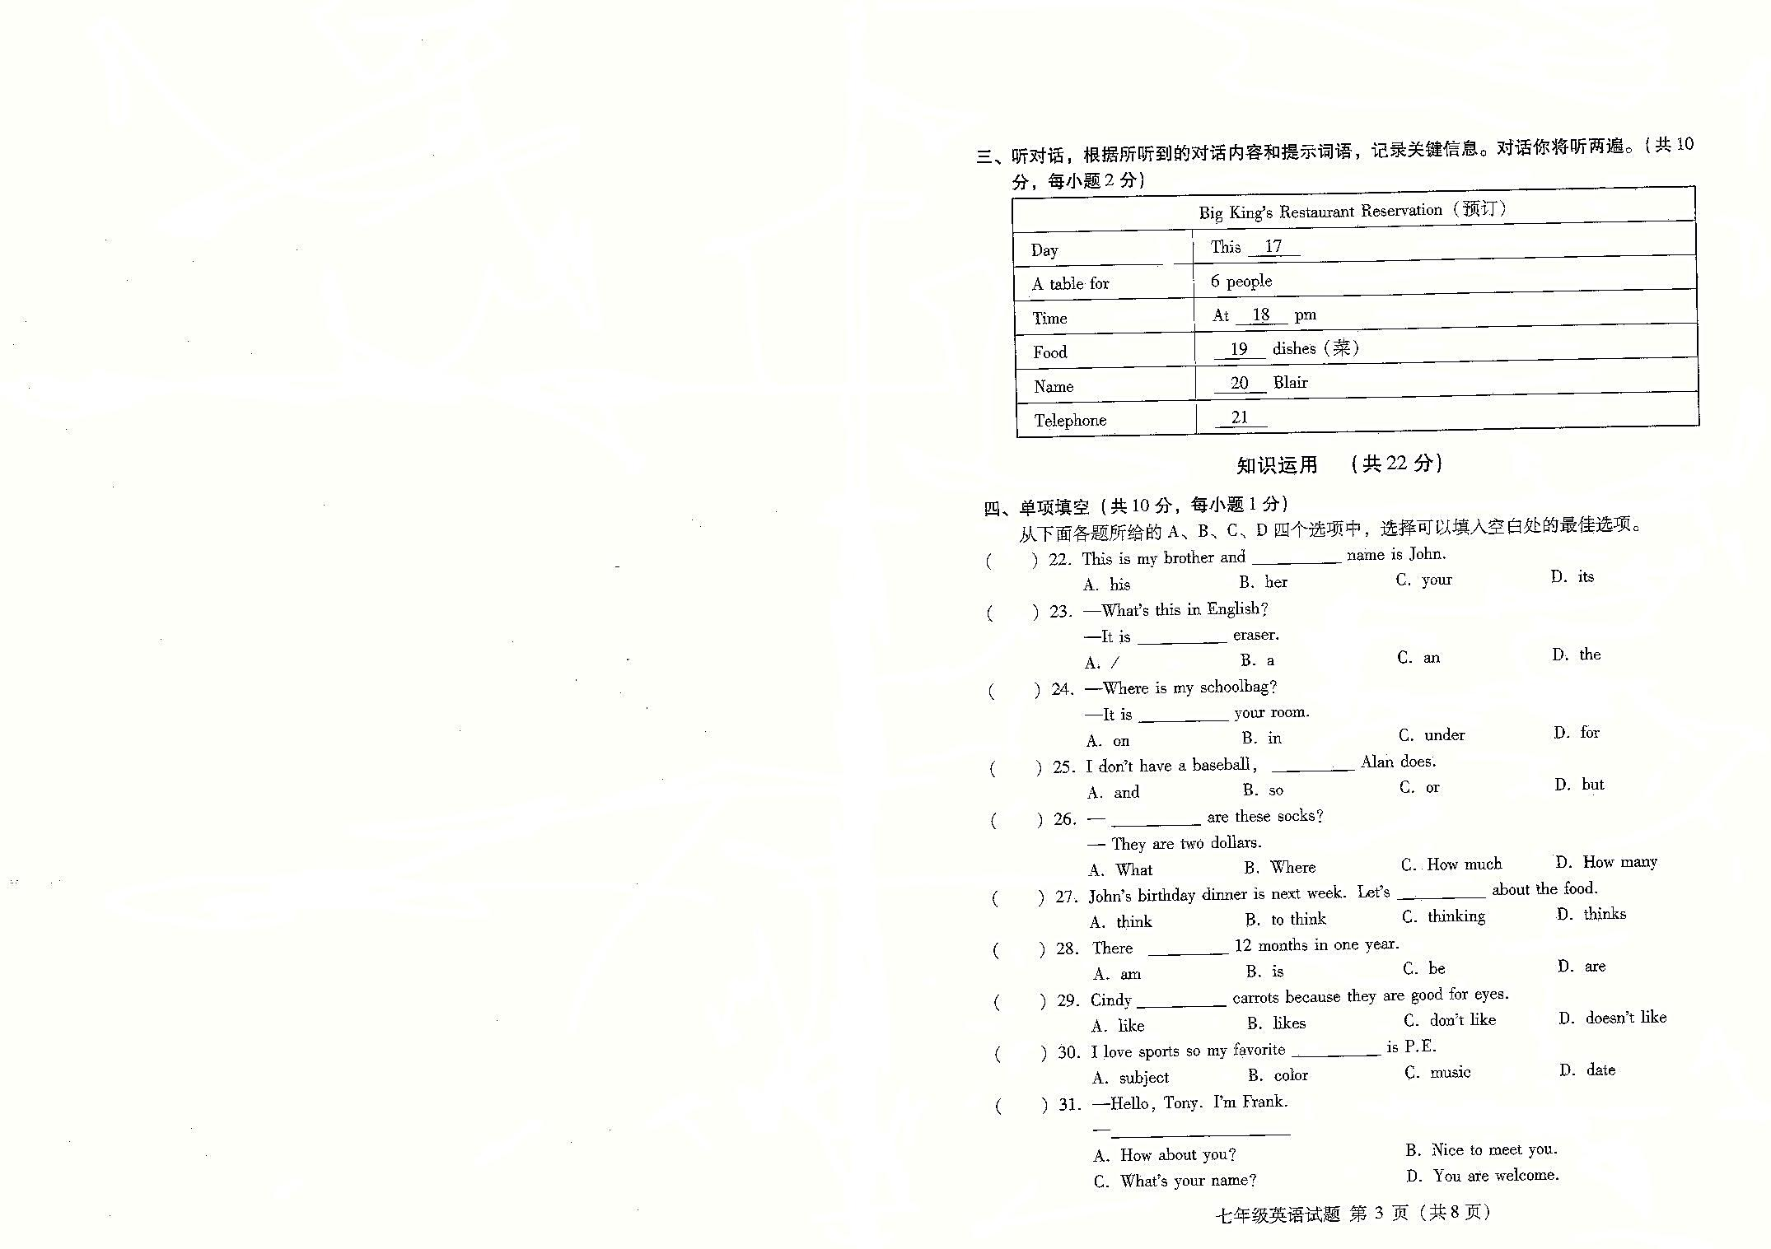
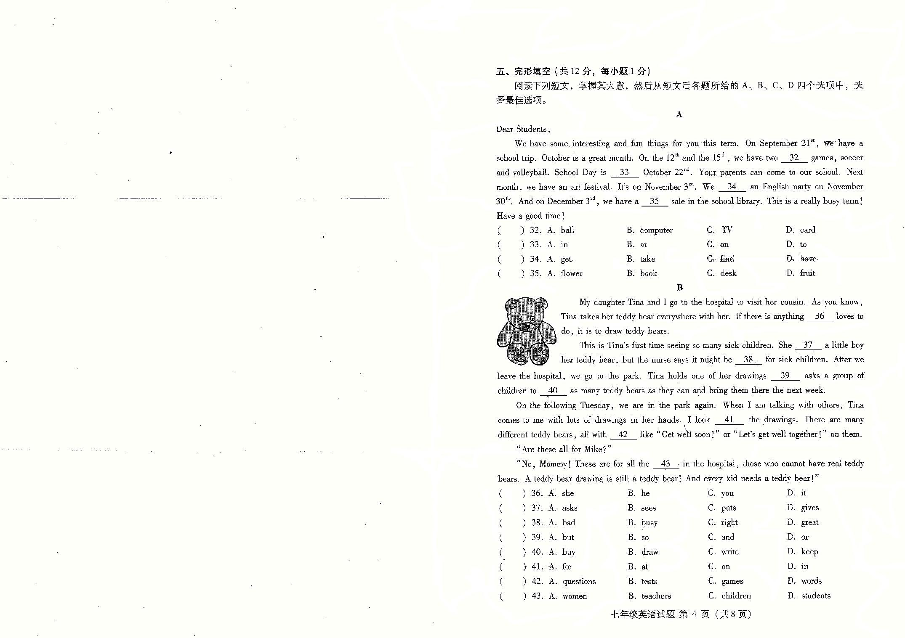
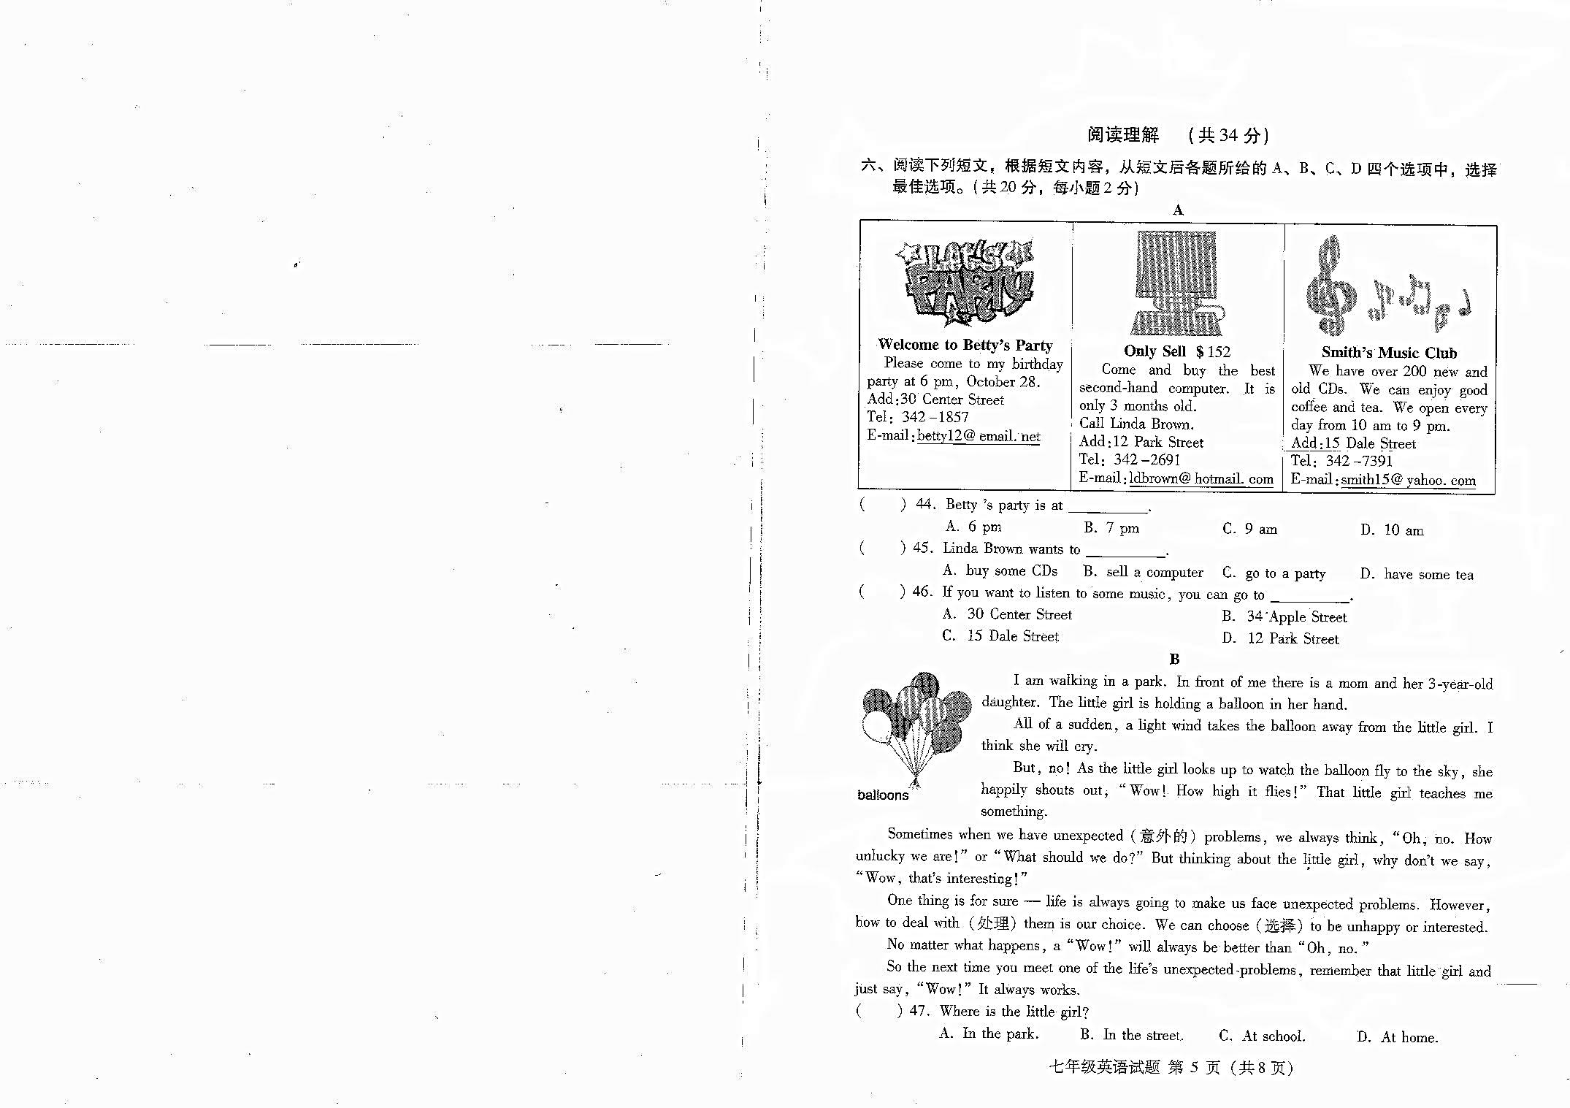
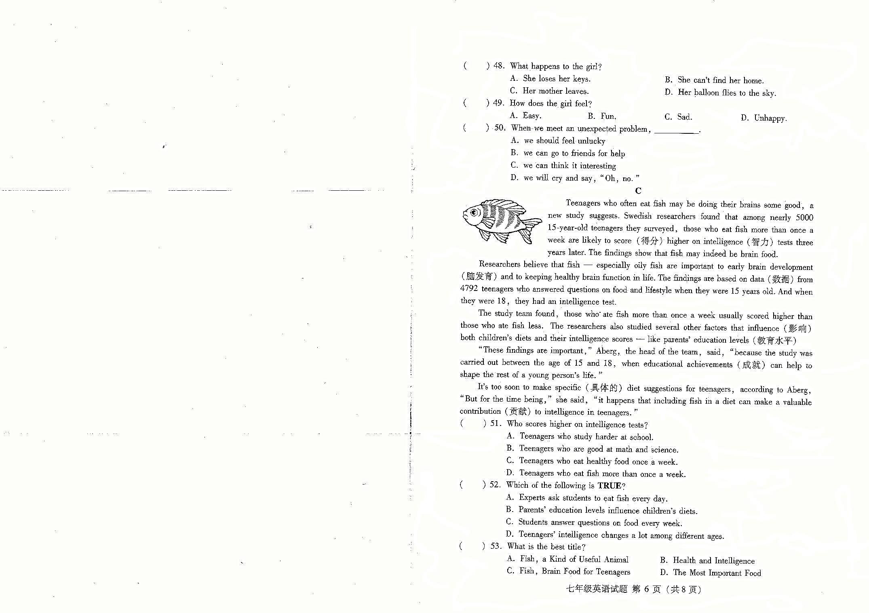
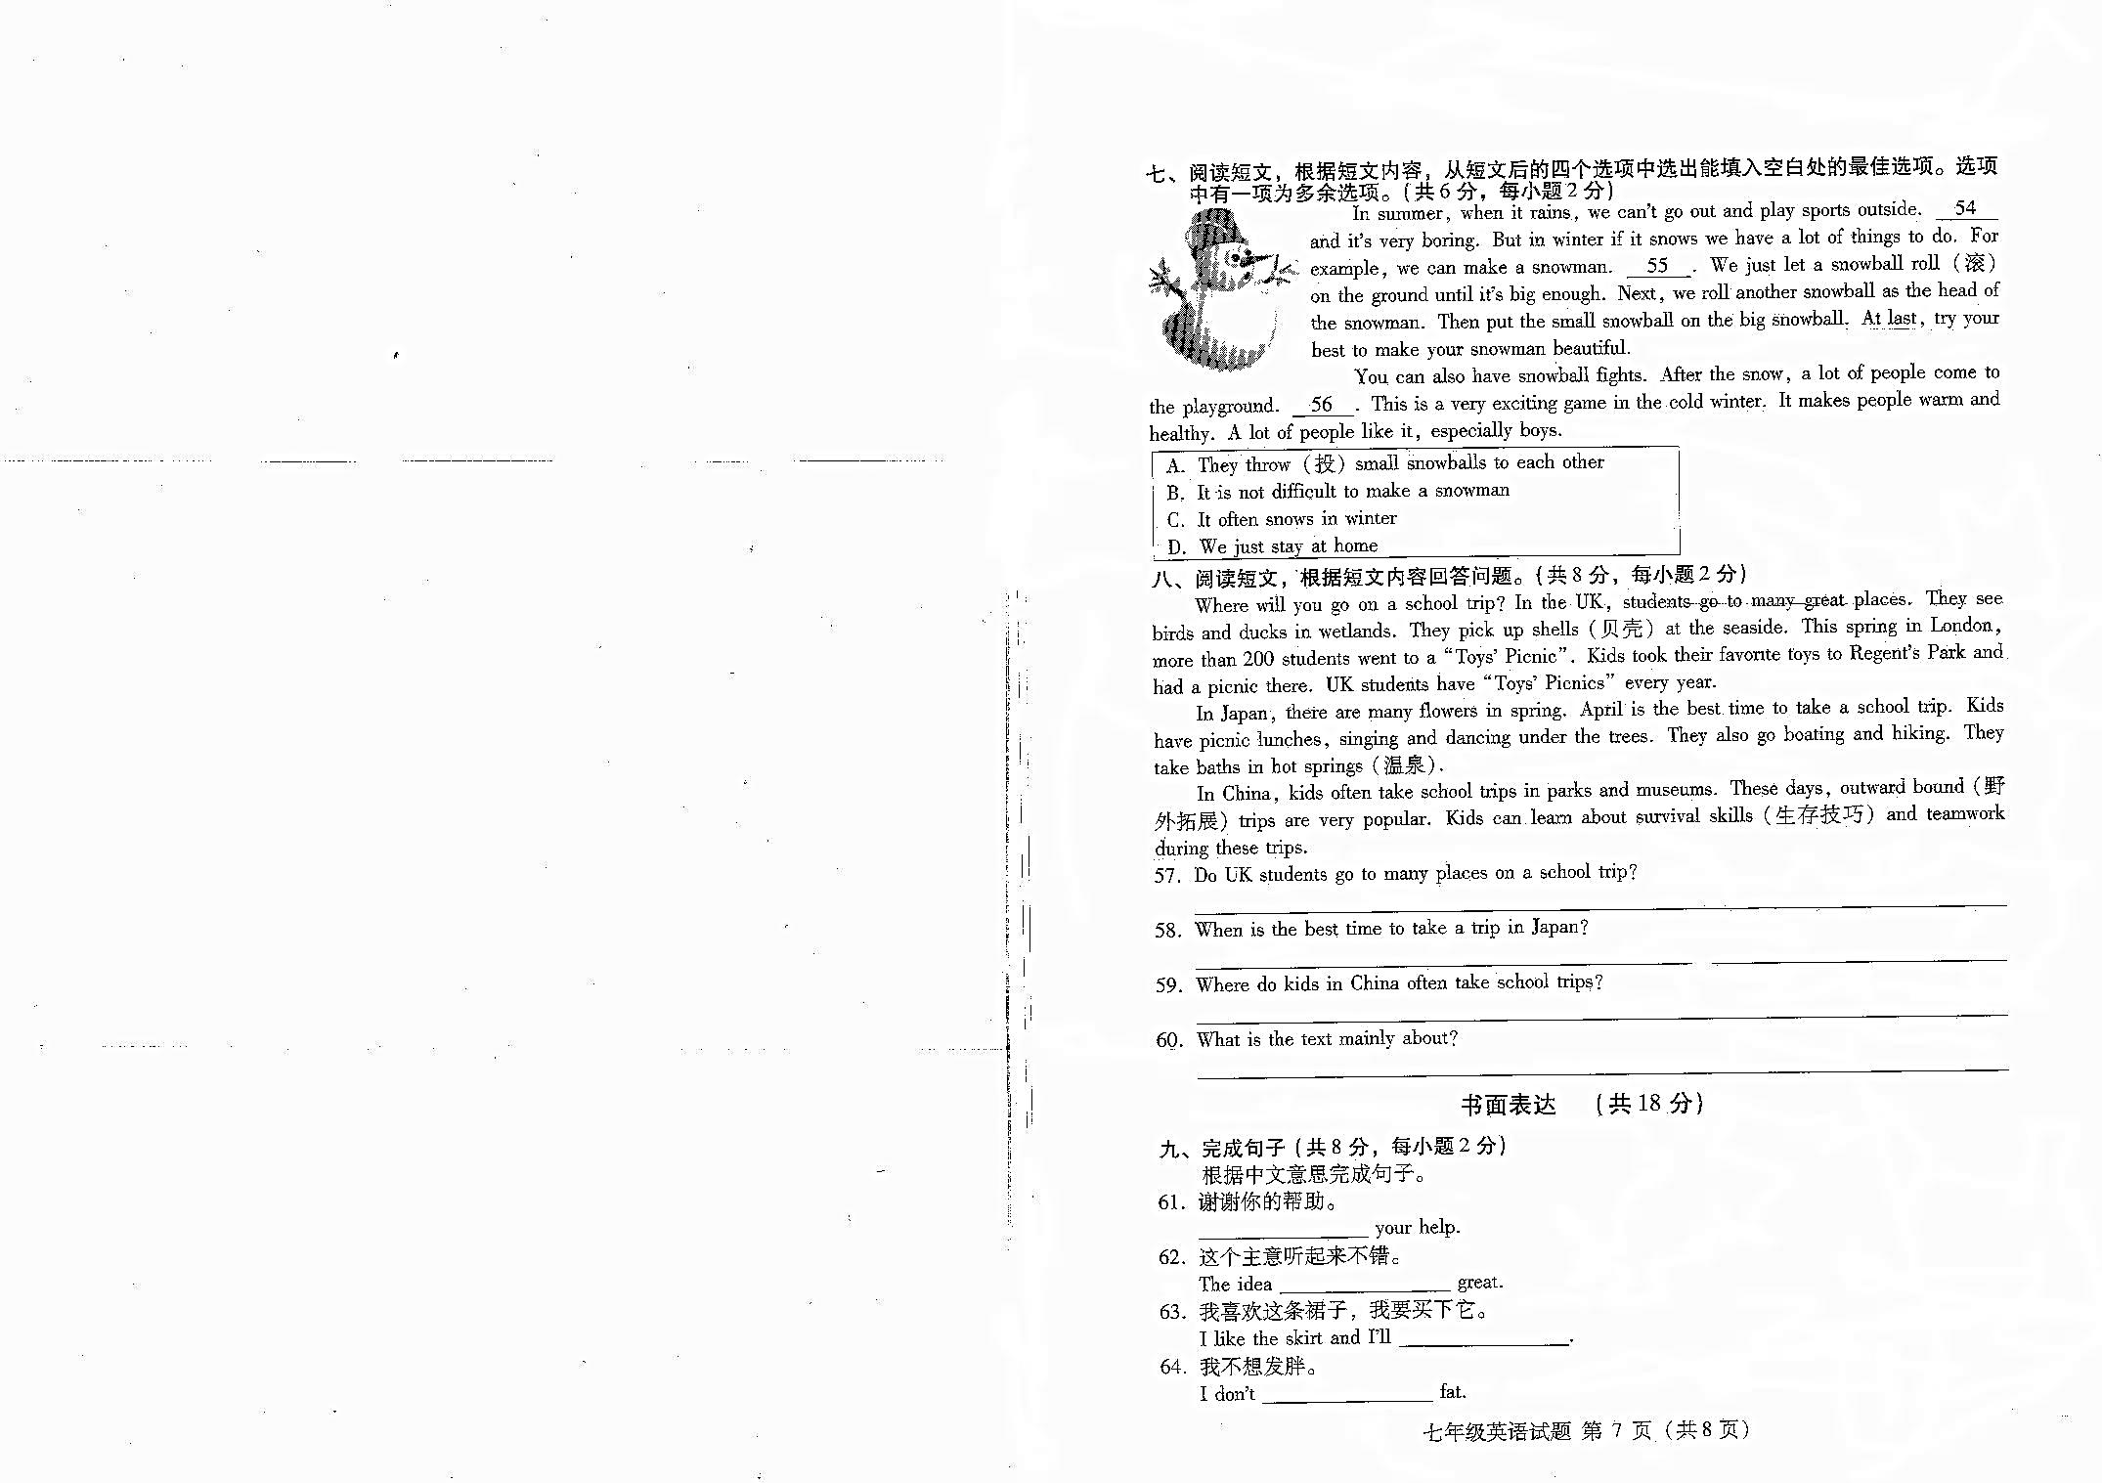
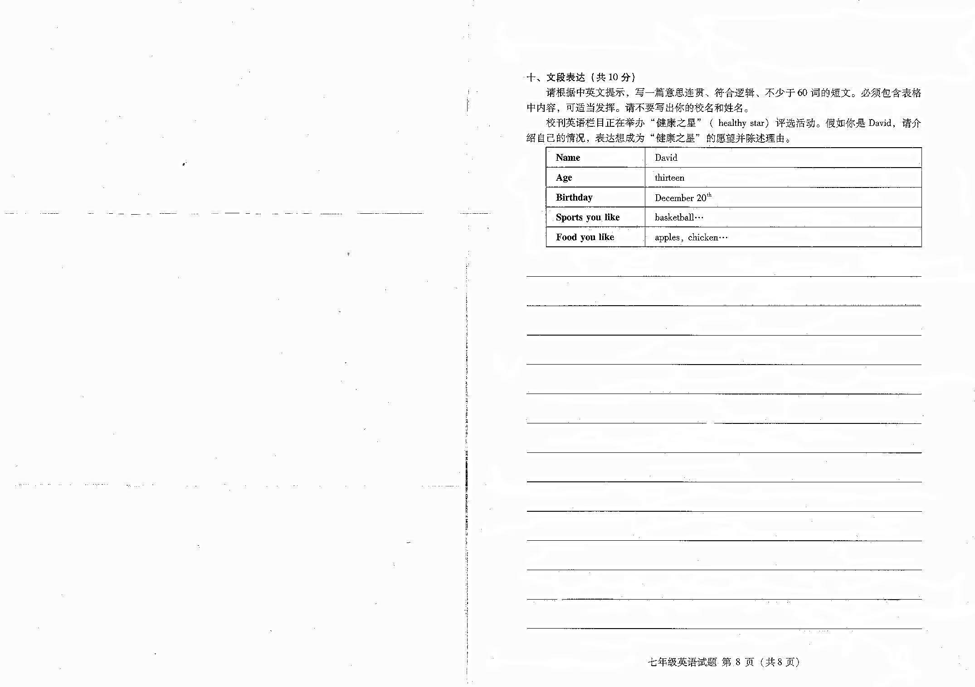

海淀区七年级第一学期期末练习
英 语
参考答案及听力录音材料
2014. 1

听力理解（共26分）
一、听对话，选择图片。（共4分, 每小题1分）
1. B 2. A 3. B 4. C
二、听对话或独白，选择最佳选项。（共12分, 每小题1分）
5.A 6.B 7.C 8. C 9. A 10. C 11.B 12. C 13.A 14. A 15. C 16.B
三、听对话，记录关键信息。（共10分，每小题2分）
17. Friday 18. 8 /eight 19. Chinese 20. Kate 21. 51370318
知识运用（共22分）
四、单项选择（共10分，每小题1分）
22. A 23. C 24. B 25. D 26. C 27. A 28.D 29. B 30 A 31. B
五、完形填空 （共12分，每小题1分）
32. A 33. C 34. D 35. B 36. A 37. D 38. A 39. C 40. B 41. B
42. D 43. C
阅读理解（共34分）
六、阅读理解 （共20分，每小题2分）
44.A 45.B 46. C 47. A 48. D 49. B 50. C 51. D 52. B 53. C
七、阅读短文，还原句子。 （共6分, 每小题2分）
54.D 55.B 56. A
八、阅读短文，回答问题。（共8分，每小题2分）
57.Yes, they do. (Yes.)
58. April.
59. In parks and museums.
60. School trips in different countries.
书面表达（共18分）
九、完成句子 （共8分，每小题2分）
61. Thanks for / Thank you for 62. sounds 63. take / get/ buy it 64. want to be
十、文段表达 （共10分）
A possible version:
I want to be a healthy star in our school. Let me tell you about myself. My name is David. I’m thirteen. My birthday is on December 20th. As a strong boy, I like outdoor activities — playing soccer and basketball. And I like healthy food，especially fruit, such as apples, bananas and oranges. As for vegetables, I like carrots and tomatoes. I also like chicken and milk. I am sure I’ll be the perfect one to be the star. Thank you!
附1：书面表达评分标准：
请先根据文章整体内容和语言表达确定档次，然后根据语言质量在该档次内评出分数。
第一档：（10~8分）
 完全符合题目要求，观点正确，要点齐全。句式多样，词汇丰富。语言准确，语意连贯，表达清楚，具有逻辑性。
第二档：（8~6分）
 基本符合题目要求，观点正确，要点齐全。语法结构和词汇基本满足文章需要。语言基本通顺，语意基本连贯，表达基本清楚。虽然有少量语言错误，但不影响整体理解。
第三档：（6~3分）
 部分内容符合题目要求，要点不齐全。语法结构和词汇错误较多，语言不通顺，表达不够清楚，影响整体理解。
第四档：（3~0分）
 与题目有关内容不多，只是简单拼凑提示词语，所写内容难以理解。
附 2：听力理解材料
一、听对话，从下面各题所给的A、B、C三幅图片中选择与对话内容相符的图片。每段对话你将听两遍。
- W: Do you have a basketball?
M: Yes, I do.
2. W: What do you like for lunch?
M: Hamburgers.
3. M: Excuse me, is this your hat?
W: Oh, yes! Thank you.
4. M: What’s your favorite subject?
W: My favorite subject is math.
二、听对话或独白，根据对话或独白的内容，从下面各题所给的A、B、C三个选项中选择最佳选项。每段对话或独白你将听两遍。
请听一段对话，完成第5至第6小题。
W: Can I help you?
M: Yes, please. I need a sweater for school.
W: What color do you want?
M: Green.
W: How about this one?
M: It looks nice.
请听一段对话，完成第7至第8小题。
W: Do you want to come to my birthday party?
M: Oh yes! How old are you, Helen?
W: I am 12.
M: And when is your birthday?
W: My birthday is on March 6th .
请听一段对话，完成第9至第10小题。
M: Look, this is my family. Let me start with my mother. My mother is very kind and she cooks healthy food for us.
W: What about your father?
M: My father is really a good man and he often plays tennis with me.
W: You have a sister. Is she younger or older?
M: Younger. My sister is funny and she is the only person who can make me laugh at any moment.
W: Well, it sounds like you have a nice family.
请听一段对话，完成第11至第13小题。
W: Hello. Today I'm talking to Bob about his school life. Now Bob, what time do you go to school?
M: Eight o’clock.
W: Eight o’clock. And do you walk by yourself, or take a school bus?
M: I take a school bus.
W: And what do you study at school?
M: We study English, math, history, geography. And, let me see . . . , we also have art, P.E. and music.
W: What’s your favorite subject?
M: Well, I like history because it’s interesting.
W: What do you do after class?
M: I am on the volleyball team and we play volleyball three times a week.
W: That’s great.
请听一段独白，完成第14至第16小题。
Hello, shoppers. We have a lost boy. His name is Mike and he was found in our store. He is looking for his mom. He is five years old and he is not tall. He’s wearing a blue and white shirt, white trousers and a pair of black shoes. You can find him at the check-out counter at the main gate and you can call us at 685-6034. Thank you.
三、听对话，根据所听到的对话内容和提示词语，记录关键信息。对话你将听两遍。
M: Hello. This is Big King’s Restaurant.
W: Oh, hello. Do you have a table for six this Friday?
M: At what time?
W: How about eight?
M: OK, a table for six at eight in the evening.
W: That will be fine. I just want to check something else. I have a friend from China. Have you got any Chinese food?
M: No problem, ma’am. We have Chinese dishes on the menu.
W: That’s great.
M: May I have your name, please?
W: Kate Blair. K-A-T-E, Kate; B-L-A-I-R, Blair.
M: OK. Could you leave us your telephone number, please?
W: Yes. 5-1-3-7-0-3-1-8.
M: 5-1-3-7-0-3-1-8. Fine. Thanks.

