本试卷共14页，共150分。考试时长120分钟。考生务必将答案答在答题卡上，在试卷上作答无效。考试结束后，将本试卷和答题卡一并交回。

第一部分：听力理解（共三节，30分）
第一节（共5小题；每小题1.5分，共7.5分）
听下面5段对话或独白。每段对话或独白后有一道小题，从每题所给的A、B、C三个选项中选出最佳选项。听完每段对话或独白后，你将有10秒钟的时间来回答有关小题和阅读下一小题。每段对话或独白你将听一遍。
例：What is the man going to read?
A．A newspaper.
B．A magazine.
C．A book.
答案是A。
1. What sport does the man like?
A. Swimming. B. Tennis. C. Skating.
2. Where are the speakers?
A. In a supermarket. B. In a post office. C. At a ticket office.
3. What is the man going to do?
A. To take a flight. B. To see a friend off. C. To make a telephone call.
4. Why is the announcement made?
A. To advertise the “Crocodile” brand.
B. To find the owner of a wallet.
C. To welcome people to Java Mall.
5. What does the woman suggest?
A. They come to work earlier.
B. They get more work done.
C. They share one car to work.
第二节（共10小题；每小题1.5分，共15分）
听下面4段对话或独白。每段对话或独白后有几道小题，从每题所给的A、B、C三个选项中选出最佳选项。听每段对话或独白前，你将有5秒钟的时间阅读每小题。听完后，每小题将给出5秒钟的作答时间。每段对话或独白你将听两遍。
听第6段材料，回答第6至7题。
6. What did the man do last night?
A. He went to see a doctor.
B. He sent his father to hospital.
C. He looked after his mother.
7. How long did the man stay in the hospital?
A. 3 hours. B. 5 hours. C. 7 hours.
听第7段材料，回答第8至9题。
8. Why can’t the woman go to the culture festival?
A. She’s going to do some cleaning.
B. She’s going to do homework.
C. She’s going to work.
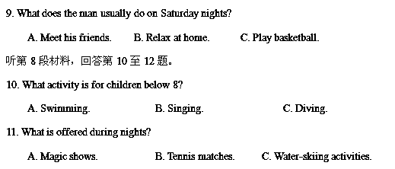
12. Who is the speech intended for?
A. Travellers. B. Teachers. C. Coaches.
听第9段材料，回答第13至15题。
13. What is the woman?
A. A writer. B. A TV hostess. C. A waitress.
14. What is the man talking about?
A. A programme. B. A restaurant. C. A club.
15. How does the woman feel about the man’s words?
A. Relaxed. B. Amazed. C. Worried.
第三节（共5小题；每小题1.5分，共7.5分）
听下面一段对话，完成第16至20五道小题，每小题仅填写一个词。听对话前，你将有20秒钟的时间阅读试题，听完后你将有60秒钟的作答时间。这段对话你将听两遍。

Note about Mill House Farm
The owner: Mrs Jane 16
Price: ￡4 a night per student
Other information:
• All the equipment is very 17 .
• Big clean areas
• No 18 or hot water
• Students need to bring 19 bags.
• Students need to do their own 20 .

第二部分：知识运用（共两节，45分）
第一节 单项填空（共15小题；每小题1分，共15分）
从每题所给的A、B、C、D四个选项中，选出可以填入空白处的最佳选项，并在答题卡上将该项涂黑。
例：It’s so nice to hear from her again. _____, we last met more than thirty years ago.
A．What’s more B．That’s to say
C．In other words D．Believe it or not
答案是D。
21. Everyone tells me I’m a good speaker, _____ I really don’t like speaking in public.
A. and B. so C. but D. or
【答案】C
【解析】
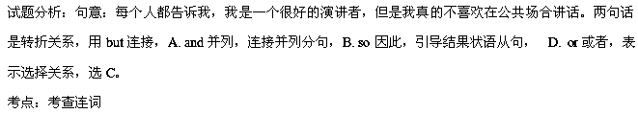22. Try not to wake up the baby if you _____ into the bedroom.
A. go B. went C. have gone D. will go
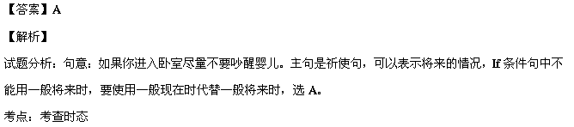23. John seemed puzzled about _____ the question meant.
A. how B. why C. what D. which
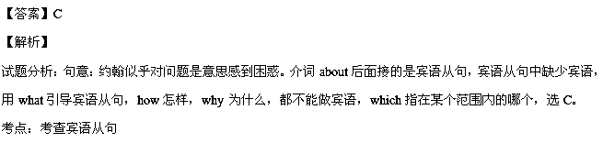24. — Do you like the school?
— Yeah. I only wish the classes _____ a little smaller.
A. be B. were C. had been D. should have been
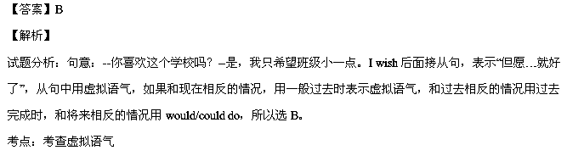25. According to the factory safety rules, all accidents _____ be reported to the safety
officer.
A. may B. can C. would D. must
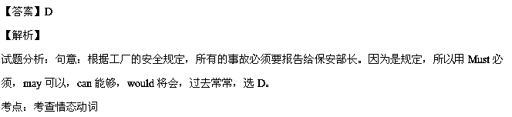26. We can’t go ahead with the plan because very few people _____ any interest so far.
A. had shown B. show C. will show D. have shown
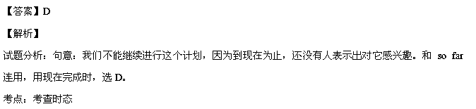27. We climbed higher _____ we might see the scenes better.
A. so that B. even though C. in case D. as if
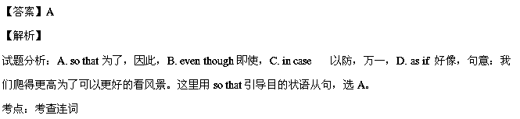28. Most of my friends shop at the stores _____ the goods are very cheap.
A. which B. where C. whose D. why
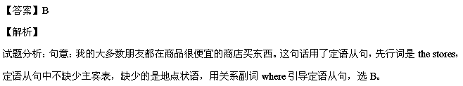考点：考查定语从句
29. At first I regretted _____ them to stay, but we soon became great friends.
A. to invite B. invited C. to have invited D. inviting
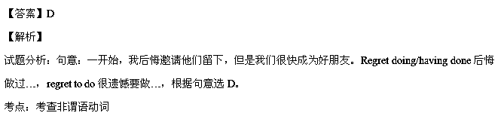30. The visiting professor was interested in the teaching methods _____ in the classroom.
A. use B. to use C. using D. used
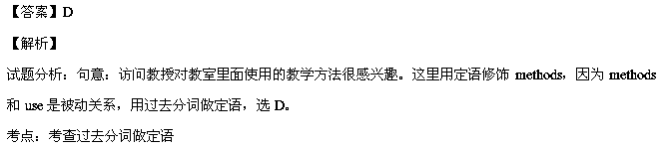31. Mr. Carter will be the main speaker ______ the graduation ceremony.
A. at B. to C. among D. about
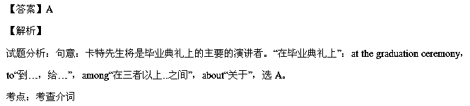32. The painting ______ to someone who later donated it to the college.
A. had sold B. was sold C. will sell D. is sold
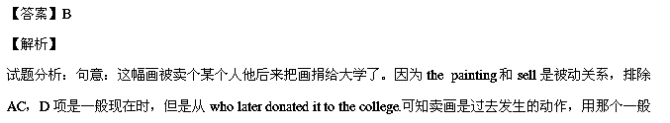过去式的被动语态，选B。
考点：考查时态语态
33. — Joe, don’t forget to bring your laptop with you tomorrow, OK?
— Oh, thank you. I wouldn’t bring it if you _____ me.
A. wouldn’t remind B. haven’t reminded
C. hadn’t reminded D. shouldn’t have reminded
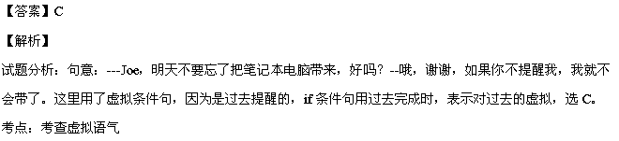34. _____ more effectively with others, more and more people equip themselves with a
higher education.
A. Compete B. Being competed C. To compete D. Competing
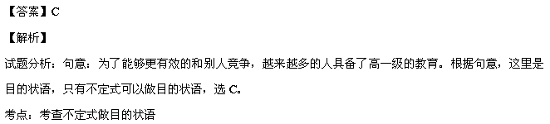35. Health experts believe that even a little exercise is far better than _____at all.
A. none B. little C. everything D. anything
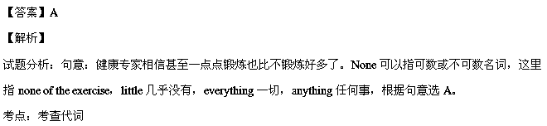第二节 完形填空（共20小题；每小题1.5分，共30分）
阅读下面短文，掌握其大意，从每题所给的A、B、C、D四个选项中，选出最佳选项，并在答题卡上将该项涂黑。

My father and I disagreed about curfew (晚间在家的时间). He’d say I was to be in by 9:30 on weekdays, and 11:00 on weekends, no exceptions without my first asking. I told him it made me 36 like a junior-high kid. He explained that while a curfew
37 sound like a restriction, it’s really about people looking out for one another.
The very next Friday after that pretty heated 38 , my dad and I had tickets to see our town’s professional football game. On that day he was 39 to a nearby city to meet with some major clients and 40 me that his getting home and our leaving for the game would be tight.
To make sure we could 41 off the moment he walked in, I got everything prepared. When a half hour had passed from the time he said he’d be home, I
understood that he was a little 42 . But then, nearly a whole hour passed. I was getting 43 . We were going to miss the kick-off! And why hadn’t he 44 me and let me know he was going to be really late? As I anxiously 45 the floor, another half hour passed. That’s when I got really angry. How inconsiderate of my father! Now we were going to 46 the whole game! When yet another half hour passed, my anger turned to 47 . What if something terrible had happened to my dad, like he had a heart attack or had been in an accident, or something? I began to really 48 . I’d already called his cellphone about ten times, but no 49 .
I was beside myself, assuming the worst had happened.
Finally, the phone rang, and my dad said 50 , “Son, I’m so sorry about the game, but…there was a terrible accident…on the freeway coming home, and I 51 to help… and ended up going to the hospital. I 52 my cellphone in the car, so I couldn’t call until now.”
I was so relieved to hear from my father and to 53 that he was safe that I actually cried. That was 54 I “got” the importance of a curfew: Checking in! It’s about knowing that someone you love is 55 . It was one more proof of my father’s loving me as much as he does.
【小题1】A. go B. feel C. turn D. grow
【小题2】A. might B. must C. needed D. should
【小题3】A. speech B. match C. description D. exchange
【小题4】 A. cycling B. driving C. flying D. walking
【小题5】A. allowed B. advised C. informed D. ordered
【小题6】A. pay B. hold C. cut D. move
【小题7】A. late B. lazy C. forgetful D. careless
【小题8】A. upset B. sorry C. rude D. puzzled
【小题9】A. warned B. signalled C. phoned D. showed
【小题10】A. hit B. paced C. cleared D. measured
【小题11】A. play B. watch C. miss D. start
【小题12】A. sadness B. surprise C. doubt D. fear
【小题13】 A. envy B. worry C. regret D. cry
【小题14】A. excuse B. way C. time D. answer
【小题15】A. strangely B. casually C. breathlessly D. angrily
【小题16】A. stopped B. forgot C. failed D. refused
【小题17】A. left B. lost C. saw D. got
【小题18】A. wonder B. guess C. expect D. learn
【小题19】A. what B. when C. whether D. why
【小题20】A. confident B. great C. safe D. honest
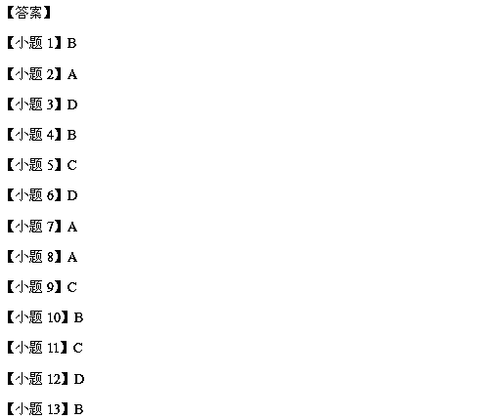
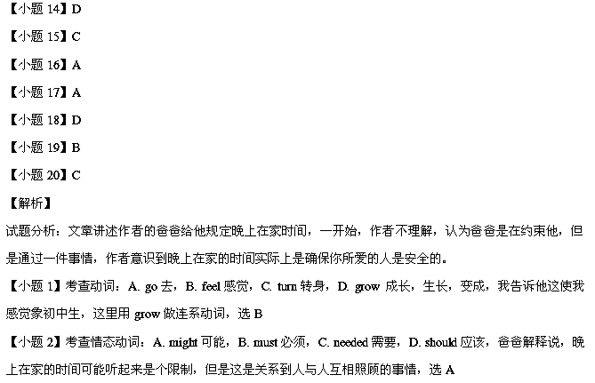【小题3】考查名词：A. speech演讲，B. match比赛，C. description描述，D. exchange交换，上文是作者和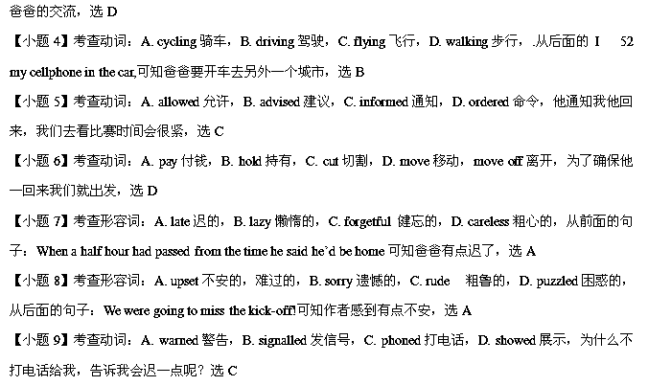angrily生气地，从后面爸爸的话“Son, I’m so sorry about the game, but…there was a terrible accident…on the 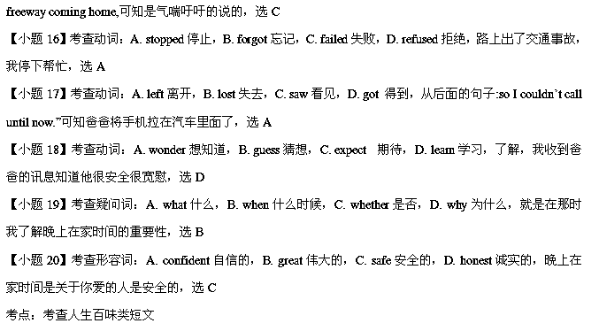第三部分：阅读理解（共两节，40分）
第一节（共15小题；每小题2分，共30分）
阅读下列短文，从每题所给的A、B、C、D四个选项中，选出最佳选项，并在答题卡上将该项涂黑。
A
“Thanks for coming,” Everett said, shaking hands with Mr. Hanson, the town councillor(议员).
“I’m curious about the ideas in your letter.” Mr. Hanson nodded toward the parking lot near where they stood. “Please tell me more.”
Everett took a deep breath. “Ever since the school closed two years ago, this area has become worse. But if we clean up the litter and repair the fence, it will be a great place for a skateboard park.” Mr. Hanson scanned the broken concrete, nodding. “The old school is being adapted to a community arts centre. This area could become a vital part of the neighbourhood again.”
“Here’s a picture of a skateboard park in another town. Look how busy it is.” Everett was relieved that the community representative seemed receptive to the idea. Mr. Hanson studied the photograph, and then asked, “If town council provides the money, how will you and your friends contribute?” Everett felt optimistic now. “We’ll help design and build the ramps(坡道). More experienced boarders could give lessons to raise money!” Everett’s voice was enthusiastic.
However, Mr. Hanson said, “We’ll still need parking spaces, and the neighbours will not like late-night noise. They might worry about the crime of deliberately damaging public property and….”
“The skateboard park would use only the back corner, which isn’t near any houses. Since young people already hang out here, why not give them something fun and physically active to do in their free time?” The lines over Mr. Hanson’s forehead unwrinkled(舒展), and Everett’s hopes rose again. “If everyone works together,” Everett thought, “maybe this idea will become reality.”
【小题1】Where were Everett and Mr. Hanson talking?
A. In the city hall. B. Outside a park.
C. Near the parking lot. D. In the art centre.
【小题2】Everett was trying to persuade Mr. Hanson to _____.
A. beautify the neighbourhood
B. cut the area of the parking lot
C. build an art centre for children
D. provide money for a skateboard park
【小题3】 How did Mr. Hanson finally feel about Everett’s suggestion?
A. Curious. B. Hopeful. C. Enthusiastic. D. Receptive.
【答案】
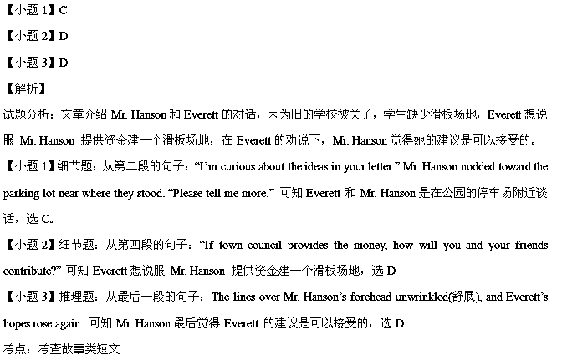B
1234 PENS is your No. 1 source for promotional pens, advertising pens, and logo pens. We have been in business since 1976, so you can be confident that you’re dealing with a trusted name in the industry.
Everyone loves a free pen, and by providing your customers with a pen featuring your company name, logo, or message, you can be sure that your company name will always be on their mind! Our custom imprinting service comes at no extra charge, so the price you see is the price you pay for the personalized pens.

★ Do you need pens fast? In a RUSH for trade shows or a corporate events? Try our 48 hour promotional pens rush service free of charge. We present you with many styles and types of printed pen. Let us know which promotional pen you like and within 48 hours you will have the pens.
★ Want to use the traditional method of promotional pens to reach out to customers, but don’t want to cause more damage to the environment? 1234 PENS now offers eco-friendly advertising pens to suit any company’s promotional needs. 1234 PENS can confidently offer products which are made from eco-friendly materials, including paper, cardboard, cornstarch, pine, bamboo and even recycled plastic water bottles. 1234 PENS offers a selection of eco-friendly retractable and stick-type ballpoint pens, mechanical pencils and highlighters, all for less than $2.00 each. Imprinting of logos and corporate information is available in sixteen different colors. Each pen has the universal recycling symbol printed on it, showing clients the company’s commitment to the environment.
Feel free to call us at 8447367 or email us info@1234PENS.com if you have any questions.

【小题1】What do we know about 1234 PENS?
A. It has a history of over 30 years.
B. It has built up a large pen market.
C. It has its name printed on each pen.
D. It charges a low price for extra service.
【小题2】What is mainly discussed in Paragraph 3?
A. The different types of the products. B. The high quality of the products.
C. The quick service of 1234 PENS. D. The trade shows of 1234 PENS.
【小题3】What is special about the pens produced in 1234 PENS?
A. They are designed in 16 styles.
B. They come in 48 different colours.
C. Their material is less harmful to the earth.
D. Their price is much lower in the pen market.
【小题4】The main purpose of the passage is to _____.
A. persuade people to order the products
B. explain the process of making logo pens
C. show people how to choose different pens
D. introduce the different services of 1234 PENS
【答案】
C
The extraordinary Eastgate Building in Harare, Zimbabwe’s capital city, is said to be the only one in the world to use the same cooling and heating principles as the termite mound(白蚁堆).
Architect Mick Pearce used precisely the same strategy when designing the Eastgate Building, which has no air-conditioning and almost no heating. The building—the country’s largest commercial and shopping complex—uses less than 10% of the energy of a conventional building of its size. The Eastgate’s owners saved $3.5 million on a $36 million building because an air-conditioning plant didn’t have to be imported.
The complex is actually two buildings linked by bridges across a shady, glass-roofed atrium(天井) open to the air. Fans suck fresh air in from the atrium, blow it upstairs through hollow spaces under the floors and from there into each office through baseboard vents(通风口). As it rises and warms, it is drawn out via ceiling vents and finally exists through forty-eight brick chimneys.
During summer’s cool nights, big fans blow air through the building seven times an hour to cool the empty floors. By day, smaller fans blow two changes of air an hour through the building, to circulate the air which has been in contact with the cool floors. For winter days, there are small heaters in the vents.
This is all possible only because Harare is 1600 feet above sea level, has cloudless skies, little dampness and rapid temperature swings—days as warm as 31℃ commonly drop to 14℃ at night. “You couldn’t do this in New York, with its fantastically hot summers and fantastically cold winters,” Pearce said.
The engineering firm of Ove Arup&Partners monitors daily temperatures. It is found that the temperature of the building has generally stayed between 23℃ and 25℃, with the exception of the annual hot period just before the summer rains in October and three days in November, when a doorkeeper accidentally switched off the fans at night. And the air is fresh—far more so than in air-conditioned buildings, where up to 30% of the air is recycled.
【小题1】Why was Eastgate cheaper to be built than a conventional building?
A. It was designed in a smaller size.
B. No air conditioners were fixed in.
C. Its heating system was less advanced.
D. It used rather different building materials.
【小题2】 What does “it” refer to in Paragraph 3?
A. Fresh air from outside. B. Heat in the building.
C. Hollow space. D. Baseboard vent.
【小题3】Why would a building like Eastgate Not work efficiently in New York?
A. New York has less clear skies as Harare.
B. Its dampness affects the circulation of air.
C. New York covers a larger area than Harare.
D. Its temperature changes seasonally rather than daily.
【小题4】The data in the last paragraph suggests Eastgate’s temperature control system_____.
A. allows a wide range of temperatures
B. functions well for most of the year
C. can recycle up to 30% of the air
D. works better in hot seasons
【答案】
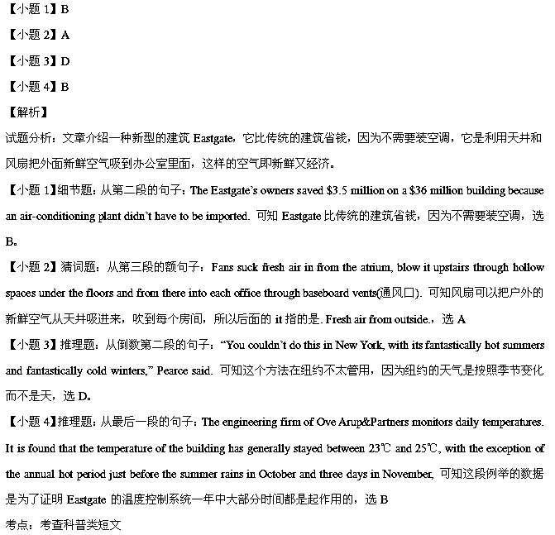D
Is the ‘Go to College’ Message Overdone?
Even in a weak job market, the old college try isn’t the answer for everyone. A briefing paper from the Brookings Institution warns that “we may have overdone the message” on college, senior fellow Isabel Sawhill said.
“We’ve been telling students and their families for years that college is the only way to succeed in the economy and of course there’s a lot of truth to that,” Ms. Sawhill said. “On average it does pay off… But if you load up on a whole lot of student debt and then you don’t graduate, that is a very bad situation.”
One comment that people often repeat among the years of slow job growth has been the value of education for landing a job and advancing in a career. April’s national unemployment rate stood at 7.5%, according to the Labor Department. The unemployment rate for high-school graduates over 25 years old who hadn’t attended college was 7.4%, compared with 3.9% for those with a bachelor’s degree or more education. The difference is even bigger among those aged 16-24. The jobless rate for those with only a high school diploma in that age group is about 20%. At the same time, recent research by Canadian economists cautions that a college degree is no guarantee of promising employment.
Ms. Sawhill pointed out that among the aspects that affect the value of a college education is the field of one’s major: Students in engineering or other sciences end up earning more than ones who major in the arts or education. The cost of tuition and the availability of financial aid are other considerations, with public institutions generally a better financial bargain than private ones.
She suggested two avenues for improving the situation: increasing vocational(职业的)-technical training programs and taking a page from Europe’s focus on early education rather than post-secondary learning. “The European countries put a little more attention to getting people prepared in the primary grades,” she said. “Then they have a higher bar for whoever goes to college—but once you get into college, you’re more likely to be highly subsidized(资助).”
She also is a supporter of technical training—to teach students how to be plumbers, welders and computer programmers—because “employers are desperate” for workers with these skills.
【小题1】People usually think that _____.
A. the cost of technical schooling is a problem
B. one will not succeed without a college degree
C. technical skills are most important for landing a job
D. there is an increased competition in getting into a college
【小题2】What does the underlined part “taking a page from” mean?
A. Hearing from. B. Changing from.
C. Differing from. D. Learning from.
【小题3】 What can we infer from the passage?
A. Public institutions charge more for education.
B. European universities are stricter with students.
C. Students with certain skills are in great demand.
D. Canadian students prefer to major in engineering.
【小题4】Ms. Sawhill may probably agree that _____.
A. too much stress has been put on the value of college degrees
B. technical training is more important than college education
C. a college degree will ensure promising employment
D. it’s easier for art students to find favorite jobs
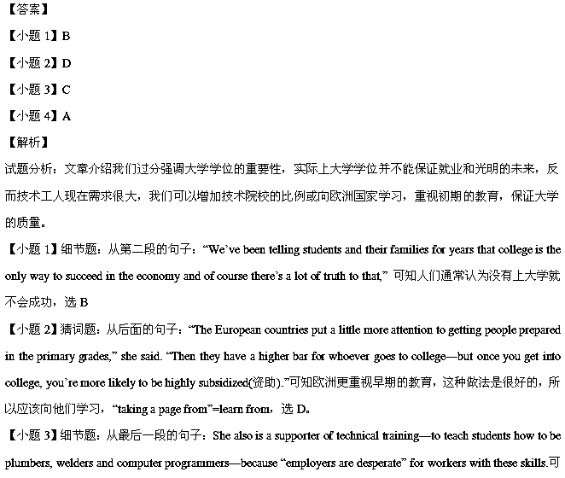知技术工人现在需求很大，选C。

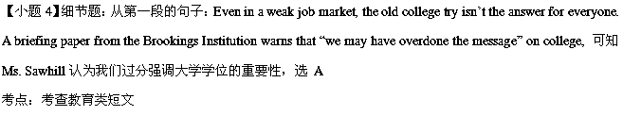第二节（共5小题；每小题2分，共10分）
根据短文内容，从短文后的七个选项中选出能填入空白处的最佳选项。选项中有两项为多余选项。
The Importance of Accessibility Awareness
At a recent Teen Leadership of Jewish Family Services meeting, people with disabilities talked about their lives. 71 However, what amazed me most was the great importance of education about handicap accommodations (残疾人便利设施).
One school-teacher who is blind, and a woman who has used a wheelchair all her life are two important members of the National Group for Disabled Persons, devoted to raising awareness about disabilities. 72 These include handicap parking spots, handrails, and wheelchair ramps. One big concern is the people who take advantage of aids, such as handicap parking spaces. 73 And the meeting focused on educating the public.
Some handicap spots have extra room next to them, marked with the “No Parking” signs. “As long as I'm not in the spot, I can take the no-parking area next to it,” some people say. However, the woman who uses a wheelchair disagrees to this. The space exists to allow someone in a wheelchair to have room to get in or out of their car. 74
Some walkways have handrails next to them to help those who require extra assistance. Whether it is a blind person seeking guidance or an elderly person seeking support, the rail is there for walking. Sometimes the rail is blocked, by a parked bicycle for instance, and consequently made useless. 75 People who are informed of the rail’s use would be less likely to mistake it for a bike rack.
Meeting some of the people who are affected by the lack of education about accommodations made me see that there is work to be done. If more people were educated about the proper uses of accommodations, there would be fewer challenges for people with physical disabilities.
A. Accommodations will vary according to the needs of the disabled.
B. As with the parking spot, this is more likely a case of lack of education.
C. They educate about all the accommodations for people with disabilities.
D. Improvement must be made so that disabled people can fully participate.
E. If there is a car in that space, the handicap parking spot is no longer useful.
F. So people without disabilities need to be educated about these accommodations.
G. I was amazed to hear about the challenges faced by people with physical disabilities.
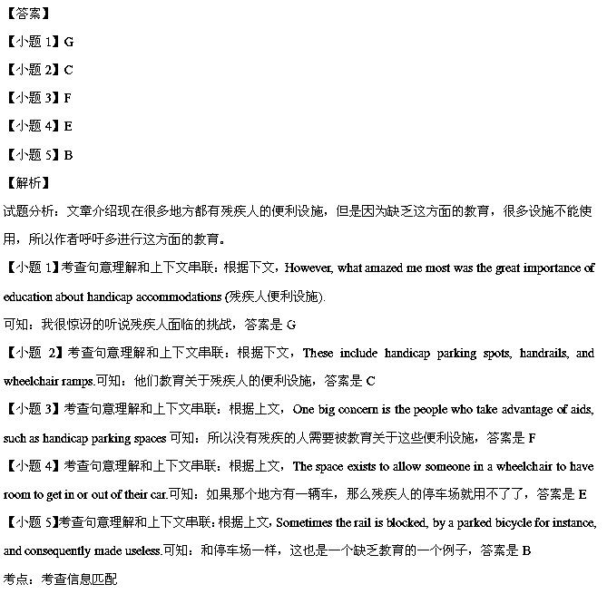第四部分：书面表达（共两节，35分）
第一节（15分）
你校将要组织美国交换生参观中国美术馆（National Art Museum of China）。请你根据下面提供的信息，口头通知活动安排。通知的开头已为你写好。字数不少于50。
- 集合时间和地点：周六早上8：30；学校门口
- 交通方式：校车
- 活动内容：了解中国画家；欣赏著名画作

Hi! Everyone. Attention, please.
_______________________________________________________________
_______________________________________________________
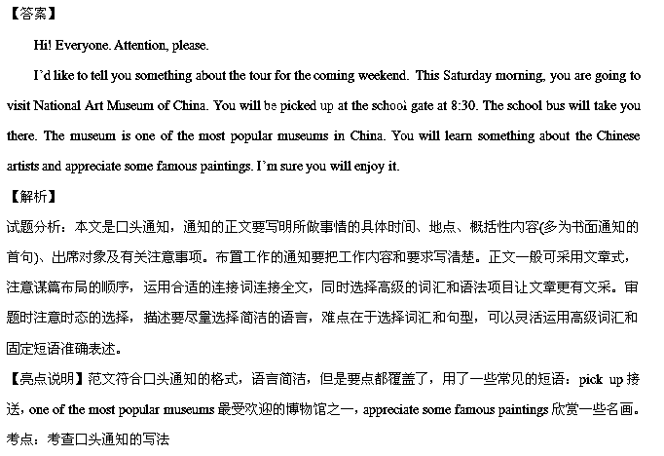第二节（20分）
假如你是红星中学高三（1）班的学生李华，10月10号你们学校举办了校庆活动。请根据以下四幅图的先后顺序，描述你们班所做的事情，给英文校报投稿。
注意：开头已给出。
词数不少于60。
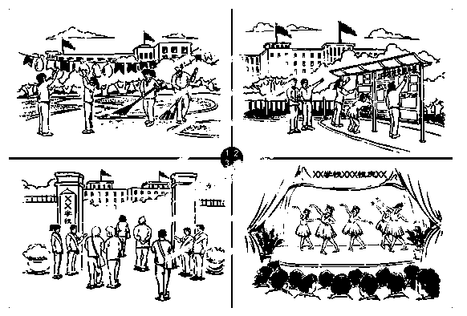

October 10th was the birthday of our school. Our class did a lot for this year’s anniversary celebration.
___________________________________________________________________
________________________________________________
