/北京市大兴区2012—2013学年第一学期期末试卷
初三英语 2012.12

考生须知 | 1．本试卷共12页，满分120分，考试时间120分钟。  2．在试卷和答题卡上准确填写学校名称、班级、姓名和考号。  3．试题答案一律填涂或书写在答题卡上，在试卷上作答无效。  4．在答题卡上，选择题用2B铅笔作答，其他试题用黑色字迹签字笔作答。  5．考试结束，请将本试卷和答题卡一并交回。

听力理解（共26分）
一、听对话，从下面各题所给的A、B、C三幅图片中选择与对话内容相符的图片。每段对话读两遍。（共4分，每小题1分）
1． 换图 A． B． C．



2． A． B． C. 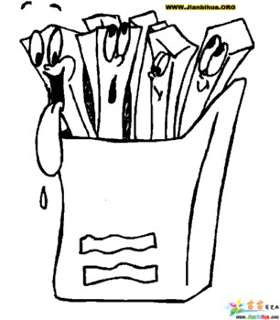  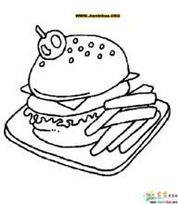

3． A． B． C．
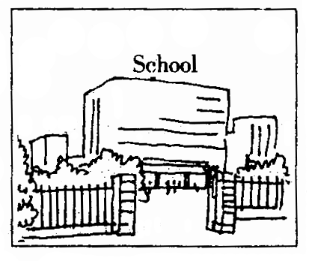
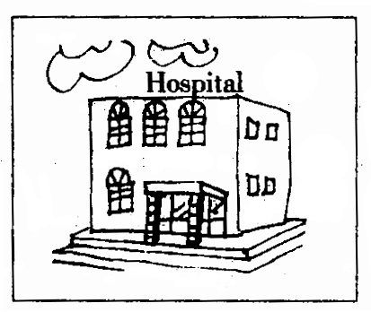
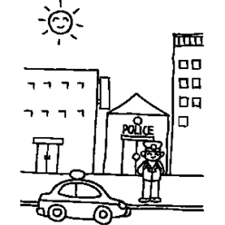

4． A． B． C．
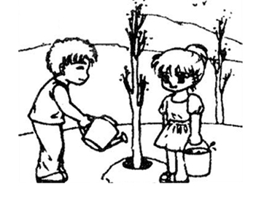
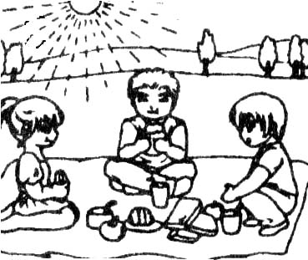
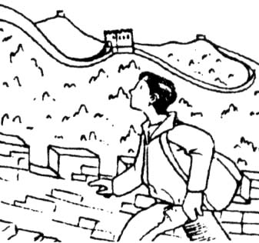

二、听对话或独白，根据对话或独白的内容，从下面各题所给的A、B、C三个选项中选择最佳选项。每段对话或独白读两遍。（共12分，每小题1分）
请听一段对话，完成第5至第6小题。
5. Whose birthday is it tomorrow?
A. Tony’s. B. Sarah’s. C. Sarah’s mother’s.
6. What gift would they buy?
A. CDs. B. A watch. C. Flowers.
请听一段对话，完成第7至第8小题。
7. Where are they talking?
A. At home. B. At school. C. In the street.
8. What should they do first when doing experiment?
A. Follow the teacher. B. Wash their hands. C. Listen and watch.
请听一段对话，完成第9至第10小题。
9. What’s Tom’s favorite food?
A. Bread and milk.
B. Chicken sandwiches.
C. Vegetable sandwiches.
10. Why did Tom’s Dad sleep late last night? Because ________.
A. he worked late
B. he went to the cinema
C. he went to meet some friends
请听一段对话，完成第11至第13小题。
11. Why did Helen make the telephone call?
A. To know about today’s homework.
B. To ask for a one-day leave for her fever.
C. For some information about a competition.
12. Who won the first place in the class?
A. Tom. B. Peter. C. Linda.
13. What do you think of Helen?
A. Kinded-hearted. B. Good-humored C. Hard-working.

请听一段独白，完成第14至第16小题。
14. How many ideas does the speaker give?
A. Three. B. Four. C. Five.
15. Which idea can help you not only make friends but also improve your English?
A. joining a club
B. Being a volunteer.
C. Joining a winter camp.
16. What is the speaker, do you think?
A. A class teacher in the school.
B. A speaker from a kids’ organization.
C. A group leader from a travel agency(机构).

三、听对话，根据所听到的对话内容和提示词语，记录关键信息。对话读两遍。请根据所听到的对话内容和卡片上的提示词语，将所缺的关键信息填写在答题卡的相应位置上。（共10分，每小题2分）
Painting Show Information
What on show | 17. ___________
Ticket price for a student | 18. ￥________
Ways of booking | 19. by ____________ or the Internet
Don’ts | 20. Don't _____________ or speak loudly
Open Days | 21. Except on ___________

知识运用（共25分）
四、单项填空（共13分，每小题1分）
从下面各题所给的A、B、C、D四个选项中，选择可以填入空白处的最佳选项。
22. －Who’s the man over there?
－He is __________ father.
A. I B. me C. my D. mine
23. Beijing is a good place to visit _____autumn.
A. on B. in C. at D. for
24.—Mr. Liu, must I hand in my homework right now?
—No, you ____.
A. needn’t B. mustn’t C. wouldn’t D. shouldn’t
25. My friends and I ______ going to Happy Valley this weekend.
A. be B. am C. is D. are
26. To help those poor children we need ______ money.
A. more B. many C. a few D. a lot
27. My grandma ______ dinner when I got home yesterday.
A. cooks B. will cook C. is cooking D. was cooking
28. We __________ in the same school since three years ago.
A. study B. were studying C. will study D. have studied
29. It’s a good idea _______ the museum shop and buy postcards.
A. visit B. to visit C. visiting D. visits
30. You ________ great progress in your studies if you work harder.
A. make B. made C. will make D. have made
31.-- Can you play football?
--Yes, ________ I can't play it very well.
A. and B. or C. so D .but
32. -- ________ do you visit your grandparents?
-- Once a week.
A. How soon B. How often C. How far D.How long
33. --Your classroom looks bright and tidy.
--It __________ after school every day.
A. cleans B. cleaned C. is cleaned D. was cleaned

34. --I really hope to keep in touch with Miss Green, my junior English teacher.
--Sorry. I don’t know ______.
A. what her number is B. what is her number
C. what her number was D. what was her number

五、完形填空（共12分，每小题1分）
阅读下面的短文，掌握其大意，然后从短文后各题所给的A、B、C、D四个选项中，选择最佳选项。
The monkey is a very lovely little animal, and is found in many parts of the world.
A lady once had a monkey. It was a birthday present from her husband. This monkey, 35 all others, was very fond of making tricks and of doing whatever he 36 others do.
The lady found him one day sitting on the toilet table, holding in one hand a little china mug(杯) with water in it, and in the 37 her toothbrush, with which he was 38 his teeth, looking all the time in the glass.
Her little daughter, Maria, had a large 39 with a very handsome head and face. She one day 40 this doll in the small bed, and went out of the room. The monkey came in, took the doll in his 41 , and jumped upon the washstand, he began to wash its face. He first rubbed it all over with soap. Then seizing the towel, he dipped(蘸水) it in the washbowl, and rubbed it 42 hard that the doll’s face was entirely ruined, and the paint was all 43 off.
There have been many tales of monkeys. They are armed with sticks, and they have joined together and made 44 against their enemies successfully. These are not true, as it is known that in their 45 state(状态) monkeys have no idea of weapons. The sticks and other objects said to be thrown at travelers as they pass under the branches of trees, are usually the dead branches, etc., accidentally broken off, as the monkeys, with the natural curiosity(好奇心) of their tribe(种族), pass along the tops of trees to watch the 46 of the people below. They can, however, be taught to use a stick, and to us it well.
35. A. as B. from C. like D. against
36. A.told B. saw C. asked D. heard
37. A.the mouth B. the toilet C. the air D. the other
38. A. cleaning B. watching C. pulling D. feeding
39. A. doll B. box C. mirror D. toy
40. A. forgot B. made C. left D. let
41. A. mouth B. face C. hands D. arms
42. A. very B.so C. such D. really
43. A. broken B. fallen C. washed D. dropped
44. A. war B. money C. friends D. trouble
45. A. normal B. poor C. good D. native
46. A. noises B. actions C. games D. running

阅读理解（共44分）
六、阅读下列短文，根据短文内容，从短文后各题所给的A、B、C、D四个选项中，选择最佳选项。（共26分，每小题2分）
A

Would you be our volunteers?
Are you ready to join psychological(心理的) experiment from the department of psychology as a volunteer next two weeks from Dec. 2 to Dec. 15?
We are going to do a psychological experiment on sound recognition（识别）. Warmly welcome to join us and you will be paid 30 yuan after one-hour experiment.
Experiment time: 8:00-11:30 on Tuesday and Thursday.
10:00-21:00 on Wednesday.
18:00-21:00 on Sunday, Monday, Tuesday
8:00-21:00 on Saturday.
Experiment place: Room 202, Round laboratory near the Liberal Arts building.
Requirements: You should come from Europe or America.
Please contact Dolphin: 18801919781

47. How much will you be paid after three hours’ experiment?
A. ￥30. B. ￥60. C. ￥90. D. ￥120.
D. You are going to do an experiment.
48. If you want to be a volunteer, you should ______.
A. come from Asian countries
B. be able to get up early in the morning
C. be free at certain time next two weeks
D. call the office of the department of psychology
49. Which of the following is experiment time?
A. 8:00-22:00 on Saturday.
B. 10:00-21:00 on Wednesday.
C. 8:00-11:30 on Monday and Thursday.
D. 18:00-21:00 on Sunday, Monday, Thursday.

B
Two weeks ago, Ruichang City in Jiangxi Province was hit by an earthquake measuring 5.7 on the Richter scale(里氏震级). It killed 18 people and left hundreds homeless.
Earthquakes are one of the most deadly natural disasters(灾难) in the world. They happen more often than you would expect.
In the 24 hours after you read this, 400 to 500 earthquakes will shake the earth. You won't notice most of them because you live in a relatively(相对地) safe area or the quake is too far away or because the quake will be too small to notice.
Earthquakes are caused by sudden breaks in rock masses(群) deep in the earth. Rock masses are always under very high pressure. If the pressure in a certain area become too much and the rock masses break, an earthquake happens. But exactly when the rock masses reach the breaking point is a mystery(谜).
China is on the Eurasia(欧亚) plate, where earthquakes happen very often due to the earth's plates knocking against each other. Up to 17,139 earthquakes have taken place in China in the past 44 years, according to scientific research.

50. What happened to the City of Ruichang?
A.18 people were killed in an earthquake.
B. Hundreds homeless people left the city.
C. An earthquake ruined thousands of houses there.
D. An earthquake measuring 7.5 on the Richter scale happened.
51. How many earthquakes can happen in a day in the world?
A. 24. B. 44. C. 400 to 500. D. 17139.
52. Why does the earth quake? Because ______.
A. we live in a relatively safe area
B. the pressure in the earth is too big
C. the rock masses is reaching the breaking point
D. the rock masses break suddenly deep in the earth

C
Once upon a time a woman found she was not easy to wake up in the morning as early as she wished. So she bought a beautiful alarm clock. These clocks are so made as to strike with loud whirring noise at any hour the owner pleases to set them.
The lady placed her clock at the head of the bed, and at the right time she found herself roused by the long, rattling sound.
She got up at once, and felt better all day for her early rising. This lasted for some weeks. The alarm clock faithfully did its duty, and was plainly heard so long as it was obeyed.
But, after a time, the lady grew tired of early rising. When she was waked by the noise, she merely turned over in bed, and slept again.
In a few days, the clock ceased to wake her from her sleep. It spoke just as loudly as ever; but she did not hear it, because she had been in the habit of not obeying it.
Finding that she might as well be without it, she made up her mind that when she heard the sound she would jump up.
Just so it is with conscience(自觉意识，诚意). If we will obey its voice, even in the least important things, we can always hear it, clear and strong.
But if we allow ourselves to do what we have some fears may not be quite right, we shall grow more and more sleepy, until the voice of conscience has no longer power to wake us.
53. Why did the clock failed to stop to get the woman up later?
A. Because she was tired of getting up early in the morning.
B. Because she could not hear the clock any more.
C. Because she was too tired to wake up at it.
D. Because the clock stopped to do its duty.
54. Both the underlined words “whirring” and “rattling” are kinds of ______.
A. colours B. sounds C. actions D. feelings
55. The writer mainly wants to tell us that ______.
A. we should always obey our clocks
B. the clock sometimes can’t wake us up as we wish
C. It is conscience that ensures early rising not the clock
D. The voice of conscience has no longer power to wake us.

D
Amy was a dear little girl, but she was too ready to waste time in getting ready to do her tasks, instead of doing them at once as she ought to.
In the village in which she lived, Mr. Thornton kept a store where he sold fruit of all kinds, including berries in their season. One day he said to Amy, whose parents were quite poor, “Would you like to earn some money?”
“Oh, yes, ” replied she, “for I want some new shoes, and papa has no money to buy them with.”
“Well, Amy,” said Mr. Thornton, “I noticed some fine, ripe blackberries in Mr. Green’s field today, and he said that anybody was welcome to them. I will pay you thirteen cents a quart(度量单位) for all you will pick for me.”
Amy was delighted at the thought of earning some money; so she ran home to get a basket, intending to go immediately to pick the berries.
Then she thought she would like to know how much money she would get if she picked five quarts. With the help of her slate(书写板) and pencil, she found out that she would get sixty-five cents.
“But supposing I should pick a dozen quarts,” thought she, “how much should I earn then?” “Dear me!” she said, after figuring(测算) a while, “I should earn a dollar and fifty-six cents.”
Amy then found out what Mr. Thornton would pay her for fifty, a hundred, and two hundred quarts. It took her some time to do this, and then it was so near dinner time that she had to stay at home until afternoon.
As soon as dinner was over, she took her basket and hurried to the field. Some boys had been there before dinner, and all the ripe berries were picked. She could not find enough to fill a quarter of a quart.
As Amy went home, she thought of what her teacher had often told her---“Do your task at once; then think about it,” for “One doer is worth a hundred dreamers.”
56. How many times did Amy figure with her slate?
A. 3. B. 4. C. 5. D. 6.
57. The underlined sentence may mean “______”.
A. she got ready to waste some time to do her tasks
B. she thought it was a waste of time to do her tasks
C. she liked to waste time when should do her tasks immediately
D. she was not ready to get her tasks ready, and it’s a waste of time
58. What can we infer from the story?
A. Amy’s family was very poor.
B. Amy was good at counting with a slate.
C. Mr. Thornton was the richest person in the village.
D. Amy would learn a better lesson from this affair than from school.
59. The best title of the passage may be “_____”.
A. The Money Amy Did Not Earn
B. The Girl Did Not Like To Waste Time
C. Amy, A Good Student To her Teachers
D. A Poor Girl Wanted To Earn Some Money

七、阅读短文，根据短文内容，从短文后的五个选项中选出能填入空白处的最佳选项。选项中有一项为多余选项。（共8分，每小题2分）
The 1960 Winter Olympic Games were held in Squaw Valley, USA. How this happened is a story that will be told for years.
60.______. That day Alexander Cushing saw an article in the San Francisco Daily saying that Reno, NV, and Anchorage, AK, had applied to hold the 1960 Winter Olympics. The idea of holding such a great event in Squaw Valley sounded funny at first. 61.______. He and Curly Grieves, the sports editor for the San Francisco Examiner, soon planned that Squaw Valley also applied for the Games.
Cushing met the IOC (International Olympic Committee) with the help of famous people, including Pulitzer Prize winner, George Weller, and French war hero Joe Marillac.62______, so that the members would treat him seriously.
On a cold spring day in 1955, in Paris, France, Alexander Cushing watched as the IOC chose Squaw Valley to host the VIII Olympic Winter Games. 63.______, and with only a fifty-room hotel, could have held such a great event.
A. Cushing even built a model of Squaw Valley
B. But Cushing didn’t give it up
C. Today people still wonder how a town with no ski hill
D. It all began on December 26th, 1954
E. Winter Olympic Games was held in Squaw Valley

八、阅读短文，根据短文内容回答问题。（共10分，每小题2分）
Who are these people rushing by you in the street?
More than 215 million now call America “home”, but most of them can trace their families back to other parts of the world.
If you look at the names on shop windows, you will see that Americans come from many different lands. The idea that these people, who once were strangers to the United States, have lost the customs and cultures of their original countries and have become “Americans” is really not true. In fact, what exists in America is more often a kind of “side by side” living in which groups of people from other countries often have kept many of their customs and habits. They join the general American society only in certain areas of their lives ----such as in schools, business, and sports--- but they keep many of their own native customs and manners socially and at home.
This living “side by side” has both advantages and disadvantages. Sometimes it may cause disagreements to develop between groups whose ways of life are very different from one another. However, there are also great advantages that come from the variety of cultures brought by settlers from other lands. There is great freedom of choice among ideas and dress, food, and social customs in America. Everyone can find some part of his or her familiar world in the United States, in churches, music, food, national groups, or newspaper.
64. How many people call America “home”?
65. What will you see if you look at the names on shop windows?
66. How do the strangers join American society?
67. What are the disadvantages of the “side by side” living?
68. What does the passage mainly tell us about?

书面表达（25分）
九、完成句子（共10分，每小题2分）
根据中文意思完成句子。
69. 发生火灾时，要尽快离开建筑物。
Leave the building ______ you can when there is a fire.
70. 由于气候变化，大部分动物都死了。
______ the changes in climate, most of the animals have died.
71. 昨天晚上，直到十点钟，他才回来。
He ______ ten o’clock last night.
72. 我们花了一个星期的时间才完成并上交自己的网页。
It ______ our own home page.
73. 事实上, 当天来的人太多了，以至于很难不践踏草坪。
______ the grass that day.

十、文段表达 （15分）
根据中文大意，写出意思连贯、符合逻辑、不少于60词的短文。请不要写出你的校名和姓名。
74. 为了增强师生们的身体素质,你们学校每周坚持开展体育活动,取得了一定的效果。为此,区教委领导领着一个美国中学访问团到你校参观。你作为学生代表要向外国友人和领导表示欢迎,并要起草一份发言稿,内容包括:
1. When do the students take part in the sports?
2. What sports do the students / teachers have every day?
3. What’s the importance of sports?
演讲稿开头已给出。
Dear foreign friends and leaders,
Welcome to our school.
___________________________________________________________________________________________________________________________________________________________________

