2016年福建省初中学业考试大纲
（英 语）
一、考试性质
初中英语学业考试是义务教育初中阶段的终结性省级考试，目的是全面、准确地反映初中毕业生是否达到《义务教育英语课程标准（2011年版）》所规定的学业水平。考试结果既是衡量学生是否达到毕业标准的主要依据，也是高中阶段学校招生的重要依据。
二、命题依据
以《义务教育英语课程标准（2011年版）》为指导，以《2016年福建省初中学业考试大纲（英语）》为依据，结合初中英语教学实际进行命题。
三、命题原则
坚持以学生为本，立足基础，难易适中，听、说、读、写四项技能全面考查，做到思想性、科学性、技术性的统一。正确发挥考试的导向功能，做到有利于激发和培养学生学习英语的兴趣，建立学习英语的成就感和自信心，提高综合语言运用能力；有利于引导教师改进教学和学生学会学习；有利于对初中教学起到正确的导向作用；有利于普通高中招生改革和事业发展。
四、考试范围
以《课程标准》所规定的九年级结束时应达到的“五级目标”基本要求作为考试范围。
五、内容和目标要求
初中毕业英语学业考试是义务教育阶段英语学科的终结性考试，目的是全面、准确地考查初中毕业生在英语学习方面达到《课程标准》所规定的级别水平的程度。英语学业考试应着重考查学生听、说、读、写等四种语言技能的综合实践能力以及灵活运用语言知识的能力。在确定具体考试内容和标准时，应依据《课程标准》中“五级目标”的基本要求及相关附录的内容。
六、考试形式、时间
考试形式包括口语测试、听力测试和笔试。口试可安排在听力测试和笔试之前或之后单独进行。口试的组织和操作有较大难度，如因暂不具备口试条件而不进行口试的设区市，应在笔试题中增设口语应用测试题型，目的是通过书面的形式，间接考查学生“说”的能力。听力测试和笔试同卷进行，采用书面作答，闭卷考试的形式。
听力测试和笔试时间总共120分钟，其中听力测试不超过30分钟。
七、试题难度
合理安排试题难度结构。容易题、中等难度题和稍难题的比例约为8：1：1。考试合格率达80%。
八、试卷结构
试卷包括听力测试和笔试两部分。口试单独命题、单独组织测试。
总分与各部分分值：总分150分；听力部分30分，笔试部分120分。
选择题与非选择题比例：约6:4。
听力测试与笔试题型
听力部分（30分）
Ⅰ.听句子（5分） 听5个单句，从所给图片中选出与所听到的句子情景相同（相近）的图片。共5小题。每个单句读两遍。
Ⅱ.听对话（15分） 共两节。第一节听5段对话，每段对话后有一个小题，从题中所给的A、B、C三个选项中选出最佳选项，并标在试卷的相应位置。每段对话读两遍。
第二节听4段对话，每段对话后有几个小题，从题中所给的A、B、C三个选项中选出最佳选项，并标在试卷的相应位置。每段对话读两遍。
Ⅲ．听短文（5分） 听一段短文，根据短文内容从题中所给的A、B、C三个选项中选出最佳选项，并标在试卷的相应位置。短文读两遍。
Ⅳ. 听短文（或对话）填表格（5分） 听一段短文或对话，根据短文或对话内容及要求填写表格。短文或对话读三遍。
笔试部分（120分）
知识运用 （共三大题，满分75分）
Ⅰ.选择填空（15分） 共15小题，每题在一或两句话中留出空白，要求考生从3个选项中选出正确答案。考查内容包括语音、词汇、语法和日常交际用语等，侧重在语境中考查灵活运用语言知识的能力。
Ⅱ.完形填空（15分） 在一段难度适中的短文中留出10个空白处，要求考生从每小题的3个选项中选择正确的答案，使补足后的短文意思通顺，结构完整。考生必须通篇考虑，掌握大意，综合运用所学词汇和语法知识，选择正确的答案。
Ⅲ.阅读理解（45分） 共5篇短文。第1、2、3篇要求考生在阅读理解的基础上，根据所给材料，从每小题的4个选项中选出最佳答案。第4篇是在一篇短文中留出5个空格，要求考生在阅读理解的基础上还原短文中的句子使短文通顺、连贯、意思完整。第5篇是一篇任务型短文，要求考生根据要求完成任务。任务形式包括把文字信息转化为图形、图像、图表、表格、数字等信息，还可以是画图、制作表格、填空、设计（广告、贺卡、名片、信封……）等。
阅读理解测试的主要要求是：
1．能根据上下文和构词法推断、理解生词含义；
2．能理解段落中各句子之间的逻辑关系；
3．能找出文章中的主题，理解故事的情节，预测故事情节的发展和可能的结局；
4. 能根据不同的阅读目的运用简单的阅读策略获取信息。
写（共四大题，满分45分）
Ⅰ. 遣词造句（10分） 根据每题所提供的图画的情景、提示词，写一个与图画情景相符的句子。凡能运用关键词写出与所给图画情景相符的句子，意义和语法都正确的均可得分。
Ⅱ. 口语应用（10分） 在一段对话中，留出5个空格，根据对话内容，填入适当的句子，使对话完整、正确。
Ⅲ. 短文填空（10 分） 在一段难度适中的短文中留出10个空格，根据中文、首字母、音标和语境提示，在每个空格内填入一个适当的单词，要求所填的单词意义准确，拼写正确，并将该词完整地写在答题卡中相应的横线上。
Ⅳ. 书面表达（15分） 要求考生根据图画或提示的情景，用英语写一篇短文。词数80左右。
书面表达的总体要求是：切中题意，条理清楚，语句通顺、连贯，语言准确、得当，书写工整。
九、试题示例
例1．听短文填表格：根据你所听到的短文内容，填写下面表格，每空填一词。(短文读三遍)

Information about a（1）_________ concert
Name of band | （2）___________ Moon.
Telephone number | （3）_________ .
Price of the tickets | 300 yuan for an adult and（4）_________ yuan for a kid.
Rules | Don’t（5）_______ or take your pets into the hall
听力原文：
Hello, everyone! Welcome to Music Time! Here is some information about a pop concert. The famous band—Blue Moon will come to Shanghai soon. They will stay in Shanghai for 7 days. The concert will be held in Shanghai Music Hall. Tickets are sold in the box office of the Music Hall. If you want to book a ticket, please call 65425209. The price is 300 yuan for an adult and 200 yuan for a kid. Please remember, you are not allowed to smoke or take your pets into the hall. Hope you can enjoy it! Thank you for listening.
答案：（1）pop （2）Blue （3）65425209 （4）200 （5）smoke
例2．口语应用
在下列横线上填入适当的话语，使对话完整、正确。
King: Hello, 8447653. This is Mrs. King speaking.
Jane: Hello, Mrs. King! This is Jane. Mike didn’t come to school today. 1
King: He is ill.
Jane: Oh, 2
King: Thanks for calling, Jane.
Jane: May I speak to him now?
King: 3 He is coming.
(A moment later.)
Jane: Hello, Mike! How are you feeling now?
Mike: A little better. But I still have a headache and a cough.
Jane: 4
Mike: Yes. The doctor asked me to take some medicine and stay in bed for a few days.
Jane: 5 and you’ll be well soon.
Mike: Thank you.
答案：
1. What’s wrong with him?/ What’s the matter with him?
2. I’m sorry to hear that.
3. Hold on, please./ Just a moment, please./Wait a minute, please.
4. Did you go to see a doctor? / Have you seen a doctor?
5. Follow the doctor’s advice./ You should have a good rest./ You had better have a good rest.
例3．阅读理解
1. 阅读下面短文，把A—E五个句子填入文中空缺处，使短文内容完整、正确。
Jane is a bright young woman who comes from a rich and famous family. She goes to a good university. But her family are so busy that they can hardly find time to be with her. 1 __
So she spends a lot of time on her QQ. She uses the name Linda on QQ and has made lots of friends.
Last year Jane made a very special friend on QQ. 2 _ He and Jane were both interested in rock music. 3 _ Of course, they wanted to know more about each other. 4 ___ He was a tall, good-looking young man with a big, happy smile. As time went by, they became good friends.
5 _ Jane asked him to let her go with him so that she could give David a surprise for his birthday. But when David finally stood before her, she found that her special friend was a twelve-year-old boy named Jim!
A. So it always took them hours to talk happily on QQ.
B. David sent a picture of himself.
C. In fact, Jane is quite lonely.
D. One day Jane’s father was going on a business trip to San Francisco.
E. His name was David and he lived in San Francisco.
答案：1~5 CEABD
2. 任务型阅读
You may feel worried, upset or disappointed in your life. If you feel so, you’d better do something about it. Just read the following tips (小建议) to find out some ways to fight depression (抑郁情绪) .
First, try to find out the troubles that have worked on your depression. When you know what has got you to feel blue, talk about it with a caring friend. Talking is a way to relax the mind. Ask for help if you need it. Friends and family can help let depression go instead of just watching you hurt.
Second, take a walk for 15 or 30 minutes every day—or dance, or bike if you prefer. If you need to be encouraged, make yourself do exercise anyway. Once you get into the exercise habit, it won’t take long to notice a difference in your mood.
Next, depression can affect a person’s thoughts, making everything seem hopeless. If depression makes you notice only the bad things, try to notice the good things. There are both good things and bad things in life. The more good things you notice , the less depression you’ll feel.
Then, try to do something fun for yourself. For example, you can take time to play with a friend or a pet. You can do something that you are interested in, such as painting, singing and so on. You can also find something to laugh about—a funny movie, a joke… Perhaps laughing can help cheer you up.
Finally, please remember that depression takes time to heal (治愈). So most of all, don’t forget to be patient with yourself.
任务一：根据短文内容，用简洁的句子或短语完成下列表格。
Tips | Ways to fight depression
Tip One | ★ Talk about it with friends or family.
Tip Two | ★ 1. ____________________________________
Tip Three | ★ 2. ____________________________________
Tip Four | ★ 3. ____________________________________
Tip Five | ★ 4. ____________________________________
任务二：除了文中提到的建议外，你一定还有许多自己独特的方法，请写一条与大家分享。
★ 5. _________________________________
答案：
1. Do exercise. /Make yourself do exercise. / Get into the exercise habit.
2. Try to notice the good things.
3. Try to do something fun for yourself.
4. Be patient with yourself.
5. 略（符合题意的合理建议均可得分）
例4．短文填空
阅读下面短文，根据中文、首字母、音标和语境的提示，在每个空格内填入一个适当的单词，要求所填的单词意义准确，拼写正确。
Elaine Wu is part of the first generation (代) of Chinese pianists. Born in Shanghai, she began practicing the piano at the 1 of six when she was found to show a strong interest in classical music and the piano. One year later, she w 2 the first prize at a children’s piano competition in Shanghai.
A 3 winning the prize, she went on to study under the 4 [feɪməs] Italian musician and piano educator Maestro Mario Paci. She had put all her energy into her music career in the 5 [pɑ:st] eighty years.
She put on performances at home a 6 abroad. In 1962, she was regarded 7
the national first-class pianist.
In 1993, Wu was 8 (邀请) to teach piano in Singapore. She has been living t 9
ever since. In August 2013, her 10 (第二) album (专辑), A Generation of Master 2, came out with full support from her fans.
答案：(1) age (2) won (3) After (4) famous (5) past
(6) and (7) as (8) invited (9) there (10) second
例5．书面表达
近日，我市正开展“文明礼让斑马线”活动，倡导人人自觉遵守交通规则，构建三明交通文明。请你以“Let’s Obey the Traffic Rules”为题，参考下图和提示词，用英语写一篇短文。谈谈作为一名中学生，如何从我做起，走文明路，骑文明车，做文明人。
要求：
1. 文章的开头已给出，不计入总词数；
2. 文中不得出现真实的人名、校名和地名；
3. 词数80左右。
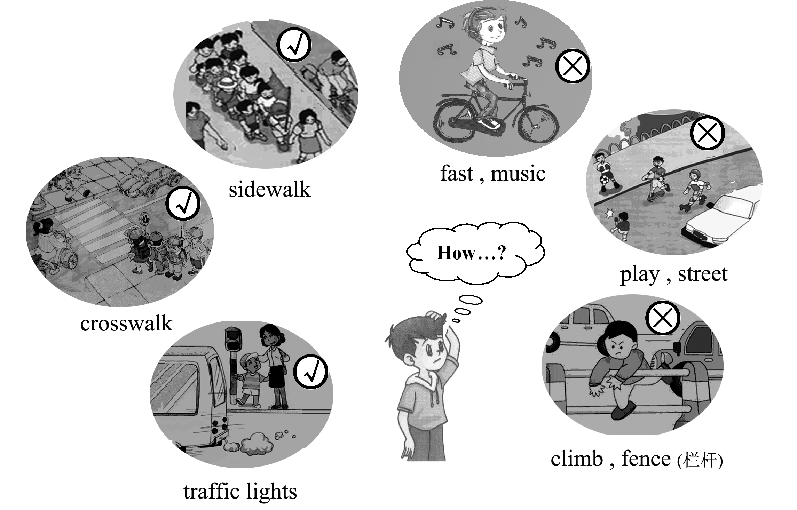

Let’s Obey the Traffic Rules
It’s important for us to obey traffic rules. As students,_______________________________
_______________________________________________________________________________
_____________________________________________________________________

One possible version:
Let’s Obey the Traffic Rules
It’s important for us to obey traffic rules. As students, let’s start with the things around us!
First, when walking across the road, we must be careful. Remember to walk on the crosswalk. We must cross the street only when we see the green “walk” sign. And always walk on the sidewalk. Second, when riding a bicycle, never ride too fast. Don’t listen to music while riding. Third, don’t play on the street or climb over the fence.
In short, it’s important for us to obey the traffic rules for safety.

