Listening test part(共20分)
一，听句子，选择与其意思相符的图片5分
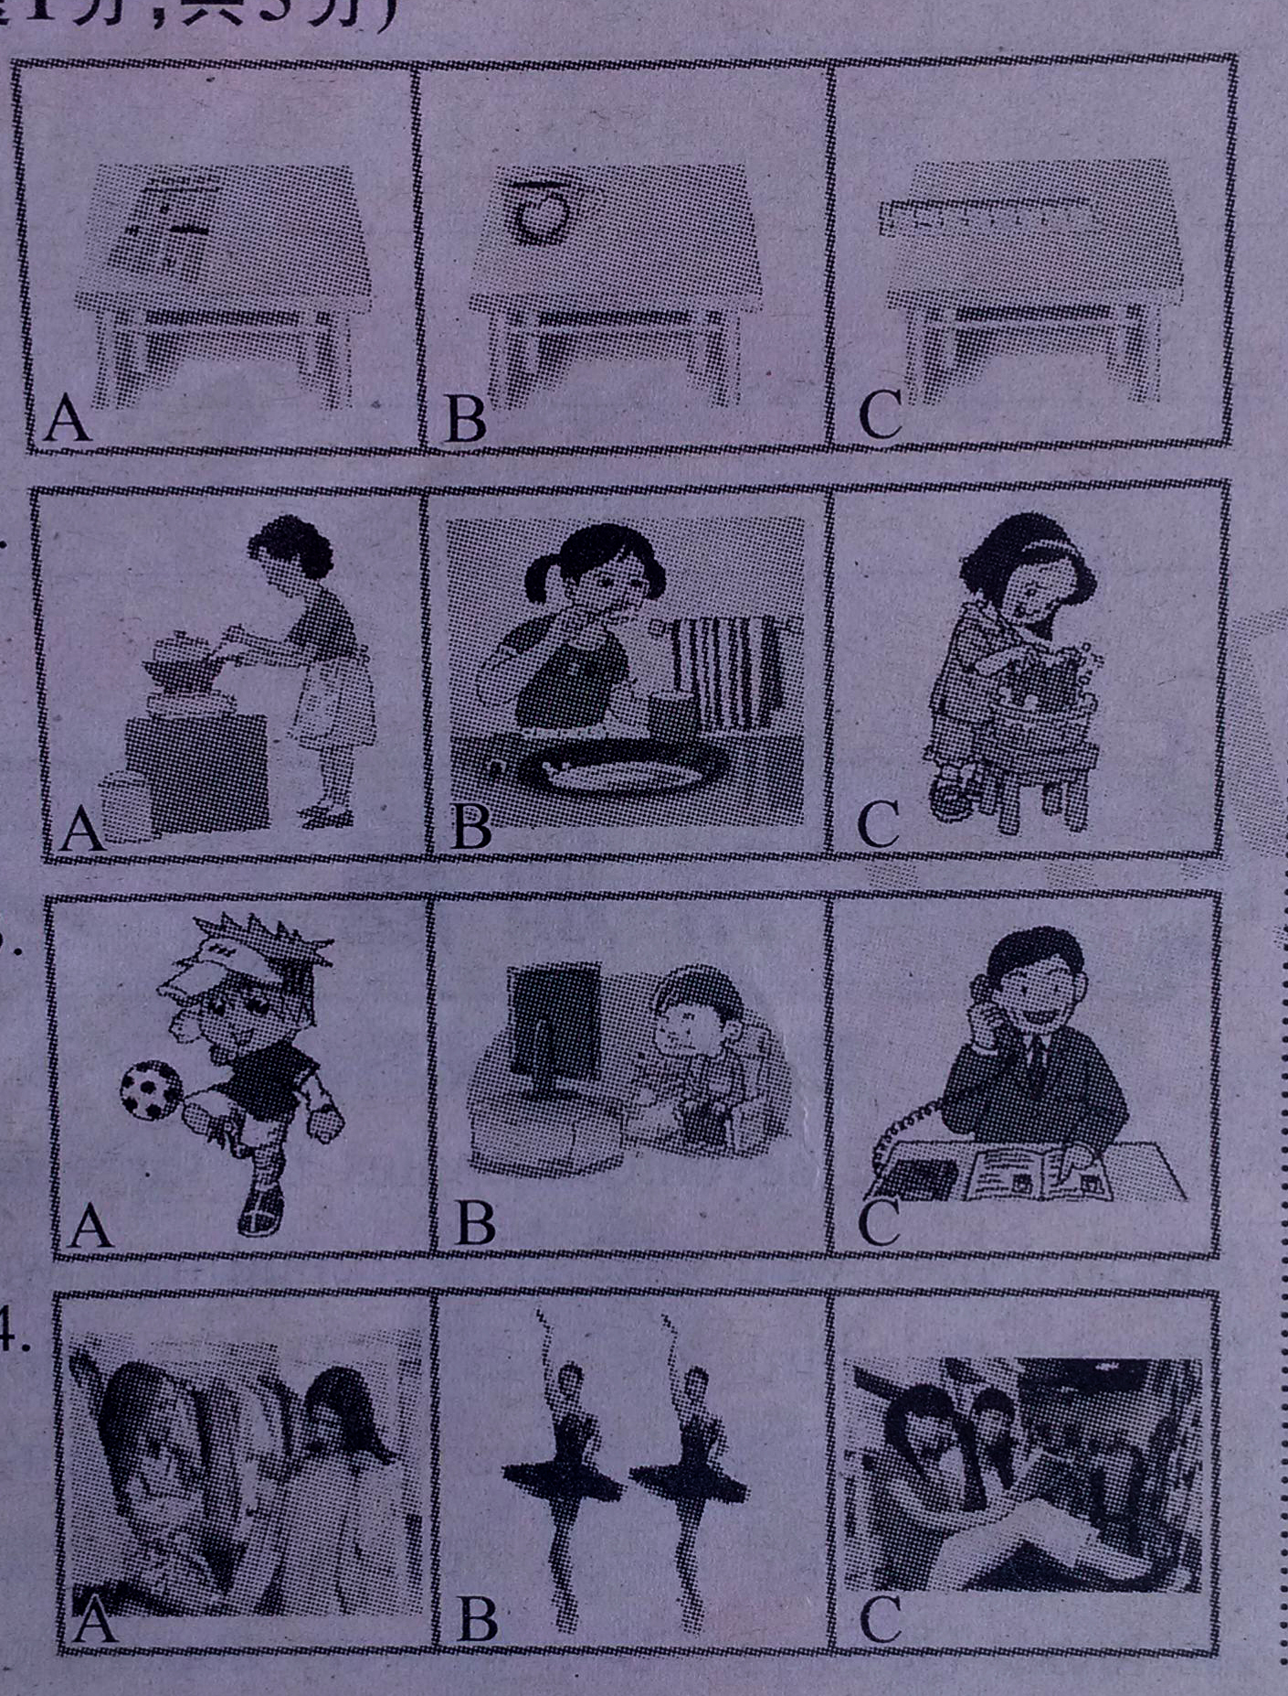

（ ）1 .

报纸 茶杯 直尺

（ ）2.

（ ）3.

（ ）4.

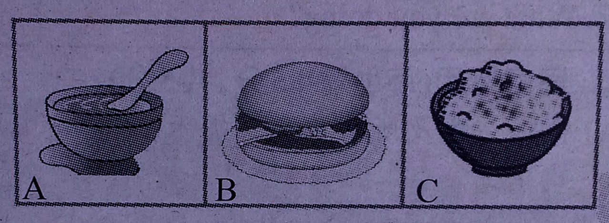
购物 跳舞 看书

（ ）5.

二，听对话，选择最佳答案。
( )6. What's Judy's favorite food?
A. Bread. B. Zongzi. C. Rice.
( )7. Where’s Helen from?
- South Africa. B The USA. C. Australia.
( )8. What is Scott's sister doing now?
A. Shopping. B.Sleeping C. Swimming.
( )9. What are they talking about?
A. Food. B. Animals. C. Sports.
( )10. Where are they talking? http:// w ww.x kb1. com
A. In the classroom. B. In the library. C, In the hallways.
三，听长对话，选择最佳答案。5分
( )1l Cindy is now.
A in the zoo B. at school C at home
( )12. Mike is _now.
A. washing clothes B. reading a book C watching animals
( )13. Cindy's favorite animals are .
A.lions B. tigers C pandas
( )14, Cindy can’t ___ on weekends.
A, go out B. watch TV C. computer games
( )15. Mike thinks Cindy’s family rule is .
A.bad B. boring C. Great
四，听短文，选择最佳答案。
( )16. Tony is a(n) boy.
A. English B. Chinese C. American
( )17. At school, Tony ’ s favorite subject is
A. math B. P.E. C.geography
( )18. Tony often practices in the sports club.
A. basketball B. Baseball C. volleyball
( ) 19. Tony often goes to the on weekends..
A. zoo B. Library C. supermarket
( )20. Tony often helps his mother to at home.
A. do the dishes B. clean the house C. wash the clothes

Written test part(共100分)
二．单项选择15分
( )21.There is elephant there. Near elephant，there is tall tree.
A. an; an; a B. a; the; a C. an; the; a D. an; the; the
（ ）22.Emma,come here,please. Here some newspapers for you.
A. is B. are C. has D. have
（ ）23.. His are very to us. We all like them.
A. friendly; friendly B. friends; friendly C. friend; friendly D. friendly; friends
（ ）24. Mr Han has a son and he is happy.
A. 3 year old B. 3 - year - old C.3 - years – old D. 3 years old
（ ）25.—Do you need a new dictionary,Susan?
—No, Mom. My uncle bought me yesterday.
A. one B. it C. the one D. another
（ ）26.Mary wants to know .
A.where Bob lives in B.where Bob lives
C. Bob lives where D.where does Bob live
（ ）27. I want to buy two pens. One is for myself, is for you.
A. Other B. Others C. the other D. the others
( )28.The father is good stories.
A. at telling B. for speaking C. at talking D.at saying
( )29.You need to brush your after .
A. tooth eat B. teeth eating C.tooth eating D.teeth eat
( )30. It usually takes her about ten minutes to school .
A. by bike B. on bike C. take a ride D.ride a bike w W w .x K b 1.c o M
( )31— is it from the radio station?
— It’s about 5 kilometers.
A. How long B.How far C. How much , D. How many
( )32 It will take the men half a year the work.
A. finish B. finishing C. to finish D. finishes
( )33. The food tastes and sells
A,good good B. well good C. good well D.well well
.( )34 —Please don’t be noisy. The baby .
—OK. I’11 go out for a walk.
A.sleeps B. Slept C. is sleeping D.was sleeping
( )35，— like the cat?
—Because she’s kind of boring and she’s lazy.
A, Why you B. Why do you C. Why not you .D.Why don’t you.
三，完型填空。10分
A young man and an old man 36 in the park. The old man37_ tired so he 38 to have a rest. There is a chair in front of the young man. The old man sees the chair. He wants _39 on the chair. He walks to the chair. The young man walks to it, too. So the old man begins to run. The young man say, “ 40 sit on the chair! ” The old man doesn ‘t 41him. Now he 42 on it. He looks 43 .The young man comes over to him. He is44 a small board一块小的板 in his hand. It 45“Wet Paint(油漆未干)”
( )36. A. are walking B. is wanting C. walking D. walk
( )37 A. am B. is C. are D. be
( )38 A .is wanting B. want C.wants D. to want
( )39. A. to sit B. sit C.sitting D. sat
( )40 A. Not B. Doesn ’ t C.Don t D. Can’ t
( )41. A. listen B. listen to C. hear of D. to hear
( )42. A. is siting B. is sitting C. are sitting D. sits
( )43. A. happily B. happy C. very happily D. more happy
( )44. . A. hold举 B. holding C. holds D. held
( )45. A. talks B. speaks C.tells D. says http:// w ww.x kb1. com
四，阅读理解30分
Rule One | Rule two
1. You can come into the room only with your teacher. | Here are the rules for Emily.  1. You must get up before 6:30am.
2. Don 't eat or drink in the room. | 2. Don’t listen to music.
3. Don ' t listen to music | 3. Don’t talk loudly on the phone.
.4. Be quiet. Don’t talk to each other | 4. Go to bed by 10:00 pm
.5. Turn off all the computers and close windows after class. | .5. You can’t meet friends if you  don’t finish your homework
 | .6. Clean your bedroom yourself.
A

( )46. In the two rules isn' t be allowed不允许.
A. eating or drinking B. listening to music
C. meeting friends D. coming into the room
( )47. When does Emily get up?
A. 6:30 a. m. B. After 6;30 a. m. C. Before 6:30 a. m D. Before 6:00 p. m.
( )48. Rule One may be for a .
A. computer room B. classroom C,bedroom D. dining room
( )49.The underlined word “finish” means in Chinese.
A. 阅读 B.拿走 C.开始 D.完成
( )50. Which rule is NOT for Emily?
A. Turn off the computers and close windows B. Don' t listen to music.
C. Don t talk loudly on the phone. D. Clean your bedroom yourself.

B
The wolves (狼) are very hungry饿. They go out to look for food. There are many sheep ( 羊 ) near the hill( 山). There are also a few sheepdogs with them. The wolves think of an idea. They speak to the sheepdogs,“ You are like us and we are brothers. But we have a very different life. We do what we like, and you must work for man. They make you look after照看 their sheep. They eat meat and give you the bones (骨头). If you listen to us and give us the sheep, we can eat them together. All of us will be happy,right？”The dogs are happy and do like this. The wolves ask the dogs to go to their house. The sheepdogs go to the wolves’ home. But the wolves eat them and then eat the sheep.
( )51. The wolves go out for food because .
A. they see the sheep near the mountain B. they see the sheepdogs
C. they are hungry D. they want to go out
( )52. The sheepdogs work for .
A. man B. sheep C. wolves D.dogs
( )53. Why do the wolves ask the sheepdogs to go to their home?
- Because they want to eat them.
- . Because they want to be sheepdogs ’ friends.
C.Because they want to help sheepdogs to get freedom( 自由).
D.Because their home is near this mountain.
( )54. What do the sheepdogs do?
A. Play with the sheep. B. Look after the sheep.
C. Work with man. D.Eat the bones.
( )55. What do you think of the wolves?
A. Shy. B. Lazy. C. Kind. D.Sly(狡猾).

C
A French woman goes to London to see her son. She knows a little English,but cannot speak it very well. One day she goes to a shop. She wants to buy a hen ( 母鸡） for supper. But she cannot remember ( 记得) the English word for“ hen” . Just then the shop waiter asks her, “Can I help you?” “ I want the egg’s mother” the woman answers. The shop waiter does not understand( 明白)her and says, “ Sorry, we have not any bigger (交大的) eggs.” Suddenly (突然））） the woman remembers(记起)the word“cock(公鸡She says, I want the cock’s wife妻子! ”This time the shop waiter laughs (笑 ).
( )56.The woman goes to London .
A. to learn English B. to have supper C. to see her son D.to buy a cock
( )57. The woman ;
- only knows a little English B. knows much English
C. doesn ’ t know English D. can speak English very well
( )58.The shop waiter thinks the egg’s mother must be
A. bigger eggs B. the cock ’s wife C.. hens D. cocks
( )59.The shop waiter laughs because he ______ http:// w ww.x kb1. com
A. understands the woman at last(最终） B.thinks it is interesting
C. does not understand the woman D. thinks the woman is shy
( )60.Is the woman clever?
A. Yes, she isn’t. B. No,he isn’t C. Yes,she is D. No,she is

五，补全对话5分
A.This way,please.这边请
B.What can I do for you'/
C.Do you live here?
D.5 yuan each.
E.What time is the last one?
F.It's my pleasure.帮助你我很乐意。
G.It takes forty minutes.

A;Excuse me,sir?
B;Yes? 61
A;I want to go to the train station,but I don't know how to get the ticket票 from the TVM （自动提款机）
B; 62 Well,just press按 here.
A;How much is the ticket?
B; 63 , .
A;All right. By the way,how often多久一次 do the trains come?
B; About every six minutes.
A; 64
B; At 11 ;00 p. m.
A:OK. Got it. Thanks for your help.
B: 65
A: Goodbye.
B;Bye -bye!
61 . 62. 63. 64. 65.
六补全短文。5分
Hi! I’m Tony. 66 In the morning, I get up at eight. Then I go to school at eight thirty. I don t have much time for breakfast, 67 For lunch, I usually eat hamburgers. After school, I sometimes play basketball for half an hour. When I get home, I always do my homework first. In the evening,I either watch TV or play computer games. At ten thirty, 68 .Mary is my sister. She usually gets up at six thirty. 69 and eats a good breakfast. After that, she goes to school at eight thirty. At twelve, she eats lots of fruit and vegetables for lunch. After lunch, she sometimes plays volleyball .She always eats ice-cream after dinner.She knows it s not good for her, 70 In the evening, she does her homework and usually swims or takes a walk. At nine thirty, she goes to bed.
A.Then she always takes a shower
B.but it tastes good!
C.I brush my teeth and then I go to bed
D.I don't like to get up early.
E.so I usually eat very quickly.

66 . 67. 68. 69. 70.
七．任务型阅读10分
A woman is at the movies,and she is enjoying the movie very much. A man in the next seat begins to look for something on the floor under him. The woman is angry (生气的)and says“What are you doing there? What are you looking for?” “A piece of chocolate巧克力. ” the man answers.“But it ’ s dirty now! Take this and be quiet, please! I am listening to the film! ” she gives the man a big one.“ But, ” the man says, “ my false ( 假的) tooth (牙齿 ) is in it on the floor地板! ”
71. What’s the woman doing?

72.Why is the woman angry?

73.Where is the man sitting?

74.What does the woman give the man?

75. Why does the man want to find the chocolate?

八．选词填空10分

good, because, ride, house, car, different, think, near, foot, boat

People go to work in 76 ways. Some people go to work on 77 because they live 78 their work places. Some people go to work by bike 79 they live farther away, or they like 80 bikes. They think it is 81 for their health. Today more people have private(私人的)cars,so they can go to work by 82 . In the south of China, many people even go to work bv 83 because water is around their 84 Will people go to work by plane? I 85 so, if necessary.
76.________77.__________78.___________79.___________80.______
81._______ 82._________ 83.__________ 84._________ 85._______
九．翻译5分
- 我的父母对我很严格。
My parents are me.
87我想遵守校规是最好的。
I think to follow the school rules.
88大象能够长时间的行走而且从不迷路。
The elephants can walk a long time and never get
89放学后我想和张老师谈谈!
I want to to Mr Zhang school.
90星期一到星期五我没时间看电视。
I don’t have time to watch TV Monday Friday.
十．书面表达10分
请你根据提示写一篇文章。
- 我叫Steve.我每天7点上学。
- 我的家离学校大约2公里。我乘公共汽车到达学校。我从来不上学迟到。
- 我擅长下象棋。但我不会弹吉他。
- 上学的晚上我不出去，我在家学习。
- 我最喜欢的动物是熊猫因为他们很可爱。
Hello!Everyone!
__________________________________________________________________________________________________________________________

This is me.Can you tell me about yourself

英语参考答案
- 听力20分，每题1分
1_____A_____2____C_____3_____C_____4_____A_____5_____A____
6__ __B_____7_____C____8_____C____9______B____10_____A____
11____C_____12____B___13_____B____14_____A____15_____A____
16____C_____17____B___18_____A_____19____A____20_____B_____
- 单项选择15分，每题1分
21____C_____22____B____23____B______24____B_____25 A
26____B_____27____C____28____A______29_____B____30____A____
31____B_____32____C___33_____C_____34_____C____35_____D____
- 完型填空15分，每题1分
36____A_____37____B____38____C______39____A____40_____C____
41____B_____42____B____43____B______44___B_____45____D_____
四阅读理解30分，每题2分
46____B____47____C____48_____A______49____D____50_____A____
51____C____52____A_____53____A_______54___B____55_____D____
56____C____57____A_____58____A_______59___B___60_____C_____
五，补全对话。5分61____B____62____A_____63____D_______64___E____65_____F____
六．阅读下列短文，根据短文内容，从短文后的选项中选出适当的选项补全短文。 (共5小题，每小题1分；计5分)
66 D 67 E 68 C 69 A 70 B
七，任务性阅读10分新|课 | 标|第 |一| 网
71 She is enjoying(seeing/watching) the movies
72 The man isn’t quiet./The man is looking for something(his false tooth)
73 In the next seat.
74 A chocolate
75 His false tooth is in the chocolate on the floor.
八，用方框中所给单词的适当形式填空，使短文完整、通顺。每词限用一次。10分
- different 77. foot 78. near 79. because 80.riding
- good 82. car 83. boat 84. houses 85.think
九．翻译5分新- 课 -标- 第 -一- 网
86 strict with 87 it’s best
88 for lost 89 talk after
90 from to

新课 标第 一 网

