青岛市二○一六年初中学业水平考试
英语试题
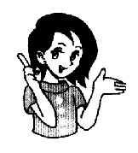
（考试时间：100分钟；满分：90分）
友情提示：Hi，亲爱的同学，欢迎你参加本次考试，祝你答题成功！

本试卷分为第I卷和第II卷两部分，共五道大题。第I卷包含：单项选择和阅读理解，共30个小题；第II卷包含：综合填空A、B、C，阅读表达A、B和书面表达。所有题目均在答题卡上作答，在试题上作答无效。
第I卷（共30分）

I．单项选择 从每小题所给的四个选项中选出能够完成或回答这一小题的最佳答案。(共15小题，每小题1分，共15分)

1．David is ______ eight-year-old boy with short black hair. [来源:学*科*网Z*X*X*K]
A. / B. a C. an D. the
2．Nancy took her temperature and found she had a ______.
A. cough B. toothache C. cold D. fever
3．— ______ do you usually share happiness with?
— My parents and my best friend.
A. Who B. Whose C. What D. How

4．I like hiking in the forest because the air is pretty ______.
A. free B. dirty C. polluted D. fresh
5．Ladies and gentlemen, attention please! I have ______ important to tell you.
A. nothing B. something C. everything D. anything
6．Tim is going to give his father a surprise ______ Father’s Day.
A. in B. at C. on D. by
7．Rules are helpful to us, ______ we have to follow them.
A. so B. but C. or D. because

8．We have worked so long. Shall we stop ______ a rest?
A. have B. to having C. having D. to have
9．The girl in the classroom ______ be Sarah. She has gone to the library.
A. may B. must C. can’t D. needn’t

10．Our country is taking action to ______ air pollution.
A. cut down B. cut up C. cut out D. cut off

11．The talent show is ______ the game show. I like both.
A. as boring as B. not so bored as C. as interesting as D. not so interested as
12．______, we saw the sun rise on top of Mount Tai.
A. Lucky B. Luckily C. Unlucky D. Unluckily
13．Children should ______ to be honest from a young age.
A. educate B. be educated C. punish D. be punished
14．William Shakespeare ______ for 400 years, but his works still have great influence today.
A. died B. was dying C. has died D. has been dead
15．— Excuse me. Could you tell me ______ about the local history and culture?
— Of course. You can check it on this computer.
A. how can I get the information B. what information did I get
C. where I can get the information D. that I got the information

II．阅读理解 阅读下列短文，做出正误判断或选出最佳答案。A篇为判断正(A)误(B)题，B、C篇为选择题。（共15小题，每小题1分，共15分）
A
Building friendships is a lifelong job but is worth spending time. Also, it’s important to keep in touch with friends.
Advice on making new friends | Advice on keeping friends
* Try to be open to new experiences and relationships.  * Join clubs or volunteer organizations. These activities will give you a chance to communicate with people who share similar interests.  * Go on with it — even if you don’t feel comfortable. It takes time to build friendships. | * Be a good listener. Don’t offer advice unless you’re asked.  * Respect (尊重) the other person’s opinion, even when you don’t agree.  * Your friends need to know they can trust you.
16．Building friendships doesn’t take long.
17．Volunteer activities can help you make some new friends.
18．You should respect your friend’s idea.
19．Offer your friends advice if you are not asked.
20．The passage talks about how to make new friends and keep friends.
B
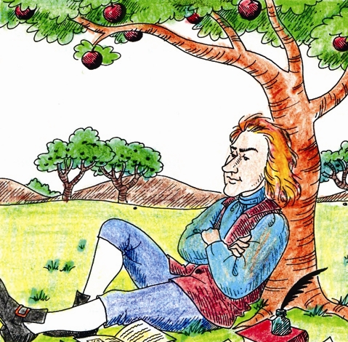
“I will think of it.” It is easy to say this, but do you know what great things have come from thinking?
Sir Isaac Newton was sitting in his garden when he saw an apple fall from a tree. He began to think and tried to find out why the apple fell. Then he discovered how the sun, moon, and stars are kept in their places.
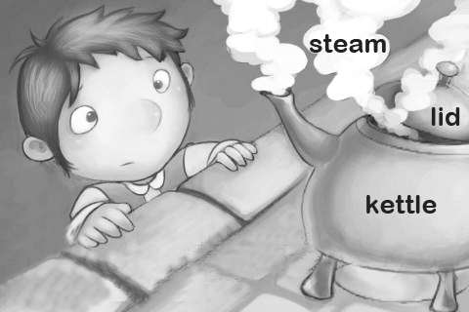
A boy named James Watt sat quietly by the fire, watching the lid of the kettle move up and down. He wanted to find out why the steam in the kettle moved the lid. From that time he went on thinking and thinking. And when he became a man, he improved the steam engine (蒸汽机) so much that it could easily do the work of many horses.
James Ferguson was a poor boy. Once, seeing the inside of a watch, he wondered. “Why should I not make a watch?” But how could he get the materials to make the mainspring (钟表的主发条)? He soon found he could make it with whalebone (鲸骨). He then made a wooden clock which kept good time. His motto (座右铭) was “I will think of it.” And he made his thoughts useful to himself and the world.
Boys and girls, when you have a difficult lesson to learn, don’t lose heart, and don’t ask someone for help before helping yourselves. Think, and by thinking you will learn how to think to some purpose.
21．From the passage, we know that some great things come from ______.
A. listening B. reading C. speaking D. thinking
22．The idea of Isaac Newton’s discovery was from ______.
A. the falling of an apple B. the cleaning of a garden
C. the falling of a tree D. the moving of a lid
23．The achievement of James Watt was that he ______.
A. kept thinking B. found the steam in the kettle
C. improved the steam engine much D. watched the lid move up and down
24．The right order of the following sentences is ______.
① James Ferguson made a wooden clock.
② James Ferguson saw the inside of a watch.
③ James Ferguson made the mainspring with whalebone.
A. ③ ② ① B. ② ③ ① C. ② ① ③ D. ③ ① ②
25．What is the main idea of the passage?
A. Learn to ask for help.
B. A difficult lesson to learn.
C. It is easy to say “I will think of it.”
D. Think, and by thinking you will learn how to think to some purpose.
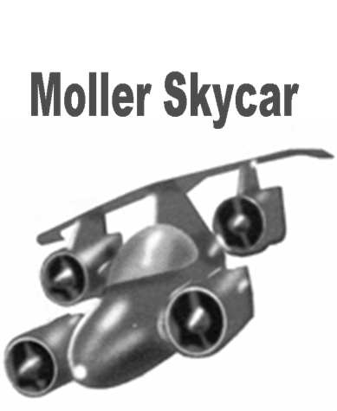
C
A science fiction flying car looks like a normal car, but it is an aircraft (飞行器) that anybody can fly directly from any place to another without using roads or runways. Science fiction writers have written about flying cars for a long time. But now flying cars will soon fly out of the world of science fiction into our real world. And the dream of the science fiction writers will soon come true.
The first-known sky car is the FSC-1. The FSC-1 looks like an expensive sports car. You can drive the FSC-1 on the road like a normal car. If you touch a button, its wings and propeller (螺旋桨) fold out and then it can take off, fly and land as an airplane. The owners of the FSC-1 can choose if they want to drive or fly.
Another flying car or sky car is the Moller Skycar M400. Although you can’t drive it on the roads, it is small and easy to fly and can take off and land like a helicopter (直升飞机). Urban Aeronautics’ X-Hawk is another type of sky car. It is expected to be available for about $3 million.
Just like any new technology, flying cars have taken a long time to be developed. But some experts think the technology is far from what people imagine when they are sitting in traffic. It still needs to be improved.
26．______ kinds of flying cars are mentioned in the passage.
A. Two B. Three C. Four D. Five
27．The writer thinks that flying cars will be no longer a dream because ______.
A. science fiction writers’ ideas are stupid B. they are too expensive to make
C. they will soon be available D. they are only in science fiction
28．The FSC-1 can ______.
A. change itself into a robot
B. move on water like a ship
C. be flown only like an airplane
D. be driven like a car and flown like an airplane
29．The Moller Skycar is different from the FSC-1 because ______.
A. it can’t fly B. it can’t be driven like a car
C. it is difficult to land D. it is much more expensive
30．Some experts think the technology of flying cars is ______.
A. normal B. traditional
C. not good enough D. strange
第II卷（共60分）

III．综合填空 (共20小题，A每小题2分，B、C每小题1分，共25分)
A. 用所给词的适当形式填空。每词限用一次。（10分）[来源:学*科*网]
pass, provide, review, bring, celebrate

1．The hotel always __________________ good service for tourists.
2．Tea __________________ to western countries in the 19th century.
3．All of us __________________ the exam. How happy we are!
4．Mike __________________ his grandpa’s birthday next Sunday.
5．Could you please turn down the TV? Your brother __________________ his lessons.
B. 根据句意和所给汉语，完成句子。每空一词。（5分）
1．In the USA, people eat with __________________ (刀) and forks.
2．I left my book at home. May I borrow __________________ (你的)?
3．You must look at the traffic lights before you go __________________ (穿过) the road.
4．It rained __________________ (大) on my way home yesterday afternoon.
5．The __________________ (越早) kids learn to be independent, the better it is for their future.
C. 选择恰当的单词填空。每词限用一次。（有两个多余的选项）（10分）
exactly, disappeared , hundreds, example, protect, when, longest, of, symbol, wide, northwest, build
The Great Wall of China is one of the greatest wonders of the world. With a history of more than 2,000 years, some parts of the Great Wall have ___1___. It is, however, still a very popular place of interest.
It is the ___2___ wall ever built. It’s from Shanhaiguan on the east coast to Gansu Province in the ___3___ of China. It is about 8 meters high. The top is 8 meters ___4___ and it gets even wider towards the bottom where it is 15 meters. It is made ___5___ stone and brick. The top is hard enough for men on horseback to ride on. The wall was built by hand and it took ___6___ of years to finish.
No one knows ___7___ when the building of the Great Wall was started. It is believed that the wall was built to ___8___ parts of the country during the Zhou Dynasty. Emperor Qin Shihuang joined the separate walls built by the Qin, Yan and Zhao Kingdoms. The wall was not only for protection in the north, it was also a ___9___ of China’s ancient civilization (文明). [来源:Z§xx§k.Com][来源:学_科_网]
Today, many of the visitors go to see the wall. ___10___they stand on top of a tower and look down on this wall, they can’t help (禁不住) saying “Wow, that’s fantastic!”

IV．阅读表达（共20分）
A
阅读下面短文，按要求完成各项任务。（共8分）
Many people run for exercise. But what will you do if you are not a “born” runner or jogger (慢跑者)? You may still want a kind of exercise that’s inexpensive and easy to do. Why not try walking?

Walking requires no special equipment (装备). It is a kind of exercise that almost any normal, healthy person can do. Walking is good for your health like jogging or running; it will just take longer. Jogging and running make your heart work harder than walking. They also put more stress on your legs and feet than walking does.
The problem with walking is that most people don’t take it seriously. But there’s a big difference between serious walking and the walking that most of us do. Walking, like jogging, should have a steady and continuous motion (稳健而持续的动作).
If you want to get your exercise by walking, you need to have your own walking plan. After all, runners and joggers set goals for themselves. Walkers need goals, too. You also need to set a course to walk. Start by walking about 15-30 minutes a day. Increase your time and distance (距离) slowly. And try increasing your walking speed little by little.
If you prefer to jog or run, follow the same advice. Start off slowly. Spend most of the first few days just walking. Then, start walking and running on the same day. Run or jog a short distance, then walk for a while, then, run, then walk. Follow that pattern for 15-30 minutes a day. Slowly make each run longer and each walk shorter. Later on, you can increase your distance, speed and exercise time.
任务一 将划线短语 a “born” runner 译为汉语。（1分） _______________
任务二 列举两条Jogging和running对身体部位的影响。（2分）
1．make _______________________________________________________
2．____________________________________________________________
任务三 回答问题。What’s the problem with walking? （2分）
____________________________________________________________
任务四 选出作者关于步行健身的两种建议，将字母代号填写在答题卡上。（2分）
A. Have a walking plan. B. Walk fast at the beginning.
C. Start by walking an hour a day. D. Increase distance and speed little by little.
1．__________ 2．___________[来源:Zxxk.Com]
任务五 找出最后一段的主题句。 （1分）
_______________________________________________________________
B
阅读下面短文，按要求完成各项任务。（共12分）
I went through some difficult times, dealing with the pressures of growing up. I found it hard to communicate with my mother. Relations between us became difficult.
One day, I ran away from home and stayed away for many hours. When I returned home at night, I saw all the pain, anger and disappointment on my mother’s face. ①_____________________. We agreed to have breakfast together the next morning. It was a turning point in both of our lives and our relationship.
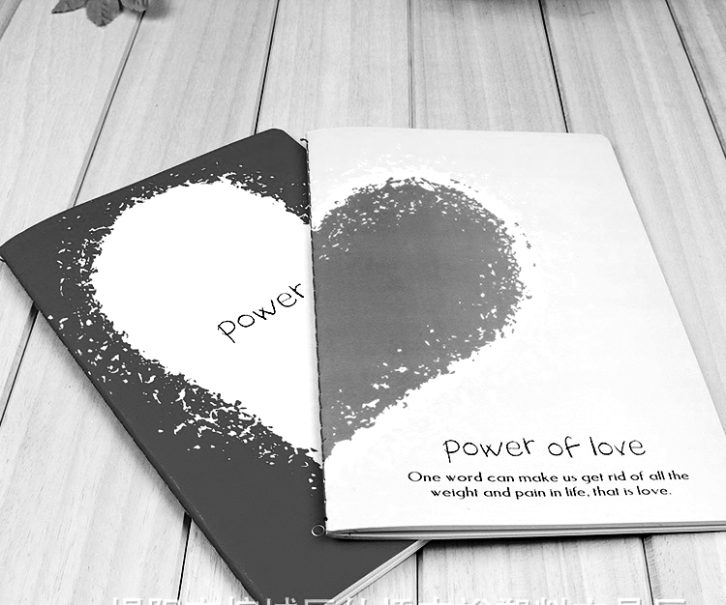
We decided to go to a restaurant. On our way to the table I noticed my mother had two notebooks. I asked her what they were for. She explained to me that sometimes it was easier to write down our feelings rather than talk about (A) them. We would write down our feelings in the form of a letter. It could be as long or as short as we wanted.
Our first topic was “Why I’m so angry?” I wrote a half page, and my mom filled up nearly three pages. (B) I watched tears run down her face as she wrote. I never realized anyone could hide so much anger. After we finished writing, we exchanged our notebooks. As soon as I started reading my mother’s words, I began to cry and so did she. When we finished reading, we discussed our feelings. ② _________________. Our talk helped me realize so many things I had never thought of before, not only about my mother but also about other people.
My mother and I continue to use our notebooks as a way of communicating our anger and worries, and our happiness as well. We know that no matter how we feel about each other, our notebooks are a safe place to express our feelings. We have come to an agreement that at the end of each letter we write, “I love you.”
任务一 选择最佳句子补全文章，将字母代号填写在答题卡上。其中有一项是多余的。 (2分)
A. We knew that we were in great need of a talk.
B. I just wish you would help a little more with the family.
C. Amazingly enough, it felt like all the anger inside me went away from my body.
① _________________ ② _________________
任务二 找出(A)处划线代词 them 所指代的内容。(1分) ___________________
任务三 将(B)处划线句子 I watched tears run down her face as she wrote. 译为汉语。（2分）
______________________________________________________________
任务四 找出与 The minute we read each other’s words, both of us started to cry. 意思相同或相近的句子。（1分）
______________________________________________________________
任务五 选择文章的最佳标题，将字母代号填写在答题卡上。（1分）_________________
A. I Love You, Mum
B. The Difficult Times in My Life
C. The Notebooks Filled With Love
任务六 完成句子。第3和第5个空每空不超过10个词，其它每空限填一词。（5分）
The relations between my mother and me used to be _____1_____. One morning, we had a talk in a _____2_____. After the talk, we _____________3_____________. Now we continue to use our _____4_____ to communicate because _____________5_______________.
V．书面表达（共15分）
初中生活即将结束，丰富多彩的学校活动一定给你留下了许多美好的回忆。根据图表提示，选择一次你最喜欢的活动进行描述。

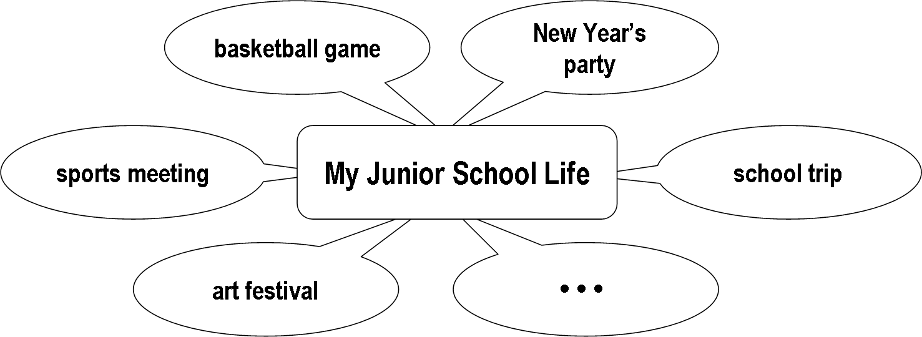

内容包括：1．此次活动的过程；
2．你的收获或感受。
要求：1．词数：80-100。开头已给出，不计入总词数。
2．文中不得出现真实的校名和人名。
My junior school life is coming to an end. I had a lot of sweet memories. _____________________
___________________________________________________________________________________

