浙江省衢州市2018年中考英语试卷
一、听カ
第一节：听小对话，从A、B、C三个选项中选出最佳选项，回答问题，对话仅读一遍。
1. Where has Lily been?
A. Australia.
B. England.
C. Germany.
2. Which subject does Sally's father teach?
A. Math.
B. PE.
C. Chinese.
3. When does the movie start?
A. At 6:30.
B. At 7:30.
C. At 8:30.
4. How will the weather be tomorrow?
A. Sunny.
B. Windy.
C. Rainy.
5. What's the possible relationship between the two speakers?
A. Teacher and student.
B. Mother and son.
C. Doctor and patient.
第二节：听长对话，从A、B、C三个选项中选出最佳选项，回答问题，对话读两遍。
听下面一段较长对话，回答第6～7小题。
5. What is Matt doing?
A. He is shopping at the market.
B. He is making a plan for his trip.
C. He is buying the ticket at the station.
7. How will Matt go to Texas?
A. By bus.
B. By train.
C. By plane.
听下面一段较长对话，回答第8～10小题。
8. Where did the man learn about the restaurant?
A. From a friend.
B. From TV
C. From a magazine.
g. What does the woman order?
A. Fruit.
B. Meat.
C. Vegetables.
10. What does the man advise the woman to do?
A. To do exercise.
B. To eat less.
C. To lose weight.
第三节；听独白，从题中所的A、B、C三个选项中选出最佳选项，完成信息表。独白读两遍。
Juliette's website
Name | _______ Girls
Development | At ten, Juliette drew _______ little girls.  She started the website with the help of her _______.  At first, there were only some simple pictures on the website.  Now, it has message boards, chat rooms, _______, music and more.
Aim(目的) | To help the girls learn more about cultures, _______ and become better.
11. A. Beautiful B. Cool C. Young
12. A. three B. four C. five
13. A. parents B. teachers C. friends
14. A. games B. stories C. movies
15. A. make friends B. build confidence C. protect themselves
二、完形填空
阅读下面短文，掌握其大意，然后从每题所的A、B、C、D四个选项中选出最佳选项，使文章完整、通顺。
It was two days before Christmas, and David wanted to give a card to everyone in his class. He opened the bag and looked 16 . "What are you looking for? his mom asked. "Ms. Ross gave us a 17 of everyone in the class, "said David. "I can't find mine. If I don t have my list, I won't know what names to put on the cards."
"Take 18 out and we'll look together," suggested Mom. They shook out all his books and 19 all the pockets in his bag, but no Christmas list. "Now I can't give out cards at school, "David said sadly.
"Don't 20 so easily, said Mom. She took a piece of paper and asked him how many children are in his class. "Seventeen," answered David "I'll never 21 them all."
"Wait, "said Mom, numbering the paper one to seventeen." Now, who do you often play with? ""Brian, Todd and John. "She wrote down their 22 . "And who sits in the first row in your classroom？”“Hmm…Angie, Jill and Brad." David tried to remember what his 23 looked like and who sat where, " And Rebecca, Travis and Erin in the second row." David's mom wrote as fast as she could.
Now, they had 24 names. Who had he missed? David thought hard.
"Why don't you write out the 25 that you have names for?" said Mom. "Maybe you'll think of the 26 name while you're writing."
David picked out a card. He 27 it and then put it into the envelope. He did this sixteen times. " 28 is missing?" One more time he thought about who sat where in his classroom.
29 he said, "I know! I know who is missing from the list!"
"who？" said Mom.
"We forgot 30 !" David said. "I'm going to wish me a Merry Christmas, too.
（）16. A. outside B. inside C. down D. up
（）17. A. list B. note C. book D. bill
（）18. A. something B. everything C. more D. less
（）19. A. checked B. touched C. found D. cleaned
（）20. A. get on B. get off C. give up D. give back
（）21. A. remember B understand C. accept D. believe
（）22. A. rules B. numbers C. names D. addresses
（）23. A. bedroom B. study C. school D. classroom
（）24. A. fifteen B. sixteen C. seventeen D. eighteen
（）25. A. posters B. letters C. cards D. messages
（）26. A. missing B. interesting C. common D. strange
（）27. A. signed B. drew C. watched D. enjoyed
（）28. A. What B. Whose C. Which D. Who
（）29. A. Sadly B. Suddenly C. Secretly D. Unluckily
（）30. A. you B. him C. her D. me
三、阅读理解
阅读下面短文，从每所给的A、B、C、D四个项中选出最佳选项。
A
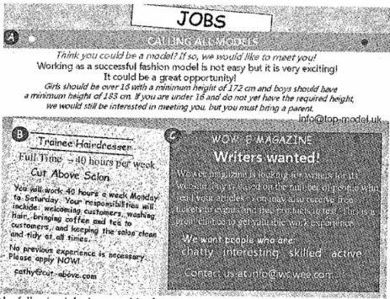
31. Which of the following jobs is wanted in the poster?
A. A model.
B, A waiter.
C. A support worker.
D. A market worker.
32. The Wowee Magazine wants writers who should ________.
A. be over 16 years old
B, be skilled and active
C. keep the salon clean and tidy
D. have the ability to care for others
33. According to the passage, the workers in ______ will work 40 hours a week.
A. Wowee Magazine
B. Golden Care
C. Top Model Company
D. Cut Above Salon
B
I have read plenty of articles about self-improvement these past few months, and most of them tell you that you need to wake up and keep positive(积极的). When you wake up, you need to think that something great is going to happen today, and that you are going to have a great day. This kind of positive attitude(态度) is supposed to change your whole day.
So this morning I woke up and decided to give it a whirl. The sun was shining brightly through my bedroom window, and it immediately gave me this warm feeling inside. I thought to myself, "Today is going to be a great day. One of the best days ever!" I got out of bed, took my morning shower and began to get dressed. I put on a pair of dress pants I have not warned in a while, followed by my dress shirt and that is when it began. I reached into my left pocket and pulled out what felt like some paper.
You know that feeling of finding a $20 hill in your pants and it feels like free money? Because you forgot all about it and thought you never did?
I pulled out a $100 bill and a $50 bill in the same pocket. It seemed like the best thing that had happened to me these days. Yes, $150 starts off my day! I'm sure if someone could have seen the smile on my face, they would have understood, I shouted in joy, with my poor dog looking at me like I was crazy!
Start your morning off thinking you are going to have the best day ever and you just might! I really want to know what will happen next.
34. ______ made the writer think in a positive way.
A Person he knew
B. A message he received
C. The articles he read
D. The pants be wore
35. The meaning of the underlined phrase "give it a whirl" is probably similar to "_______".
A. get dressed
B. have e try
C. reed books
D. make money
36. The underlined word "It" in Paragraph 4 refers to _____.
A. finding money in the pocket
B. receiving help from others
C. getting up early in the morning
D. enjoying the morning sunshine
37. What does the passage mainly tell us?
A. It is important to be honest.
B. Confidence leads us to success.
C. Sharing with others brings us happiness.
D. A positive attitude may bring a good result.
C
Do you use a calendar to help you organize your life? By listing what you need to do on any special day, you can make sure to keep all for your appointments and not worry whether you've forgotten something. Calendars are also useful for reminding(提醒) people what day a certain holiday is on and what days you might have off from work. Besides, they are used for planning fun things like vacations and outings.
A calendar is usually divided into twelve parts, and each one stands for m month with all the days laid out in a grid-like (网格状的) form. A block of space usually is for are day, and there is enough space for you to write down what you need to do on that certain day. You probably use all different kinds of calendars. A calendar on your cell phone screen is easy to use, and so is a large paper calendar that hangs on your wall.
Here is one page of Mary's calendar and it shows her plans in May.
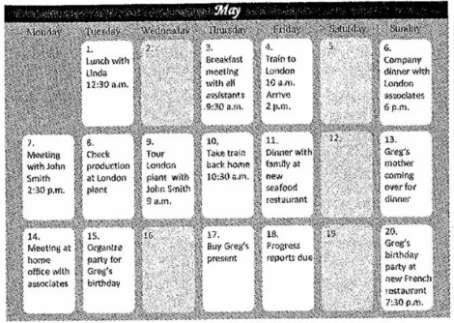
38. People use calendars to _______.
①make plans for vacations and outings
②buy birthday presents on the cell phones
③help remember their appointments
④remind themselves of the holidays and the days off
A. ①②③
B. ①②④
C. ①③④
D. ②③④
39. From Paragraph 2 we can know ________.
A. what a calendar looks like
B. what a calendar is used for
C. how we draw a calendar on the wall
D. how we organize our life with a calendar
40. When is Greg's birthday?
A. Friday May 11.
B Sunday May 13.
C. Friday May 18.
D. Sunday May 20.
41. How many full days will Mary spend in London?
A. Two days.
B. Three days
C. Four days.
D. Five days.
D
Most people use their mouths to talk, but do you know same people use their hands to speak? Some people who cannot bear use their hands to communicate messages to others. This is called sign language. These people make shapes with their fingers, movements with their hands, as well as different faces in order to talk to other people.
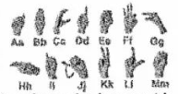
One way people speak with their hands is by making shapes for letters with their fingers. For example, if you make an "OK" sign with your thumb and finger, that is the shape for the letter "f" in American sign language. Each letter has a hand shape. This way people can spell words using their hands. For example, if you want to spell "fun", you need to make three shapes. First you make the shape for the letter "f", then the shape for the letter "u", and then the shape for the letter "n".
___________. If you move your hand from your nose to your chin(下巴), you can say“mother” in American sign language. Of course, you have to use the correct hand shape, too. That shape is like holding your hand open with all five fingers showing. If you move your hand from the top of your head to your chin, you can say "father＂， Again, you have to use the same hand shape that you used for "mother".
Finally, people can change their faces to communicate in a sign language. For example, if you want to ask a question, you need to make your eyebrows (眉毛) go up. You also need to move your head forward a little.
If you want to say "I do not know", you need to make your eyes smaller and make your eyebrows go down.
42. If you want to spell the word "nice", you need to make _______ hand shapes.
A. one
B. two
C. three
D. four
43. Which of the following can be put in the blank in Paragraph 3?
A. People also need to learn sign language
B. People also make hand shapes to communicate
C. People also move their hands to talk in a sign language
D. People also make different faces to express their meanings
44. You need to use your _______ to say "I do not know" in American sign language.
A. eyes and eyebrows
B. eyes and head
C. hand and head
D. fingers and eyes
45. The purpose of the passage is to _________.
A. help people know more about America
B. introduce American sign language to readers
C. teach readers how to make hand shapes
D. encourage people to use more sign language
四、任务型阅读
Rules for the Examination
You must be at the exam room ten minutes before. If you are more than ten minutes late, you are not allowed to enter.
You must show your student ID and exam number before you enter the room.
Depending on which exam you are taking, you may bring certain things into the center. You can use calculators(计算器)In the math exam, and some subjects may allow you to use dictionaries. But ipads, head sets, and cell phones are not allowed in the exam room
You must sit at the desk with your exam number on it. And keep the number at the top corner of your desk.
You must keep silent during the exam. And don't disturb other people when testing.
If you need a drink or to go to the restroom, you should raise your hand and ask for the teachers permission. You may not talk with anyone during the break.
You must write your answers on the official answer paper.
You may leave the exam room at any time if you do not plan to return.
You will be warned fifteen minutes, five minutes and one minute before the end of the exam.
When the time is up, you must stop writing and leave the room soon.
阅读以上内容，并完成下面摘要。每空限填一词。
The list is about the ___46___ for an examination. Students must __47____ their student. ID and exam numbers before entering the exam room. Only certain things such as calculators and ____48__ are answered in the exams. They must __49____ their hands for water or to go to the restroom. Students will be warned __50____.
五、词汇运用
根据短文内容和所给中文提示，写出空白处各单词的正确形式。每空限填一词.
Dear Future Self,
This is you from ten years ago, the same girl that you used to be, I am sitting in my grade seven classroom, staring outside. Now, trees with green leaves seem so tall and ____ (笔直的). Do you still find them large? Or perhaps they seem small to you now?
Do you still find the squirrels cute? Do you still have a strong love for ______ (动画片) Or perhaps are all of these childish for you? I ______ (想知道)if my friends now are still friends with you, ten years later? Are you still in touch with them?
Can you tell me how my high school graduation went? Did you like sitting and ______ (听) to the headmaster and teachers speak? And can you tell me what I will become in the future. Am I a doctor? Am I a teacher, engineer, officer, ______ (科学家), or writer? I'm not sure what I want to be but I'm sure that you have ______ (已经)known. That reminds me, did I do well on my math test ______ (昨天)?
Oh. I've always wanted to travel around the world! Did you visit Japan, ______ (加拿大), Italy, the United States or China yet? Or did you visit Russia, South Korea or Australia instead?
Life will always ______ (继续). Please remember all the happy times and all the terrible times, Please remember me, the you who ______ (生活) ten years ago.
Yours,
Ten Years Past Self
六、语法填空
读下面短文，按照句子的语法情况和上下文连贯的要求，在空白处填入适当的词或用括号中所给词的正确形式填空。每空不过两词
Florence Nightingale was a nurse who saved many people in the 19th century. She was named after the city of Florence in Italy.
Florence was ___61___ unusual young woman for her time, bemuse she didn't want to go to parties and get married. She wanted to be a nurse and help people. Her family ____62__ (not) want her to become a nurse because hospitals back then were dirty, horrible places.
_63____ the age of thirty-one, Florence went to Germany and learned all about nursing. It was hard work, ___64___ she loved it.
In 1854, lots of British soldiers went to fight in the Crimean War. Army hospitals were filled with injured people, but there ___65___ (be) no nurses and many soldiers died. Florence and a team of nurses went to help.
Florence worked 20 hours a day to make the hospital ___66___ (clean) and safer place. She brought fresh food, she cleaned the beds and she used clean bandages on the wounded soldiers fewer ___67___ (man) were dying.
At night, Florence talked to the injured soldiers and helped them __68____ (write) letters to their families. They called her "the lady with the lamp", __69____ she always carried a lamp.
When Florence returned to England, people called her a hero. Queen Victoria wrote her a letter to say thanks, She _70_____ (give)the honor(荣誉)----Order of Merit, becoming the first woman to receive it.
七、书面表达
71．假设你是Li Hua，以下是你的美国笔友Alex发给你的一封电子邮件，谢你根据该邮件内容给Alex回一封邮件。
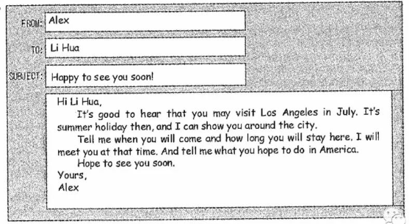
要求：①考生需按电子邮件格式完成整封邮件；②邮件中不能出现真实姓名、校名等相关信息；③字数90—110。
